Experiment 1
1. Experiment Title
Demonstrate Inline, Internal, and External JavaScript; Use Console Methods; Create a Webpage Showing User Information and a Welcome Message.

2. Software/Tools Required
- Visual Studio Code (VS Code)
- Google Chrome / Mozilla Firefox / Microsoft Edge
- HTML5
- CSS3
- JavaScript
- Windows Operating System

3. Experiment Program Code
The experiment consists of the following files:
- index.html
- styles.css
- script.js

<!DOCTYPE html>
<html lang="en">
<head>
<meta charset="UTF-8">
<meta name="viewport" content="width=device-width, initial-scale=1.0">
<title>Exp 1: Web Integration Portal</title>

<!-- [1] EXTERNAL CSS LINK -->
<link rel="stylesheet" href="style.css">

<!-- [2] INTERNAL CSS -->
<style>
@import url('https://fonts.googleapis.com/css2?family=Fira+Code:wght@400;500&family=Inter:wght@400;600;700&display=swap');

body {
background-color: #0f172a; /* Deep Slate Tech Background */
font-family: 'Inter', sans-serif;
color: #f8fafc;
margin: 0;
padding: 40px 20px;
}

.header {
text-align: center;
margin-bottom: 40px;
border-bottom: 1px solid #1e293b;
padding-bottom: 20px;
}

.header h1 {
font-size: 2.2em;
background: linear-gradient(to right, #38bdf8, #818cf8);
-webkit-background-clip: text;
-webkit-text-fill-color: transparent;
margin: 0;
}

.grid-container {
display: grid;
grid-template-columns: repeat(auto-fit, minmax(320px, 1fr));
gap: 25px;
max-width: 1200px;
margin: 0 auto;
}

.tech-card {
background: #1e293b;
border: 1px solid #334155;
border-radius: 16px;
padding: 25px;
position: relative;
overflow: hidden;
transition: transform 0.3s ease, border-color 0.3s ease;
}

.tech-card:hover {
transform: translateY(-5px);
border-color: #38bdf8;
box-shadow: 0 10px 30px -10px rgba(56, 189, 248, 0.2);
}

.method-badge {
font-family: 'Fira Code', monospace;
font-size: 0.75em;
background: #0f172a;
color: #38bdf8;
padding: 6px 12px;
border-radius: 6px;
border: 1px solid #0369a1;
display: inline-block;
margin-bottom: 15px;
}

h3 {
margin: 0 0 10px 0;
font-size: 1.2em;
color: #f1f5f9;
}

p {
color: #94a3b8;
font-size: 0.9em;
line-height: 1.6;
margin-bottom: 25px;
}

.btn-tech {
background: #38bdf8;
color: #0f172a;
border: none;
padding: 12px 20px;
border-radius: 8px;
font-weight: 600;
cursor: pointer;
width: 100%;
transition: all 0.2s ease;
margin-bottom: 10px;
}

.btn-tech:hover {
background: #7dd3fc;
box-shadow: 0 0 15px rgba(56, 189, 248, 0.4);
}

.btn-alt {
background: transparent;
color: #38bdf8;
border: 1px solid #38bdf8;
}

.btn-alt:hover {
background: rgba(56, 189, 248, 0.1);
}

.console-box {
background: #0b0f19;
border: 1px dashed #475569;
border-radius: 8px;
padding: 15px;
margin-top: 15px;
font-family: 'Fira Code', monospace;
font-size: 0.85em;
color: #10b981;
display: none;
}
</style>
</head>
<body>

<div class="header">
<!-- [3] INLINE CSS: Directly applied via style attribute -->
<h1 style="letter-spacing: -1px;">Experiment No. 01</h1>
<p style="color: #64748b; font-family: 'Fira Code', monospace;">// CSS & JS Integration Architecture</p>
</div>

<div class="grid-container">
<!-- METHOD 1 -->
<div class="tech-card">
<div class="section-tag method-badge">METHOD_01 :: INLINE</div>
<h3>Inline Architecture</h3>
<p>Styles and scripts embedded directly inside the HTML element attributes for localized, priority execution.</p>

<button class="btn-tech" onclick="alert('⚡ Inline JS Triggered Successfully!')">
Execute Inline Script
</button>
</div>

<!-- METHOD 2 -->
<div class="tech-card">
<div class="section-tag method-badge">METHOD_02 :: INTERNAL</div>
<h3>Internal DOM & Console</h3>
<p>Page-specific styles in head section. Scripts execute dynamic DOM insertion and backend console logs.</p>

<button class="btn-tech" onclick="showUserInfo()">Render Student Data</button>
<button class="btn-tech btn-alt" onclick="triggerConsoleDemo()">Trigger Console Debug</button>

<div id="userInfoBox" class="console-box"></div>
</div>

<!-- METHOD 3 -->
<div class="tech-card external-card-style">
<div class="section-tag method-badge">METHOD_03 :: EXTERNAL</div>
<h3>External Modular Files</h3>
<p>Production-grade separation of concerns using independent .css stylesheets and .js logic files.</p>

<button class="btn-tech" onclick="showWelcomeMessage()">Fetch External Response</button>

<div id="welcomeBox" class="console-box" style="color: #38bdf8;"></div>
</div>
</div>

<!-- INTERNAL JAVASCRIPT -->
<script>
function showUserInfo() {
const infoBox = document.getElementById('userInfoBox');
infoBox.innerHTML = `
<span style="color:#64748b;">// STUDENT_META_DATA</span><br>
> NAME: Arnav Band<br>
> PRN : 223<br>
> DEPT: Computer Science & Engineering<br>
> STATUS: <span style="color:#38bdf8;">ACTIVE_ENROLLMENT</span>
`;
infoBox.style.display = 'block';
}

function triggerConsoleDemo() {
console.log("%c[LOG] System initialization started.", "color: #38bdf8; font-weight:bold;");
console.info("[INFO] Modular DOM elements mounted successfully.");
console.warn("[WARN] Memory usage optimal. Debug mode enabled.");
console.error("[ERROR] Simulated error loop for testing inspection methods.");
alert("🛠️ Console diagnostics executed! Open DevTools (F12) -> Console tab to inspect.");
}
</script>

<!-- [4] EXTERNAL JAVASCRIPT LINK -->
<script src="script.js"></script>

</body>
</html>

Output:

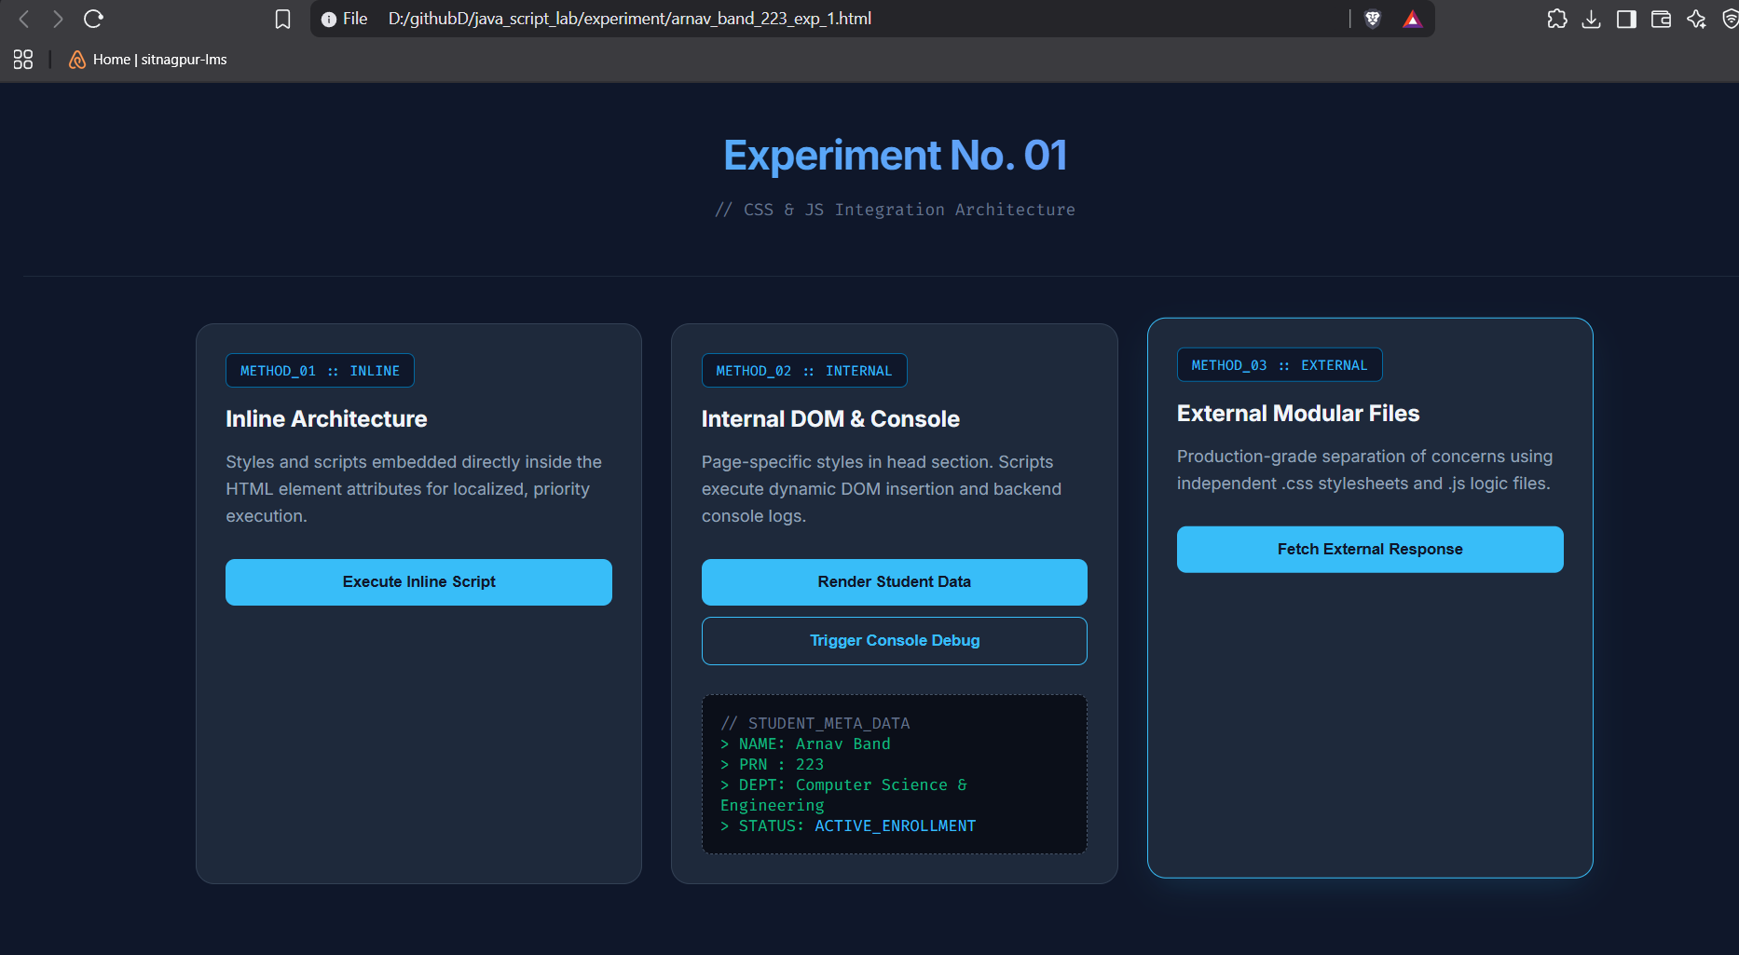

Case Study 1
1. Case Study Title
Create a Webpage for College Department and Link the Student Information Page with It and Write a JavaScript Program to Display "Welcome to SIT Nagpur" in an Alert Box.

2. Case Study Program Code
The case study consists of the following files:
- index.html – Displays the college department information and shows the alert message "Welcome to SIT Nagpur" using JavaScript.
- students.html – Displays the student information page linked from the department webpage.

<!DOCTYPE html>
<html lang="en">
<head>
<meta charset="UTF-8" />
<meta name="viewport" content="width=device-width, initial-scale=1.0" />
<meta name="description" content="SIT Nagpur - Department of Computer Science & Engineering. Explore our programs, faculty, and student resources." />
<title>SIT Nagpur | Department of Computer Science & Student Portal</title>

<link rel="preconnect" href="https://fonts.googleapis.com" />
<link rel="preconnect" href="https://fonts.gstatic.com" crossorigin />
<!-- Swapped to Poppins for modern UI and Fira Code for data/numbers -->
<link href="https://fonts.googleapis.com/css2?family=Fira+Code:wght@400;500;600&family=Poppins:wght@300;400;500;600;700;800&display=swap" rel="stylesheet" />

<style>
/* =========================================================
1. GLOBAL & VARIABLES (MODERN DARK THEME)
========================================================= */
*, *::before, *::after { margin: 0; padding: 0; box-sizing: border-box; }

:root {
--primary: #06b6d4; /* Cyber Cyan */
--primary-dark: #0891b2;
--accent: #8b5cf6; /* Neon Purple */
--secondary: #f43f5e; /* Rose */
--gold: #fbbf24;
--green: #10b981;
--orange: #f97316;

/* Dark Theme Backgrounds */
--bg-dark: #0f172a; /* Deep Slate */
--bg-card: #1e293b; /* Lighter Slate for Cards */
--bg-card2: #334155; /* Hover/Input States */

/* Dark Theme Typography */
--text-main: #f8fafc; /* Crisp Off-White */
--text-muted: #94a3b8; /* Slate Gray */
--border: #334155;

--shadow: 0 10px 40px rgba(0, 0, 0, 0.4);
--radius: 16px;
--transition: 0.35s cubic-bezier(0.4, 0, 0.2, 1);
}

html { scroll-behavior: smooth; }

body {
font-family: 'Poppins', sans-serif;
background: var(--bg-dark);
color: var(--text-main);
overflow-x: hidden;
min-height: 100vh;
}

/* Updated Background Glowing Orbs for Dark Mode */
body::before {
content: '';
position: fixed;
inset: 0;
background:
radial-gradient(ellipse 80% 60% at 20% 10%, rgba(6, 182, 212, 0.1) 0%, transparent 60%),
radial-gradient(ellipse 60% 50% at 80% 80%, rgba(139, 92, 246, 0.1) 0%, transparent 60%),
radial-gradient(ellipse 50% 40% at 50% 50%, rgba(244, 63, 94, 0.05) 0%, transparent 70%);
pointer-events: none;
z-index: 0;
}

/* Font Utility for Numbers/Code */
.mono-font {
font-family: 'Fira Code', monospace;
}

/* =========================================================
2. NAVBAR
========================================================= */
nav {
position: sticky; top: 0; z-index: 100;
backdrop-filter: blur(20px);
background: rgba(15, 23, 42, 0.85); /* Dark transparent nav */
border-bottom: 1px solid var(--border);
padding: 0 5%;
display: flex; align-items: center; justify-content: space-between;
height: 70px;
animation: slideDown 0.6s ease;
}

@keyframes slideDown {
from { transform: translateY(-100%); opacity: 0; }
to { transform: translateY(0); opacity: 1; }
}

.nav-logo {
display: flex; align-items: center; gap: 12px;
text-decoration: none;
}

.logo-icon {
width: 42px; height: 42px;
background: linear-gradient(135deg, var(--primary), var(--accent));
border-radius: 10px;
display: grid; place-items: center;
font-size: 20px; font-weight: 800; color: #fff;
box-shadow: 0 4px 18px rgba(6, 182, 212, 0.4);
}

.nav-logo span {
font-weight: 700; font-size: 1.1rem; color: var(--text-main);
}

.nav-links { display: flex; gap: 6px; list-style: none; }

.nav-links a {
color: var(--text-muted); text-decoration: none;
font-size: 0.9rem; font-weight: 500;
padding: 8px 16px; border-radius: 8px;
transition: var(--transition);
cursor: pointer;
}

.nav-links a:hover { color: var(--text-main); background: rgba(255,255,255,0.05); }
.nav-links a.active { color: var(--primary); background: rgba(6, 182, 212, 0.1); }

.nav-cta {
background: linear-gradient(135deg, var(--primary), var(--accent)) !important;
color: #fff !important;
border-radius: 10px !important;
box-shadow: 0 4px 16px rgba(139, 92, 246, 0.3);
}

/* =========================================================
3. DEPARTMENT VIEW STYLES
========================================================= */
.hero {
position: relative; z-index: 1;
min-height: calc(100vh - 70px);
display: flex; flex-direction: column; align-items: center; justify-content: center;
text-align: center; padding: 80px 5% 60px;
}

.hero-badge {
display: inline-flex; align-items: center; gap: 8px;
background: rgba(6, 182, 212, 0.1);
border: 1px solid rgba(6, 182, 212, 0.2);
border-radius: 50px; padding: 8px 20px;
font-size: 0.82rem; font-weight: 600;
color: var(--primary); letter-spacing: 0.06em; text-transform: uppercase;
margin-bottom: 28px;
animation: fadeUp 0.8s ease 0.2s both;
}

.hero-badge::before {
content: '●'; font-size: 8px; color: var(--primary);
animation: pulse 2s infinite;
}

@keyframes pulse { 0%,100%{opacity:1} 50%{opacity:0.3} }

.hero h1 {
font-size: clamp(2.4rem, 6vw, 4.8rem);
font-weight: 800; line-height: 1.1;
margin-bottom: 24px;
animation: fadeUp 0.8s ease 0.35s both;
}

.highlight {
background: linear-gradient(to right, var(--primary), var(--accent));
-webkit-background-clip: text;
-webkit-text-fill-color: transparent;
}

.hero p {
max-width: 620px; color: var(--text-muted);
font-size: 1.08rem; line-height: 1.8;
margin-bottom: 44px;
animation: fadeUp 0.8s ease 0.5s both;
}

.hero-btns {
display: flex; gap: 16px; flex-wrap: wrap; justify-content: center;
animation: fadeUp 0.8s ease 0.65s both;
}

@keyframes fadeUp {
from { opacity:0; transform:translateY(30px); }
to { opacity:1; transform:translateY(0); }
}

.btn-primary {
background: linear-gradient(135deg, var(--primary), var(--primary-dark));
color: #fff; border: none;
padding: 16px 36px; border-radius: 14px;
font-size: 1rem; font-weight: 600; cursor: pointer;
text-decoration: none; display: inline-flex; align-items: center; gap: 10px;
box-shadow: 0 6px 28px rgba(6, 182, 212, 0.25);
transition: var(--transition);
}

.btn-primary:hover { transform: translateY(-3px); box-shadow: 0 12px 40px rgba(6, 182, 212, 0.4); }

.btn-secondary {
background: var(--bg-card);
color: var(--text-main);
border: 1px solid var(--border);
padding: 16px 36px; border-radius: 14px;
font-size: 1rem; font-weight: 600; cursor: pointer;
text-decoration: none; display: inline-flex; align-items: center; gap: 10px;
backdrop-filter: blur(10px);
transition: var(--transition);
}

.btn-secondary:hover { background: var(--bg-card2); border-color: var(--primary); transform: translateY(-3px); }

/* STATS STRIP */
.stats-strip {
position: relative; z-index: 1;
display: flex; justify-content: center; flex-wrap: wrap;
background: rgba(30, 41, 59, 0.6);
border-top: 1px solid var(--border);
border-bottom: 1px solid var(--border);
backdrop-filter: blur(12px);
}

.stat-item {
flex: 1; min-width: 160px;
padding: 32px 20px; text-align: center;
border-right: 1px solid var(--border);
transition: var(--transition);
}

.stat-item:last-child { border-right: none; }
.stat-item:hover { background: rgba(255,255,255,0.02); }

.stat-num {
font-size: 2.4rem; font-weight: 800;
color: var(--primary);
display: block;
}

.stat-label { font-size: 0.85rem; color: var(--text-muted); font-weight: 500; margin-top: 4px; }

/* SECTION COMMON */
section { position: relative; z-index: 1; padding: 90px 5%; }

.section-tag {
display: inline-block;
background: rgba(139, 92, 246, 0.1);
border: 1px solid rgba(139, 92, 246, 0.2);
color: var(--accent);
font-size: 0.78rem; font-weight: 700;
letter-spacing: 0.1em; text-transform: uppercase;
padding: 6px 16px; border-radius: 50px; margin-bottom: 18px;
}

.section-title {
font-size: clamp(1.8rem, 3.5vw, 2.8rem);
font-weight: 800; margin-bottom: 14px;
}

.section-sub {
color: var(--text-muted); font-size: 1rem;
line-height: 1.7; max-width: 560px; margin-bottom: 56px;
}

/* ABOUT */
#about {
display: grid; grid-template-columns: 1fr 1fr;
gap: 64px; align-items: center;
}

.about-visual { position: relative; }

.about-card-main {
background: var(--bg-card);
border: 1px solid var(--border);
border-radius: 24px; padding: 40px;
box-shadow: var(--shadow);
}

.about-icon {
width: 60px; height: 60px;
background: linear-gradient(135deg, var(--primary), var(--accent));
border-radius: 14px;
display: grid; place-items: center;
font-size: 28px; margin-bottom: 20px; color: white;
box-shadow: 0 8px 24px rgba(6, 182, 212, 0.3);
}

.about-card-main h3 { font-size: 1.4rem; font-weight: 700; margin-bottom: 12px; }
.about-card-main p { color: var(--text-muted); line-height: 1.7; font-size: 0.95rem; }

.floating-badge {
position: absolute;
background: linear-gradient(135deg, var(--gold), #f59e0b);
color: #1a1400; font-weight: 700; font-size: 0.82rem;
padding: 10px 18px; border-radius: 50px;
box-shadow: 0 8px 24px rgba(251,191,36,0.3);
}

.floating-badge.top-right { top: -18px; right: -18px; }
.floating-badge.bot-left { bottom: -18px; left: -18px; }

.feature-list { list-style: none; display: flex; flex-direction: column; gap: 14px; }

.feature-list li {
display: flex; align-items: center; gap: 12px;
font-size: 0.95rem; color: var(--text-muted);
}

.feature-list li::before {
content: '✓';
width: 26px; height: 26px;
background: rgba(6, 182, 212, 0.15);
border: 1px solid rgba(6, 182, 212, 0.3);
color: var(--primary); border-radius: 50%;
display: grid; place-items: center;
font-size: 0.7rem; font-weight: 800; flex-shrink: 0;
}

/* PROGRAMS */
#programs { background: rgba(255,255,255,0.01); }

.programs-list {
display: flex; flex-direction: column; gap: 16px;
max-width: 1000px; margin: 0 auto;
}

.program-row {
display: grid; grid-template-columns: auto 1fr auto; gap: 40px;
align-items: center; padding: 32px 40px;
background: var(--bg-card); border: 1px solid var(--border);
border-radius: 16px; transition: var(--transition); cursor: pointer;
}

.program-row:hover {
border-color: var(--primary);
box-shadow: var(--shadow);
transform: translateX(4px);
}

.prog-number {
font-size: 2.5rem; font-weight: 800; color: var(--border);
transition: var(--transition);
}

.program-row:hover .prog-number { color: var(--primary); }

.prog-content h3 { font-size: 1.3rem; font-weight: 700; margin-bottom: 8px; color: var(--text-main); }
.prog-content p { color: var(--text-muted); font-size: 0.95rem; line-height: 1.6; max-width: 600px; }

.prog-meta { text-align: right; }
.prog-duration { display: block; color: var(--primary); font-size: 0.95rem; font-weight: 700; margin-bottom: 4px; }
.prog-seats { color: var(--text-muted); font-size: 0.85rem; font-weight: 500; }

@media (max-width: 768px) {
.program-row { grid-template-columns: 1fr; gap: 16px; padding: 24px; }
.prog-meta { text-align: left; }
.prog-number { display: none; }
}

/* FACULTY */
.faculty-list {
display: flex; flex-direction: column; gap: 16px; max-width: 900px; margin: 0 auto;
}

.faculty-row {
display: flex; align-items: center; gap: 24px; padding: 24px 32px;
background: var(--bg-card); border: 1px solid var(--border);
border-radius: 16px; transition: var(--transition); cursor: pointer;
}

.faculty-row:hover { border-color: var(--accent); transform: translateX(4px); box-shadow: var(--shadow); }

.faculty-avatar {
width: 56px; height: 56px; border-radius: 50%; display: grid; place-items: center;
font-size: 1.1rem; font-weight: 700; flex-shrink: 0; color: #fff;
}

.faculty-info { flex: 1; display: flex; flex-direction: column; gap: 4px; }
.faculty-row h4 { font-weight: 700; font-size: 1.15rem; color: var(--text-main); margin: 0; }

.faculty-meta { display: flex; justify-content: space-between; align-items: center; width: 100%; }
.designation { color: var(--primary); font-size: 0.9rem; font-weight: 600; margin: 0; }
.specialization { color: var(--text-muted); font-size: 0.85rem; font-weight: 500; }

@media (max-width: 600px) {
.faculty-row { flex-direction: column; align-items: flex-start; gap: 16px; }
.faculty-meta { flex-direction: column; align-items: flex-start; gap: 8px; }
}

/* STUDENT BANNER */
.student-banner {
position: relative; z-index: 1; margin: 0 5% 80px;
background: linear-gradient(135deg, rgba(6, 182, 212, 0.1), rgba(139, 92, 246, 0.1));
border: 1px solid rgba(139, 92, 246, 0.3);
border-radius: 24px; padding: 56px 60px;
display: flex; align-items: center; justify-content: space-between; gap: 40px; overflow: hidden;
}

.student-banner::before {
content: '🎓'; position: absolute; right: 60px; top: 50%; transform: translateY(-50%);
font-size: 140px; opacity: 0.05; pointer-events: none;
}

.banner-content h2 { font-size: clamp(1.4rem, 3vw, 2rem); font-weight: 800; margin-bottom: 12px; }
.banner-content p { color: var(--text-muted); font-size: 0.95rem; line-height: 1.7; max-width: 500px; }

/* DEPT FOOTER */
footer.dept-footer {
position: relative; z-index: 1; background: var(--bg-card);
border-top: 1px solid var(--border); padding: 56px 5% 28px;
}

.footer-grid { display: grid; grid-template-columns: 2fr 1fr 1fr 1fr; gap: 48px; margin-bottom: 48px; }
.footer-brand p { color: var(--text-muted); font-size: 0.88rem; line-height: 1.7; margin-top: 14px; max-width: 280px; }
.footer-col h5 { font-weight: 700; font-size: 0.95rem; margin-bottom: 16px; color: var(--text-main); }
.footer-col ul { list-style: none; display: flex; flex-direction: column; gap: 10px; }
.footer-col ul a { color: var(--text-muted); text-decoration: none; font-size: 0.88rem; transition: var(--transition); }
.footer-col ul a:hover { color: var(--primary); }
.footer-bottom {
border-top: 1px solid var(--border); padding-top: 24px;
display: flex; align-items: center; justify-content: space-between;
color: var(--text-muted); font-size: 0.82rem;
}

/* =========================================================
4. STUDENT PORTAL VIEW STYLES
========================================================= */
.page-header {
position: relative; z-index: 1;
background: linear-gradient(135deg, rgba(6, 182, 212, 0.1), rgba(15, 23, 42, 0.8));
border-bottom: 1px solid var(--border);
padding: 60px 5% 48px; text-align: center;
}

.page-header .section-tag {
display: inline-block; background: rgba(6, 182, 212, 0.1);
border: 1px solid rgba(6, 182, 212, 0.3); color: var(--primary);
font-size: 0.78rem; font-weight: 700; letter-spacing: 0.1em; text-transform: uppercase;
padding: 6px 18px; border-radius: 50px; margin-bottom: 20px;
animation: fadeUp 0.7s ease 0.1s both;
}

.page-header h1 {
font-size: clamp(2rem, 5vw, 3.5rem);
font-weight: 900; margin-bottom: 14px; animation: fadeUp 0.7s ease 0.25s both;
}

.page-header h1 span { color: var(--primary); }
.page-header p {
color: var(--text-muted); font-size: 1rem; max-width: 520px;
margin: 0 auto; line-height: 1.7; animation: fadeUp 0.7s ease 0.4s both;
}

/* SEARCH & FILTER */
.search-bar-wrap {
position: relative; z-index: 1; padding: 32px 5%;
display: flex; gap: 16px; flex-wrap: wrap;
align-items: center; justify-content: center;
}

.search-input-wrap { position: relative; flex: 1; max-width: 480px; min-width: 240px; }
.search-input-wrap input {
width: 100%; background: var(--bg-card2); border: 1px solid var(--border);
border-radius: 12px; padding: 14px 20px 14px 48px; color: var(--text-main);
font-size: 0.95rem; font-family: 'Poppins', sans-serif; outline: none; transition: var(--transition);
}
.search-input-wrap input:focus { border-color: var(--primary); box-shadow: 0 0 0 3px rgba(6, 182, 212, 0.2); }
.search-input-wrap input::placeholder { color: var(--text-muted); }
.search-icon { position: absolute; left: 16px; top: 50%; transform: translateY(-50%); font-size: 1rem; pointer-events: none; color: var(--text-muted); }

.filter-select {
background: var(--bg-card2); border: 1px solid var(--border);
border-radius: 12px; padding: 14px 20px; color: var(--text-main);
font-size: 0.9rem; font-family: 'Poppins', sans-serif; outline: none; cursor: pointer;
transition: var(--transition); appearance: none; min-width: 160px;
}
.filter-select:focus { border-color: var(--primary); }

/* STATS ROW */
.stats-row {
position: relative; z-index: 1; display: grid; grid-template-columns: repeat(auto-fit, minmax(180px, 1fr));
gap: 20px; padding: 0 5% 48px;
}
.mini-stat {
background: var(--bg-card); border: 1px solid var(--border); border-radius: var(--radius);
padding: 24px 20px; display: flex; align-items: center; gap: 16px; transition: var(--transition);
}
.mini-stat:hover { border-color: var(--primary); transform: translateY(-3px); box-shadow: var(--shadow); }
.mini-stat-icon { width: 48px; height: 48px; border-radius: 12px; display: grid; place-items: center; font-size: 1.4rem; flex-shrink: 0; color: #fff; }
.mini-stat-data strong { font-size: 1.6rem; font-weight: 800; display: block; color: var(--text-main); }
.mini-stat-data span { color: var(--text-muted); font-size: 0.82rem; font-weight: 500; }

/* STUDENT TABLE */
.table-section { position: relative; z-index: 1; padding: 0 5% 80px; }
.table-wrap { background: var(--bg-card); border: 1px solid var(--border); border-radius: 20px; overflow: hidden; box-shadow: var(--shadow); }
.table-header-row { padding: 20px 28px; display: flex; align-items: center; justify-content: space-between; border-bottom: 1px solid var(--border); background: rgba(255,255,255,0.02); }
.table-header-row h3 { font-weight: 700; font-size: 1.1rem; }
.table-header-row span { color: var(--text-muted); font-size: 0.85rem; }

table { width: 100%; border-collapse: collapse; }
thead tr { background: rgba(255,255,255,0.03); }
thead th { padding: 14px 20px; text-align: left; font-size: 0.78rem; font-weight: 700; color: var(--text-muted); letter-spacing: 0.06em; text-transform: uppercase; border-bottom: 1px solid var(--border); }
tbody tr { border-bottom: 1px solid var(--border); transition: var(--transition); }
tbody tr:last-child { border-bottom: none; }
tbody tr:hover { background: rgba(255,255,255,0.02); }
tbody td { padding: 16px 20px; font-size: 0.9rem; vertical-align: middle; }

.student-avatar {
width: 38px; height: 38px; border-radius: 50%; display: inline-grid; place-items: center;
font-size: 0.85rem; font-weight: 700; color: #fff; margin-right: 10px; vertical-align: middle;
}
.student-name { font-weight: 600; color: var(--text-main); }
.student-id { color: var(--text-muted); font-size: 0.8rem; }

.badge { display: inline-block; padding: 4px 12px; border-radius: 50px; font-size: 0.76rem; font-weight: 700; }
.badge-blue { background: rgba(6, 182, 212, 0.2); color: #22d3ee; border: 1px solid rgba(6, 182, 212, 0.3); }
.badge-green { background: rgba(16, 185, 129, 0.2); color: #34d399; border: 1px solid rgba(16, 185, 129, 0.3); }
.badge-orange { background: rgba(249, 115, 22, 0.2); color: #fb923c; border: 1px solid rgba(249, 115, 22, 0.3); }
.badge-red { background: rgba(244, 63, 94, 0.2); color: #fb7185; border: 1px solid rgba(244, 63, 94, 0.3); }
.badge-teal { background: rgba(139, 92, 246, 0.2); color: #a78bfa; border: 1px solid rgba(139, 92, 246, 0.3); }

.progress-bar-wrap { background: var(--bg-card2); border-radius: 50px; height: 8px; width: 100px; overflow: hidden; }
.progress-bar { height: 100%; border-radius: 50px; background: linear-gradient(90deg, var(--primary), var(--accent)); transition: width 1s ease; }
.cgpa-val { font-weight: 700; color: var(--accent); font-size: 0.95rem; }

.pagination { padding: 24px 28px; display: flex; align-items: center; justify-content: center; gap: 8px; border-top: 1px solid var(--border); }
.page-btn {
width: 38px; height: 38px; border-radius: 10px; display: grid; place-items: center;
background: none; border: 1px solid var(--border); color: var(--text-muted); cursor: pointer;
font-size: 0.88rem; transition: var(--transition);
}
.page-btn:hover, .page-btn.active { background: var(--primary); border-color: var(--primary); color: #fff; }

/* PROFILE CARDS */
.profile-section { position: relative; z-index: 1; padding: 0 5% 80px; }
.profile-section-title { font-size: 1.5rem; font-weight: 800; margin-bottom: 28px; }
.profile-list { display: flex; flex-direction: column; gap: 16px; max-width: 1000px; margin: 0 auto; }
.profile-row {
display: flex; align-items: center; gap: 32px; padding: 24px 32px;
background: var(--bg-card); border: 1px solid var(--border); border-radius: 16px; transition: var(--transition); cursor: pointer;
}
.profile-row:hover { border-color: var(--accent); transform: translateX(4px); box-shadow: var(--shadow); }
.profile-ava { width: 64px; height: 64px; border-radius: 50%; display: grid; place-items: center; font-size: 1.2rem; font-weight: 800; color: #fff; flex-shrink: 0; }
.profile-info { flex: 1; display: flex; flex-direction: column; gap: 4px; }
.profile-row h4 { font-weight: 700; font-size: 1.15rem; margin: 0; color: var(--text-main); }
.profile-row .roll { color: var(--text-muted); font-size: 0.85rem; }
.profile-tags { display: flex; gap: 6px; flex-wrap: wrap; margin-top: 4px; }
.profile-stats { display: flex; gap: 32px; text-align: right; }
.pstat { display: flex; flex-direction: column; align-items: flex-end; }
.pstat strong { font-size: 1.15rem; font-weight: 800; color: var(--text-main); }
.pstat span { color: var(--text-muted); font-size: 0.75rem; font-weight: 600; text-transform: uppercase; letter-spacing: 0.05em; }

@media (max-width: 768px) {
.profile-row { flex-direction: column; align-items: flex-start; gap: 16px; }
.profile-stats { justify-content: space-between; width: 100%; text-align: left; }
.pstat { align-items: flex-start; }
}

/* NOTICES */
.notices-section { position: relative; z-index: 1; padding: 0 5% 80px; }
.notices-list { display: flex; flex-direction: column; gap: 16px; max-width: 1000px; margin: 0 auto; }
.notice-card {
display: flex; align-items: center; gap: 24px; background: var(--bg-card);
border: 1px solid var(--border); border-left: 4px solid var(--primary);
border-radius: 12px; padding: 24px 32px; transition: var(--transition);
}
.notice-card:hover { transform: translateX(4px); box-shadow: var(--shadow); }
.notice-card.urgent { border-left-color: var(--secondary); }
.notice-card.success { border-left-color: var(--green); }
.notice-card.info { border-left-color: var(--accent); }
.notice-content { flex: 1; }
.notice-head { display: flex; align-items: center; gap: 10px; margin-bottom: 8px; }
.notice-head .tag { font-size: 0.72rem; font-weight: 700; text-transform: uppercase; padding: 4px 12px; border-radius: 50px; }
.notice-card h4 { font-weight: 700; font-size: 1.1rem; margin-bottom: 6px; color: var(--text-main); }
.notice-card p { color: var(--text-muted); font-size: 0.9rem; line-height: 1.6; max-width: 800px; margin: 0; }
.notice-date-container { text-align: right; min-width: 100px; }
.notice-date { color: var(--text-muted); font-size: 0.85rem; font-weight: 500; }

/* STUDENT FOOTER */
footer.student-footer {
position: relative; z-index: 1; background: var(--bg-card); border-top: 1px solid var(--border);
padding: 28px 5%; display: flex; align-items: center; justify-content: space-between;
flex-wrap: wrap; gap: 16px;
}
footer.student-footer p { color: var(--text-muted); font-size: 0.85rem; }
.footer-links { display: flex; gap: 20px; }
.footer-links a { color: var(--text-muted); text-decoration: none; font-size: 0.85rem; transition: var(--transition); cursor: pointer; }
.footer-links a:hover { color: var(--primary); }

/* =========================================================
5. UTILITY & RESPONSIVE
========================================================= */
.reveal { opacity: 0; transform: translateY(30px); transition: opacity 0.7s ease, transform 0.7s ease; }
.reveal.visible { opacity: 1; transform: translateY(0); }
.student-row.hidden { display: none; }

@media (max-width: 900px) {
#about { grid-template-columns: 1fr; }
.footer-grid { grid-template-columns: 1fr 1fr; }
.student-banner { flex-direction: column; text-align: center; }
.notices-grid { grid-template-columns: 1fr; }
}

@media (max-width: 700px) {
.nav-links { display: none; }
.footer-grid { grid-template-columns: 1fr; }
.hero-btns { flex-direction: column; align-items: center; }
table thead { display: none; }
tbody td { display: block; }
}
</style>

<script src="https://unpkg.com/lucide@latest"></script>
<style>
i[data-lucide] {
width: 1.2em;
height: 1.2em;
vertical-align: text-bottom;
display: inline-block;
}
</style>
</head>
<body>

<!-- NAVBAR -->
<nav id="main-nav">
<a href="#" onclick="switchView('department'); return false;" class="nav-logo">
<div class="logo-icon">S</div>
<span>SIT Nagpur</span>
</a>
<ul class="nav-links">
<li><a href="#about" class="nav-item active" onclick="goToSection('#about'); return false;">About</a></li>
<li><a href="#programs" class="nav-item" onclick="goToSection('#programs'); return false;">Programs</a></li>
<li><a href="#faculty" class="nav-item" onclick="goToSection('#faculty'); return false;">Faculty</a></li>
<li><a href="#" class="nav-cta" id="nav-student-btn" onclick="switchView('students'); return false;">Student Info</a></li>
</ul>
</nav>

<!-- =========================================================
VIEW 1: DEPARTMENT CONTENT
========================================================= -->
<div id="view-department">
<!-- HERO -->
<section class="hero">
<div class="hero-badge">Affiliated to RTMNU &middot; AICTE Approved</div>
<h1>
Department of<br>
<span class="highlight">Computer Science</span><br>
&amp; Engineering
</h1>
<p>
Empowering the next generation of innovators at
<strong>Symbiosis Institute of Technology, Nagpur</strong>.
Excellence in education, research, and industry collaboration.
</p>
<div class="hero-btns">
<a href="#" onclick="switchView('students'); return false;" class="btn-primary" id="student-info-btn">
<i data-lucide="terminal"></i> Student Information
</a>
<a href="#programs" onclick="goToSection('#programs'); return false;" class="btn-secondary">
<i data-lucide="book-open"></i> Explore Programs
</a>
</div>
</section>

<!-- STATS -->
<div class="stats-strip">
<div class="stat-item">
<span class="stat-num mono-font">1200+</span>
<span class="stat-label">Students Enrolled</span>
</div>
<div class="stat-item">
<span class="stat-num mono-font">48</span>
<span class="stat-label">Expert Faculty</span>
</div>
<div class="stat-item">
<span class="stat-num mono-font">95%</span>
<span class="stat-label">Placement Rate</span>
</div>
<div class="stat-item">
<span class="stat-num mono-font">25+</span>
<span class="stat-label">Years of Excellence</span>
</div>
<div class="stat-item">
<span class="stat-num mono-font">150+</span>
<span class="stat-label">Research Papers</span>
</div>
</div>

<!-- ABOUT -->
<section id="about">
<div class="about-visual reveal">
<div class="about-card-main">
<div class="about-icon"><i data-lucide="cpu"></i></div>
<h3>Vision of the Department</h3>
<p>
To be a globally recognized centre of excellence in Computer Science
&amp; Engineering education, producing competent graduates who contribute
meaningfully to society through innovation and ethical practice.
</p>
</div>
<div class="floating-badge top-right"><i data-lucide="shield-check"></i> NAAC Accredited</div>
<div class="floating-badge bot-left"><i data-lucide="award"></i> NBA Approved</div>
</div>

<div class="about-text reveal">
<div class="section-tag">About Us</div>
<h2 class="section-title">Shaping Tomorrow's<br>Tech Leaders</h2>
<p class="section-sub" style="max-width:100%; margin-bottom:28px;">
The Department of Computer Science &amp; Engineering at SIT Nagpur has been
at the forefront of technological education since its establishment. We foster
a culture of learning, research, and innovation.
</p>
<ul class="feature-list">
<li>State-of-the-art Computing Laboratories</li>
<li>Industry-integrated Curriculum &amp; Live Projects</li>
<li>Research Collaborations with IITs &amp; NITs</li>
<li>Active Placement Cell with 200+ Company Tie-ups</li>
<li>Student Clubs: Coding, AI/ML, Robotics, Cybersecurity</li>
<li>Merit Scholarships &amp; Financial Aid Programs</li>
</ul>
</div>
</section>

<!-- PROGRAMS -->
<section id="programs">
<div style="text-align:center; margin-bottom:56px;">
<div class="section-tag">Academics</div>
<h2 class="section-title">Our Programs</h2>
<p class="section-sub" style="margin:0 auto;">
Choose from a diverse range of undergraduate and postgraduate programs
designed to meet global industry standards.
</p>
</div>
<div class="programs-list">
<div class="program-row reveal">
<div class="prog-number mono-font">01</div>
<div class="prog-content">
<h3>B.E. Computer Science &amp; Engineering</h3>
<p>Comprehensive 4-year program covering algorithms, OS, networks, databases, AI/ML, and software engineering.</p>
</div>
<div class="prog-meta">
<span class="prog-duration mono-font">4 Years</span>
<span class="prog-seats">60 Seats</span>
</div>
</div>
<div class="program-row reveal">
<div class="prog-number mono-font">02</div>
<div class="prog-content">
<h3>B.E. AI &amp; Machine Learning</h3>
<p>Specialized program focusing on deep learning, data science, computer vision, and intelligent systems.</p>
</div>
<div class="prog-meta">
<span class="prog-duration mono-font">4 Years</span>
<span class="prog-seats">60 Seats</span>
</div>
</div>
<div class="program-row reveal">
<div class="prog-number mono-font">03</div>
<div class="prog-content">
<h3>B.E. Cybersecurity</h3>
<p>Modern curriculum covering ethical hacking, network security, cryptography, and digital forensics.</p>
</div>
<div class="prog-meta">
<span class="prog-duration mono-font">4 Years</span>
<span class="prog-seats">30 Seats</span>
</div>
</div>
<div class="program-row reveal">
<div class="prog-number mono-font">04</div>
<div class="prog-content">
<h3>B.E. Information Technology</h3>
<p>Broad-based program in software development, web technologies, cloud computing, and enterprise systems.</p>
</div>
<div class="prog-meta">
<span class="prog-duration mono-font">4 Years</span>
<span class="prog-seats">60 Seats</span>
</div>
</div>
<div class="program-row reveal">
<div class="prog-number mono-font">05</div>
<div class="prog-content">
<h3>M.Tech Computer Science</h3>
<p>Advanced 2-year postgraduate program with research opportunities and specializations in cutting-edge areas.</p>
</div>
<div class="prog-meta">
<span class="prog-duration mono-font">2 Years</span>
<span class="prog-seats">24 Seats</span>
</div>
</div>
<div class="program-row reveal">
<div class="prog-number mono-font">06</div>
<div class="prog-content">
<h3>M.Tech Data Science</h3>
<p>Data-driven postgraduate program with hands-on industry projects, big data, and analytics specialization.</p>
</div>
<div class="prog-meta">
<span class="prog-duration mono-font">2 Years</span>
<span class="prog-seats">24 Seats</span>
</div>
</div>
</div>
</section>

<!-- FACULTY -->
<section id="faculty">
<div style="text-align:center; margin-bottom:56px;">
<div class="section-tag">Our Team</div>
<h2 class="section-title">Meet the Faculty</h2>
<p class="section-sub" style="margin:0 auto;">
Learn from experienced academicians and industry experts who are passionate
about shaping your future.
</p>
</div>
<div class="faculty-list">
<div class="faculty-row reveal">
<div class="faculty-avatar" style="background:linear-gradient(135deg,var(--primary),var(--primary-dark));">DR</div>
<div class="faculty-info">
<h4>Dr. Rajesh Sharma</h4>
<div class="faculty-meta">
<span class="designation">Head of Department</span>
<span class="specialization">Ph.D &middot; AI &amp; Machine Learning</span>
</div>
</div>
</div>
<div class="faculty-row reveal">
<div class="faculty-avatar" style="background:linear-gradient(135deg,var(--accent),#6d28d9);">PM</div>
<div class="faculty-info">
<h4>Prof. Priya Mehta</h4>
<div class="faculty-meta">
<span class="designation">Associate Professor</span>
<span class="specialization">M.Tech &middot; Data Science</span>
</div>
</div>
</div>
<div class="faculty-row reveal">
<div class="faculty-avatar" style="background:linear-gradient(135deg,var(--secondary),#be123c);">AK</div>
<div class="faculty-info">
<h4>Prof. Amit Kumar</h4>
<div class="faculty-meta">
<span class="designation">Assistant Professor</span>
<span class="specialization">Ph.D &middot; Cybersecurity</span>
</div>
</div>
</div>
<div class="faculty-row reveal">
<div class="faculty-avatar" style="background:linear-gradient(135deg,var(--orange),#c2410c);">SP</div>
<div class="faculty-info">
<h4>Dr. Sneha Patil</h4>
<div class="faculty-meta">
<span class="designation">Associate Professor</span>
<span class="specialization">Ph.D &middot; Cloud Computing</span>
</div>
</div>
</div>
</div>
</section>

<!-- STUDENT BANNER -->
<div class="student-banner reveal">
<div class="banner-content">
<h2><i data-lucide="terminal"></i> Access Student Information Portal</h2>
<p>
View student profiles, academic records, attendance, results, and
important notices — all in one place. Click below to explore the
student information dashboard.
</p>
</div>
<a href="#" onclick="switchView('students'); return false;" class="btn-primary" style="flex-shrink:0;">
Launch Dashboard <i data-lucide="chevron-right"></i>
</a>
</div>

<!-- DEPT FOOTER -->
<footer class="dept-footer">
<div class="footer-grid">
<div class="footer-brand">
<a href="#" onclick="switchView('department'); return false;" class="nav-logo" style="display:inline-flex; margin-bottom:8px;">
<div class="logo-icon">S</div>
<span>SIT Nagpur</span>
</a>
<p>Symbiosis Institute of Technology, Nagpur.<br>
Department of Computer Science &amp; Engineering.<br>
Committed to excellence in technical education.</p>
</div>
<div class="footer-col">
<h5>Quick Links</h5>
<ul>
<li><a href="#" onclick="goToSection('#about'); return false;">About Us</a></li>
<li><a href="#" onclick="goToSection('#programs'); return false;">Programs</a></li>
<li><a href="#" onclick="goToSection('#faculty'); return false;">Faculty</a></li>
<li><a href="#" onclick="switchView('students'); return false;">Student Info</a></li>
</ul>
</div>
<div class="footer-col">
<h5>Resources</h5>
<ul>
<li><a href="#">Library</a></li>
<li><a href="#">E-Learning</a></li>
<li><a href="#">Research Lab</a></li>
<li><a href="#">Placement Cell</a></li>
</ul>
</div>
<div class="footer-col">
<h5>Contact</h5>
<ul>
<li><a href="#"><i data-lucide="map-pin"></i> Nagpur, Maharashtra</a></li>
<li><a href="#"><i data-lucide="phone"></i> +91 712 000 0000</a></li>
<li><a href="#"><i data-lucide="mail"></i> cse@sitnagpur.edu.in</a></li>
</ul>
</div>
</div>
<div class="footer-bottom">
<span>&copy; 2026 SIT Nagpur &mdash; Department of CSE. All rights reserved.</span>
<span>Designed with <i data-lucide="terminal"></i> and excellence</span>
</div>
</footer>
</div>

<!-- =========================================================
VIEW 2: STUDENT INFORMATION PORTAL
========================================================= -->
<div id="view-students" style="display: none;">
<!-- PAGE HEADER -->
<div class="page-header">
<div class="section-tag"><i data-lucide="database"></i> System Logs</div>
<h1>Student <span>Information</span> Dashboard</h1>
<p>
Access comprehensive academic profiles, performance records, attendance data,
and important notices for all enrolled students.
</p>
</div>

<!-- SEARCH & FILTER -->
<div class="search-bar-wrap">
<div class="search-input-wrap">
<span class="search-icon"><i data-lucide="search"></i></span>
<input
type="text"
id="student-search"
placeholder="Search by name, PRN, or branch..."
/>
</div>
<select class="filter-select" id="branch-filter">
<option value="">All Branches</option>
<option value="CSE">CSE</option>
<option value="AI/ML">AI/ML</option>
<option value="IT">IT</option>
<option value="Cyber">Cybersecurity</option>
</select>
<select class="filter-select" id="year-filter">
<option value="">All Years</option>
<option value="1st">1st Year</option>
<option value="2nd">2nd Year</option>
<option value="3rd">3rd Year</option>
<option value="4th">4th Year</option>
</select>
</div>

<!-- MINI STATS -->
<div class="stats-row reveal">
<div class="mini-stat">
<div class="mini-stat-icon" style="background:rgba(6,182,212,0.15); color:#22d3ee;"><i data-lucide="users"></i></div>
<div class="mini-stat-data">
<strong class="mono-font">1,247</strong>
<span>Total Students</span>
</div>
</div>
<div class="mini-stat">
<div class="mini-stat-icon" style="background:rgba(16,185,129,0.15); color:#34d399;"><i data-lucide="check-circle"></i></div>
<div class="mini-stat-data">
<strong class="mono-font">87.3%</strong>
<span>Avg. Attendance</span>
</div>
</div>
<div class="mini-stat">
<div class="mini-stat-icon" style="background:rgba(139,92,246,0.15); color:#a78bfa;"><i data-lucide="star"></i></div>
<div class="mini-stat-data">
<strong class="mono-font">7.94</strong>
<span>Average CGPA</span>
</div>
</div>
<div class="mini-stat">
<div class="mini-stat-icon" style="background:rgba(249,115,22,0.15); color:#fb923c;"><i data-lucide="trophy"></i></div>
<div class="mini-stat-data">
<strong class="mono-font">342</strong>
<span>Placed This Year</span>
</div>
</div>
<div class="mini-stat">
<div class="mini-stat-icon" style="background:rgba(244,63,94,0.15); color:#fb7185;"><i data-lucide="book-open"></i></div>
<div class="mini-stat-data">
<strong class="mono-font">96</strong>
<span>Backlogs Active</span>
</div>
</div>
</div>

<!-- STUDENT TABLE -->
<div class="table-section reveal">
<div class="table-wrap">
<div class="table-header-row">
<h3><i data-lucide="table"></i> All Student Records</h3>
<span id="record-count">Showing records</span>
</div>
<div style="overflow-x:auto;">
<table id="student-table">
<thead>
<tr>
<th>Student</th>
<th>PRN / Roll No.</th>
<th>Branch</th>
<th>Year</th>
<th>Attendance</th>
<th>CGPA</th>
<th>Status</th>
</tr>
</thead>
<tbody id="student-tbody">
<!-- Rows injected by JS -->
</tbody>
</table>
</div>
<div class="pagination">
<button class="page-btn active" id="page-1">1</button>
<button class="page-btn" id="page-2">2</button>
<button class="page-btn" id="page-3">3</button>
<button class="page-btn"><i data-lucide="chevron-right"></i></button>
</div>
</div>
</div>

<!-- PROFILE CARDS -->
<div class="profile-section">
<h3 class="profile-section-title reveal"><i data-lucide="medal"></i> Top Performers</h3>
<div class="profile-list">
<div class="profile-row reveal">
<div class="profile-ava" style="background:linear-gradient(135deg,var(--primary),var(--primary-dark));">AR</div>
<div class="profile-info">
<h4>Arnav</h4>
<div class="roll mono-font">24070521223</div>
<div class="profile-tags"><span class="badge badge-blue">CSE</span>
<span class="badge badge-teal">1st Year</span>
<span class="badge badge-green">Gold</span></div>
</div>
<div class="profile-stats">
<div class="pstat"><strong class="mono-font">9.7</strong><span>CGPA</span></div>
<div class="pstat"><strong class="mono-font">98%</strong><span>Attend.</span></div>
<div class="pstat"><strong class="mono-font">5</strong><span>Awards</span></div>
</div>
</div>

<div class="profile-row reveal">
<div class="profile-ava" style="background:linear-gradient(135deg,var(--accent),#6d28d9);">PR</div>
<div class="profile-info">
<h4>Priya Raut</h4>
<div class="roll mono-font">SIT/AI/2022/012</div>
<div class="profile-tags"><span class="badge badge-teal">AI/ML</span>
<span class="badge badge-teal">4th Year</span>
<span class="badge badge-green">Silver</span></div>
</div>
<div class="profile-stats">
<div class="pstat"><strong class="mono-font">9.5</strong><span>CGPA</span></div>
<div class="pstat"><strong class="mono-font">95%</strong><span>Attend.</span></div>
<div class="pstat"><strong class="mono-font">3</strong><span>Awards</span></div>
</div>
</div>

<div class="profile-row reveal">
<div class="profile-ava" style="background:linear-gradient(135deg,var(--gold),#d97706);">RK</div>
<div class="profile-info">
<h4>Rahul Kamble</h4>
<div class="roll mono-font">SIT/CSE/2023/031</div>
<div class="profile-tags"><span class="badge badge-blue">CSE</span>
<span class="badge badge-orange">3rd Year</span>
<span class="badge badge-green">Bronze</span></div>
</div>
<div class="profile-stats">
<div class="pstat"><strong class="mono-font">9.2</strong><span>CGPA</span></div>
<div class="pstat"><strong class="mono-font">91%</strong><span>Attend.</span></div>
<div class="pstat"><strong class="mono-font">2</strong><span>Awards</span></div>
</div>
</div>

<div class="profile-row reveal">
<div class="profile-ava" style="background:linear-gradient(135deg,var(--secondary),#be123c);">SN</div>
<div class="profile-info">
<h4>Sanvi Naik</h4>
<div class="roll mono-font">SIT/IT/2023/044</div>
<div class="profile-tags"><span class="badge badge-orange">IT</span>
<span class="badge badge-orange">3rd Year</span></div>
</div>
<div class="profile-stats">
<div class="pstat"><strong class="mono-font">9.0</strong><span>CGPA</span></div>
<div class="pstat"><strong class="mono-font">93%</strong><span>Attend.</span></div>
<div class="pstat"><strong class="mono-font">1</strong><span>Awards</span></div>
</div>
</div>
</div>
</div>

<!-- NOTICES -->
<div class="notices-section">
<h3 class="profile-section-title reveal"><i data-lucide="bell"></i> Important Notices</h3>
<div class="notices-list">
<div class="notice-card reveal">
<div class="notice-content">
<div class="notice-head"><span class="tag badge badge-blue">Academic</span></div>
<h4>End Semester Examination Schedule — Nov 2026</h4>
<p>The end-semester examination timetable for all programmes has been released. Students are advised to check their hall tickets on the portal.</p>
</div>
<div class="notice-date-container">
<div class="notice-date"><i data-lucide="calendar"></i> 05 Jul 2026</div>
</div>
</div>

<div class="notice-card urgent reveal">
<div class="notice-content">
<div class="notice-head"><span class="tag badge badge-red">Urgent</span></div>
<h4>Last Date for Fee Payment — 15 July 2026</h4>
<p>All students with pending dues are requested to clear their fees before 15th July to avoid de-barring from examinations.</p>
</div>
<div class="notice-date-container">
<div class="notice-date"><i data-lucide="calendar"></i> 01 Jul 2026</div>
</div>
</div>

<div class="notice-card success reveal">
<div class="notice-content">
<div class="notice-head"><span class="tag badge badge-green">Placement</span></div>
<h4>TCS &amp; Infosys Campus Drive — 20 July 2026</h4>
<p>Eligible final year students may register for the upcoming campus placement drive by TCS and Infosys. Registration closes on 12th July.</p>
</div>
<div class="notice-date-container">
<div class="notice-date"><i data-lucide="calendar"></i> 28 Jun 2026</div>
</div>
</div>

<div class="notice-card info reveal">
<div class="notice-content">
<div class="notice-head"><span class="tag badge badge-teal">Event</span></div>
<h4>TechFest 2026 — Annual National Technical Fest</h4>
<p>SIT TechFest 2026 is scheduled for 25–27 July. Students can participate in hackathons, robotics, paper presentations, and more.</p>
</div>
<div class="notice-date-container">
<div class="notice-date"><i data-lucide="calendar"></i> 25 Jun 2026</div>
</div>
</div>
</div>
</div>

<!-- STUDENT FOOTER -->
<footer class="student-footer">
<p>&copy; 2026 SIT Nagpur &mdash; Student Information Portal</p>
<div class="footer-links">
<a href="#" onclick="switchView('department'); return false;"><i data-lucide="arrow-left"></i> Back to Department</a>
<a href="#">Privacy Policy</a>
<a href="#">Support</a>
</div>
</footer>
</div>

<!-- =========================================================
6. UNIFIED JAVASCRIPT
========================================================= -->
<script>
// ===============================================
// SPA ROUTING LOGIC
// ===============================================
function switchView(view) {
if (view === 'students') {
document.getElementById('view-department').style.display = 'none';
document.getElementById('view-students').style.display = 'block';
document.querySelectorAll('.nav-item').forEach(el => el.classList.remove('active'));
document.getElementById('nav-student-btn').classList.add('active');
} else {
document.getElementById('view-department').style.display = 'block';
document.getElementById('view-students').style.display = 'none';
document.getElementById('nav-student-btn').classList.remove('active');
}
window.scrollTo(0, 0);
}

function goToSection(sectionId) {
switchView('department'); // Ensure we are on the department view
setTimeout(() => {
const target = document.querySelector(sectionId);
if (target) {
target.scrollIntoView({ behavior: 'smooth', block: 'start' });
}
}, 50);
}

// ============================================================
// STUDENT DATA
// ============================================================
const students = [
{ name:'Arnav', roll:'24070521223', branch:'CSE', year:'1st', attend:98, cgpa:9.7, status:'Active' },
{ name:'Priya Raut', roll:'SIT/AI/22/012', branch:'AI/ML', year:'4th', attend:95, cgpa:9.5, status:'Active' },
{ name:'Rahul Kamble', roll:'SIT/CSE/23/031', branch:'CSE', year:'3rd', attend:91, cgpa:9.2, status:'Active' },
{ name:'Sanvi Naik', roll:'SIT/IT/23/044', branch:'IT', year:'3rd', attend:93, cgpa:9.0, status:'Active' },
{ name:'Karan Deshmukh', roll:'SIT/CY/24/008', branch:'Cyber', year:'2nd', attend:85, cgpa:8.4, status:'Active' },
{ name:'Neha Joshi', roll:'SIT/CSE/24/019', branch:'CSE', year:'2nd', attend:78, cgpa:7.8, status:'Backlog' },
{ name:'Rohit Sharma', roll:'SIT/AI/25/003', branch:'AI/ML', year:'1st', attend:88, cgpa:8.0, status:'Active' },
{ name:'Pooja Wankhede', roll:'SIT/IT/22/055', branch:'IT', year:'4th', attend:72, cgpa:7.1, status:'Backlog' },
{ name:'Arjun Patil', roll:'SIT/CSE/23/062', branch:'CSE', year:'3rd', attend:96, cgpa:8.8, status:'Active' },
{ name:'Divya Bhatt', roll:'SIT/CY/24/017', branch:'Cyber', year:'2nd', attend:90, cgpa:8.5, status:'Active' },
{ name:'Siddharth Rao', roll:'SIT/AI/22/028', branch:'AI/ML', year:'4th', attend:82, cgpa:8.2, status:'Active' },
{ name:'Meera Kulkarni', roll:'SIT/IT/25/011', branch:'IT', year:'1st', attend:94, cgpa:8.9, status:'Active' },
];

const branchColors = {
CSE: 'badge-blue',
'AI/ML':'badge-teal',
IT: 'badge-orange',
Cyber: 'badge-red',
};

const avatarColors = [
'linear-gradient(135deg,#06b6d4,#0891b2)',
'linear-gradient(135deg,#8b5cf6,#6d28d9)',
'linear-gradient(135deg,#f43f5e,#be123c)',
'linear-gradient(135deg,#fbbf24,#b45309)',
'linear-gradient(135deg,#10b981,#047857)',
];

function initials(name) {
return name.split(' ').map(w => w[0]).join('').toUpperCase();
}

// ============================================================
// RENDER TABLE
// ============================================================
function renderTable(data) {
const tbody = document.getElementById('student-tbody');
document.getElementById('record-count').textContent = 'Showing ' + data.length + ' records';
tbody.innerHTML = '';

data.forEach((s, i) => {
const color = avatarColors[i % avatarColors.length];
const attend = s.attend;
const attendColor = attend >= 90 ? '#34d399' : attend >= 75 ? '#fbbf24' : '#fb7185';
const statusClass = s.status === 'Active' ? 'badge-green' : 'badge-red';

const tr = document.createElement('tr');
tr.classList.add('student-row');
tr.dataset.branch = s.branch;
tr.dataset.year = s.year;

tr.innerHTML = `
<td>
<span class="student-avatar" style="background:${color};">${initials(s.name)}</span>
<span class="student-name">${s.name}</span>
</td>
<td><span class="student-id mono-font">${s.roll}</span></td>
<td><span class="badge ${branchColors[s.branch] || 'badge-blue'}">${s.branch}</span></td>
<td>${s.year}</td>
<td>
<div style="display:flex; align-items:center; gap:10px;">
<div class="progress-bar-wrap">
<div class="progress-bar" style="width:${attend}%; background:linear-gradient(90deg,${attendColor},${attendColor}cc);"></div>
</div>
<span class="mono-font" style="color:${attendColor}; font-weight:700; font-size:0.85rem;">${attend}%</span>
</div>
</td>
<td><span class="cgpa-val mono-font">${s.cgpa.toFixed(1)}</span></td>
<td><span class="badge ${statusClass}">${s.status}</span></td>
`;
tbody.appendChild(tr);
});
}

renderTable(students);

// ============================================================
// SEARCH & FILTER
// ============================================================
function applyFilters() {
const searchVal = document.getElementById('student-search').value.toLowerCase();
const branchVal = document.getElementById('branch-filter').value;
const yearVal = document.getElementById('year-filter').value;

const filtered = students.filter(s => {
const matchSearch = s.name.toLowerCase().includes(searchVal) ||
s.roll.toLowerCase().includes(searchVal) ||
s.branch.toLowerCase().includes(searchVal);
const matchBranch = !branchVal || s.branch === branchVal;
const matchYear = !yearVal || s.year === yearVal;
return matchSearch && matchBranch && matchYear;
});

renderTable(filtered);
}

document.getElementById('student-search').addEventListener('input', applyFilters);
document.getElementById('branch-filter').addEventListener('change', applyFilters);
document.getElementById('year-filter').addEventListener('change', applyFilters);

// ===============================================
// Scroll Reveal Animation
// ===============================================
const revealObserver = new IntersectionObserver(
(entries) => {
entries.forEach((entry) => {
if (entry.isIntersecting) {
entry.target.classList.add('visible');
revealObserver.unobserve(entry.target);
}
});
},
{ threshold: 0.1 }
);
document.querySelectorAll('.reveal').forEach((el) => revealObserver.observe(el));

// ===============================================
// Active Nav on Scroll
// ===============================================
const navItems = document.querySelectorAll('.nav-item');
const navObserver = new IntersectionObserver(
(entries) => {
entries.forEach((entry) => {
if (entry.isIntersecting && document.getElementById('view-department').style.display !== 'none') {
navItems.forEach((link) => {
link.classList.remove('active');
if (link.getAttribute('onclick') && link.getAttribute('onclick').includes(entry.target.id)) {
link.classList.add('active');
}
});
}
});
},
{ threshold: 0.4 }
);
document.querySelectorAll('section[id]').forEach((sec) => navObserver.observe(sec));

// ============================================================
// PAGINATION (UI only)
// ============================================================
document.querySelectorAll('.page-btn').forEach(btn => {
btn.addEventListener('click', function () {
document.querySelectorAll('.page-btn').forEach(b => b.classList.remove('active'));
this.classList.add('active');
});
});

</script>
<script>
lucide.createIcons();
</script>
</body>
</html>

3. Output
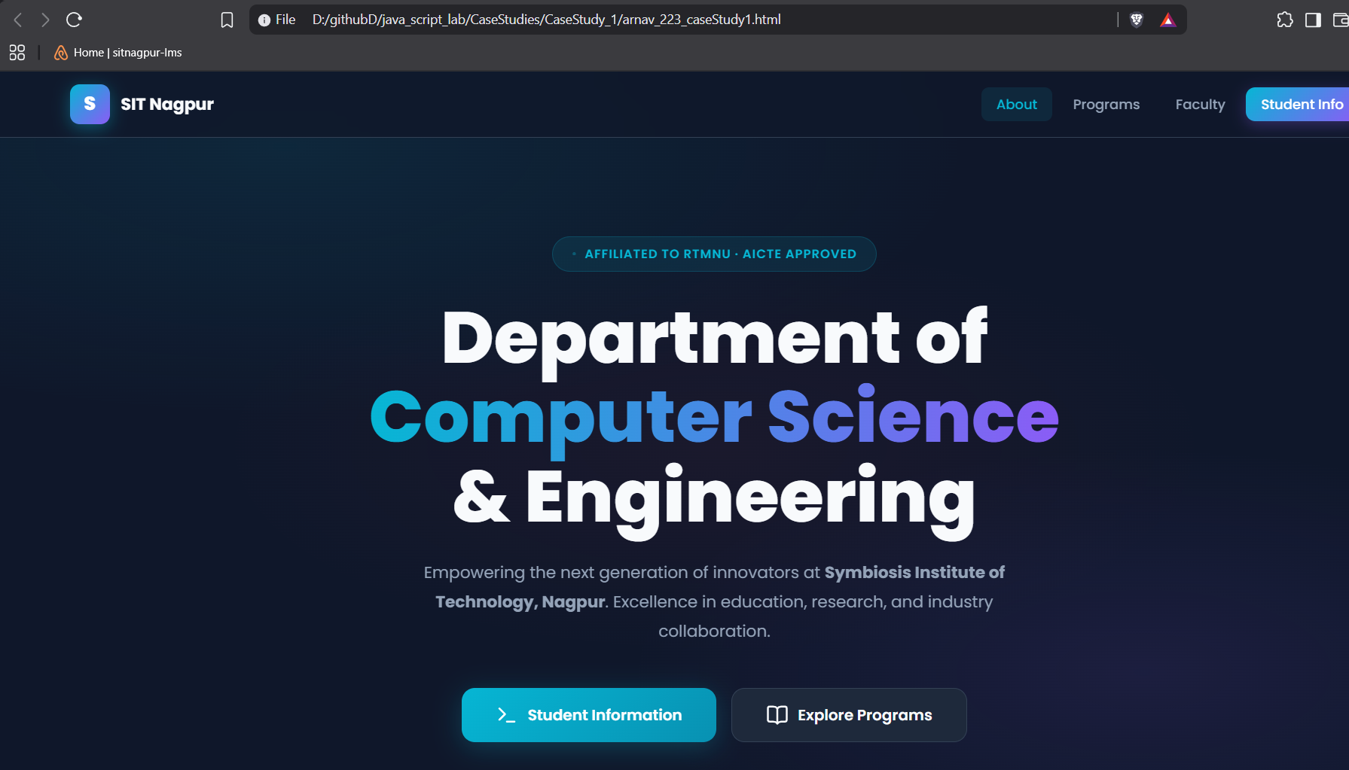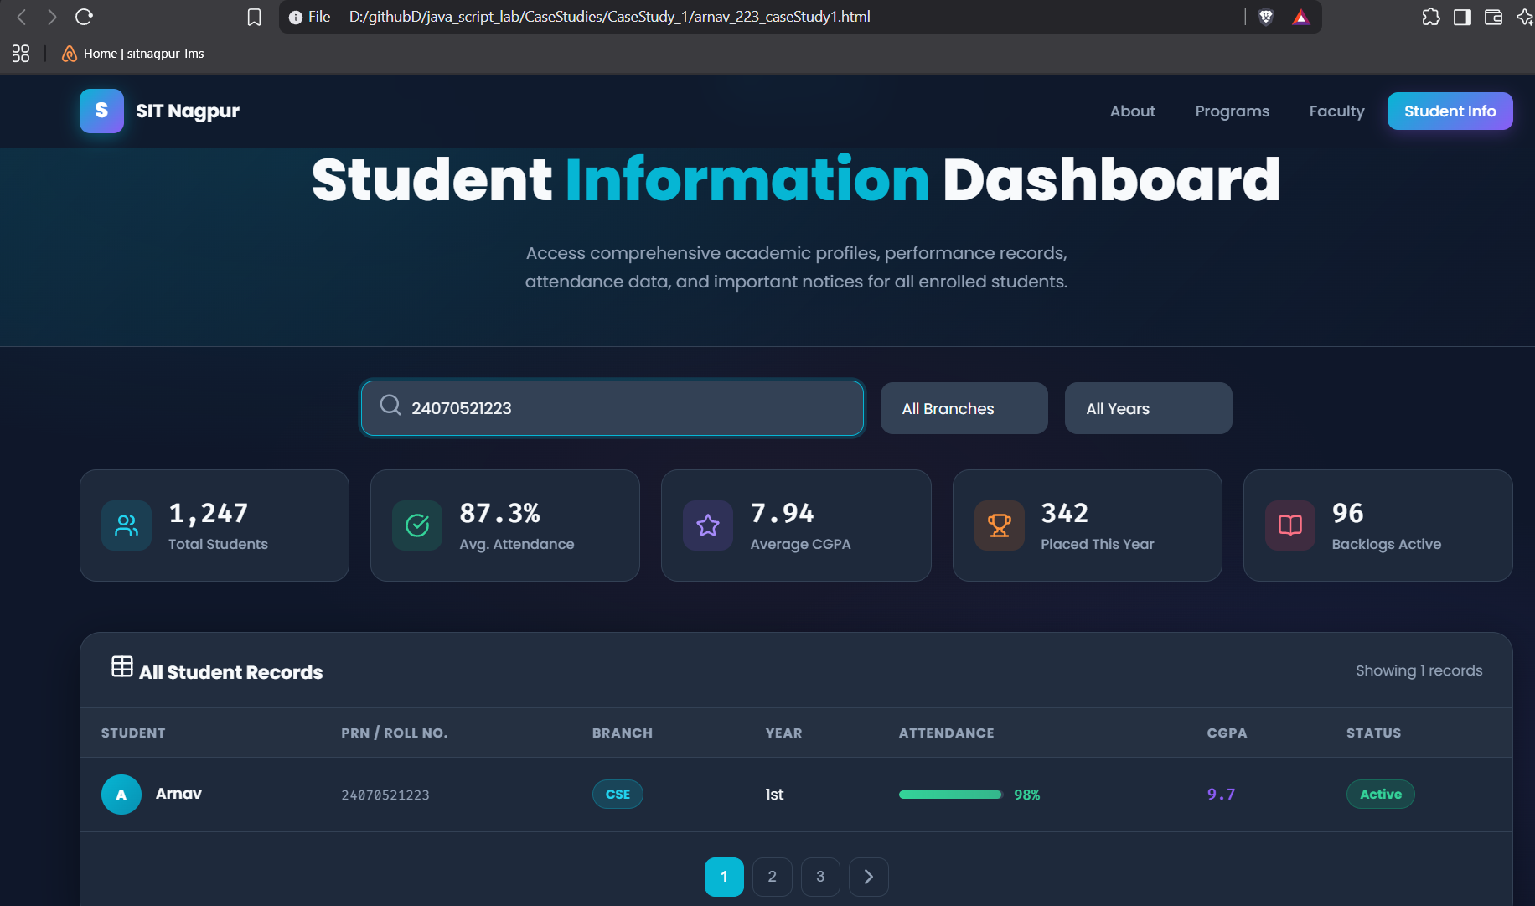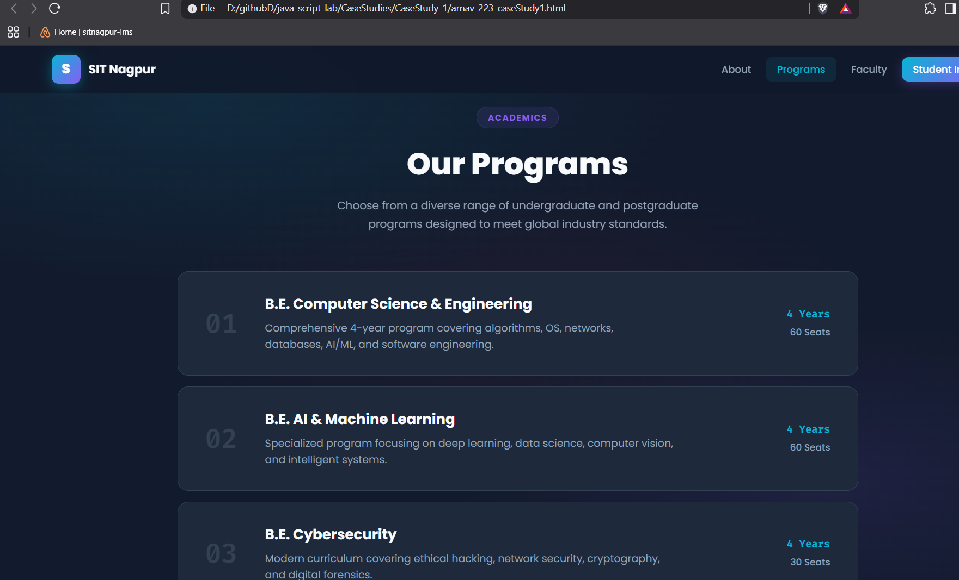

4. Result / Conclusion
The case study was successfully implemented by creating a college department webpage and linking it to a student information page. JavaScript was used to display the welcome message "Welcome to SIT Nagpur" in an alert box. The webpages were designed using HTML and CSS, while JavaScript provided the required interactivity. The objectives of the case study were successfully achieved.

Experiment 2
1. Experiment Title
Use var, let, const, and demonstrate basic features like template literals and destructuring; build a billing calculator with user input.

2. Software/Tools Required
- Visual Studio Code (VS Code)
- Google Chrome / Mozilla Firefox / Microsoft Edge
- HTML5
- CSS3
- JavaScript
- Windows Operating System

3. Experiment Program Code
The experiment consists of the following files:
- index.html
- styles.css
- script.js

<!DOCTYPE html>
<html lang="en">
<head>
<meta charset="utf-8">
<meta name="viewport" content="width=device-width, initial-scale=1.0">
<title>Exp 2: Smart Invoice Terminal</title>
<style>
@import url('https://fonts.googleapis.com/css2?family=Plus+Jakarta+Sans:wght@400;500;600;700&family=Space+Mono&display=swap');

body {
font-family: 'Plus Jakarta Sans', sans-serif;
background-color: #f1f5f9;
margin: 0;
padding: 40px 20px;
display: flex;
justify-content: center;
align-items: center;
min-height: 100vh;
color: #0f172a;
}

.checkout-container {
display: flex;
background: #ffffff;
border-radius: 20px;
box-shadow: 0 20px 40px rgba(0,0,0,0.06);
overflow: hidden;
width: 100%;
max-width: 900px;
border: 1px solid #e2e8f0;
}

/* Left Side: Form */
.form-section {
flex: 1.2;
padding: 40px;
}

.form-section h2 {
margin: 0 0 5px 0;
font-size: 1.6em;
color: #0f172a;
}

.form-section p {
color: #64748b;
font-size: 0.9em;
margin-bottom: 30px;
}

.input-row {
display: flex;
gap: 15px;
margin-bottom: 20px;
}

.input-field {
flex: 1;
}

label {
display: block;
font-size: 0.8em;
font-weight: 700;
text-transform: uppercase;
color: #475569;
margin-bottom: 6px;
letter-spacing: 0.5px;
}

input {
width: 100%;
padding: 12px 15px;
border: 1.5px solid #cbd5e1;
border-radius: 10px;
font-size: 0.95em;
font-family: inherit;
box-sizing: border-box;
transition: all 0.2s;
background: #f8fafc;
}

input:focus {
outline: none;
border-color: #4f46e5;
background: #ffffff;
box-shadow: 0 0 0 4px rgba(79, 70, 229, 0.1);
}

.btn-generate {
background: #4f46e5;
color: white;
border: none;
padding: 15px;
border-radius: 10px;
font-size: 1em;
font-weight: 600;
cursor: pointer;
width: 100%;
margin-top: 10px;
transition: all 0.2s;
box-shadow: 0 4px 12px rgba(79, 70, 229, 0.3);
}

.btn-generate:hover {
background: #4338ca;
transform: translateY(-2px);
}

/* Right Side: Live Receipt Preview */
.receipt-section {
flex: 1;
background: #0f172a;
color: #f8fafc;
padding: 40px;
display: flex;
flex-direction: column;
justify-content: space-between;
position: relative;
}

.receipt-header h3 {
margin: 0;
font-size: 1.2em;
font-family: 'Space Mono', monospace;
color: #818cf8;
letter-spacing: 1px;
}

.receipt-header p {
color: #64748b;
font-size: 0.8em;
margin: 5px 0 0 0;
font-family: 'Space Mono', monospace;
}

.invoice-body {
background: #1e293b;
border: 1px dashed #334155;
border-radius: 12px;
padding: 20px;
margin: 20px 0;
font-family: 'Space Mono', monospace;
font-size: 0.85em;
min-height: 180px;
display: flex;
flex-direction: column;
justify-content: center;
}

.placeholder-text {
text-align: center;
color: #475569;
font-style: italic;
}

.invoice-row {
display: flex;
justify-content: space-between;
margin-bottom: 12px;
color: #cbd5e1;
}

.invoice-divider {
border-top: 1px dashed #475569;
margin: 15px 0;
}

.invoice-total {
display: flex;
justify-content: space-between;
font-size: 1.2em;
font-weight: 700;
color: #38bdf8;
}
</style>
</head>
<body>

<div class="checkout-container">
<!-- Left Column: Input Form -->
<div class="form-section">
<h2>Invoice Terminal</h2>
<p>Enter order items to compute GST and generate a receipt.</p>

<div class="input-field" style="margin-bottom: 20px;">
<label>Customer Name</label>
<input type="text" id="cName" placeholder="e.g., Arnav Band">
</div>

<div class="input-field" style="margin-bottom: 20px;">
<label>Product Description</label>
<input type="text" id="pName" placeholder="e.g., Gaming Mouse">
</div>

<div class="input-row">
<div class="input-field">
<label>Quantity</label>
<input type="number" id="qty" placeholder="0" min="1">
</div>
<div class="input-field">
<label>Unit Price (₹)</label>
<input type="number" id="price" placeholder="0.00" min="1">
</div>
</div>

<button class="btn-generate" onclick="generateInvoice()">Compute & Issue Invoice</button>
</div>

<!-- Right Column: Live Receipt -->
<div class="receipt-section">
<div class="receipt-header">
<h3>// INVOICE_PREVIEW</h3>
<p>STATUS: AWAITING_CALCULATION</p>
</div>

<div class="invoice-body" id="invoiceDisplay">
<div class="placeholder-text">
Fill out the form and click generate to view the invoice summary.
</div>
</div>

<div style="font-size: 0.75em; color: #475569; font-family: 'Space Mono', monospace; text-align: center;">
SYSTEM: ES6 DESTRUCTURING ENGINE ACTIVE
</div>
</div>
</div>

<script>
function generateInvoice() {
const GST_RATE = 0.18;

let customerName = document.getElementById("cName").value;
let productName = document.getElementById("pName").value;
let quantity = Number(document.getElementById("qty").value);
let price = Number(document.getElementById("price").value);

if (!customerName || !productName || quantity <= 0 || price <= 0) {
alert("Please provide valid inputs for all fields.");
return;
}

let total = quantity * price;
let gstAmount = total * GST_RATE;
let finalBill = total + gstAmount;

// JS Object logic
const bill = {
customer: customerName,
product: productName,
quantity,
price,
total,
gstAmount,
finalBill
};

// ES6 Object Destructuring logic
const {
customer,
product,
quantity: qtyVal,
price: priceVal,
gstAmount: gst,
finalBill: amount
} = bill;

// DOM Manipulation
const invoiceHTML = `
<div class="invoice-row"><span>CLIENT:</span> <strong>${customer}</strong></div>
<div class="invoice-row"><span>ITEM:</span> <span>${product}</span></div>
<div class="invoice-row"><span>QTY & PRICE:</span> <span>${qtyVal} x ₹${priceVal.toFixed(2)}</span></div>
<div class="invoice-divider"></div>
<div class="invoice-row"><span>SUBTOTAL:</span> <span>₹${total.toFixed(2)}</span></div>
<div class="invoice-row"><span>GST (18%):</span> <span>₹${gst.toFixed(2)}</span></div>
<div class="invoice-divider"></div>
<div class="invoice-total"><span>TOTAL:</span> <span>₹${amount.toFixed(2)}</span></div>
`;

document.getElementById("invoiceDisplay").innerHTML = invoiceHTML;
}
</script>

</body>
</html>

Output: 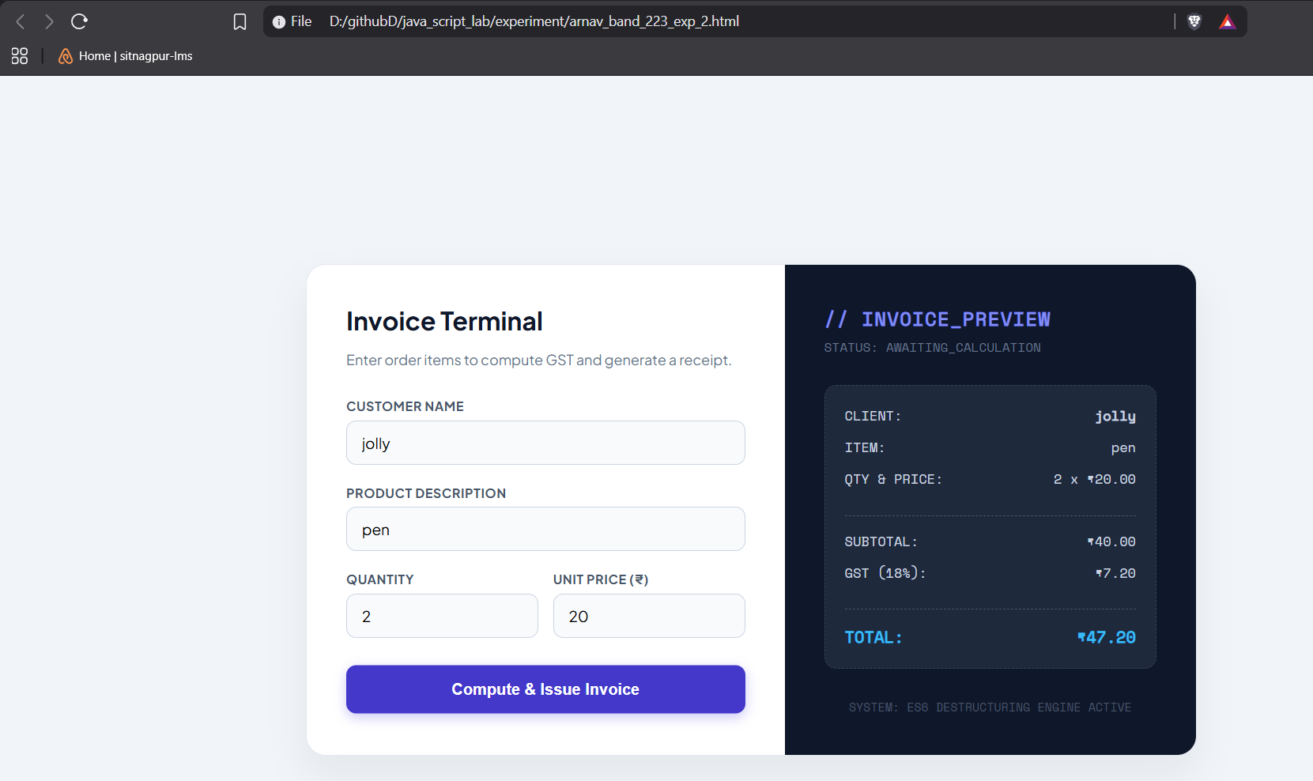

Case Study 2
1. Case Study Title
Develop the webpage for an online shopping website with using HTML CSS and HTML5 tags and calculate the bill.

2. Case Study Program Code
The case study consists of the following files:
• index.html – Displays the Premium Bill Calculator webpage containing a form to input customer and product details for generating an invoice.

• script.js – Processes the form data, performs calculations (like base amount, discount, GST, and final total) by demonstrating various data types and type coercions, and dynamically updates the invoice summary on the webpage.

• style.css – Contains the styling rules for the layout, typography, and visual elements of the bill calculator application.

Output:
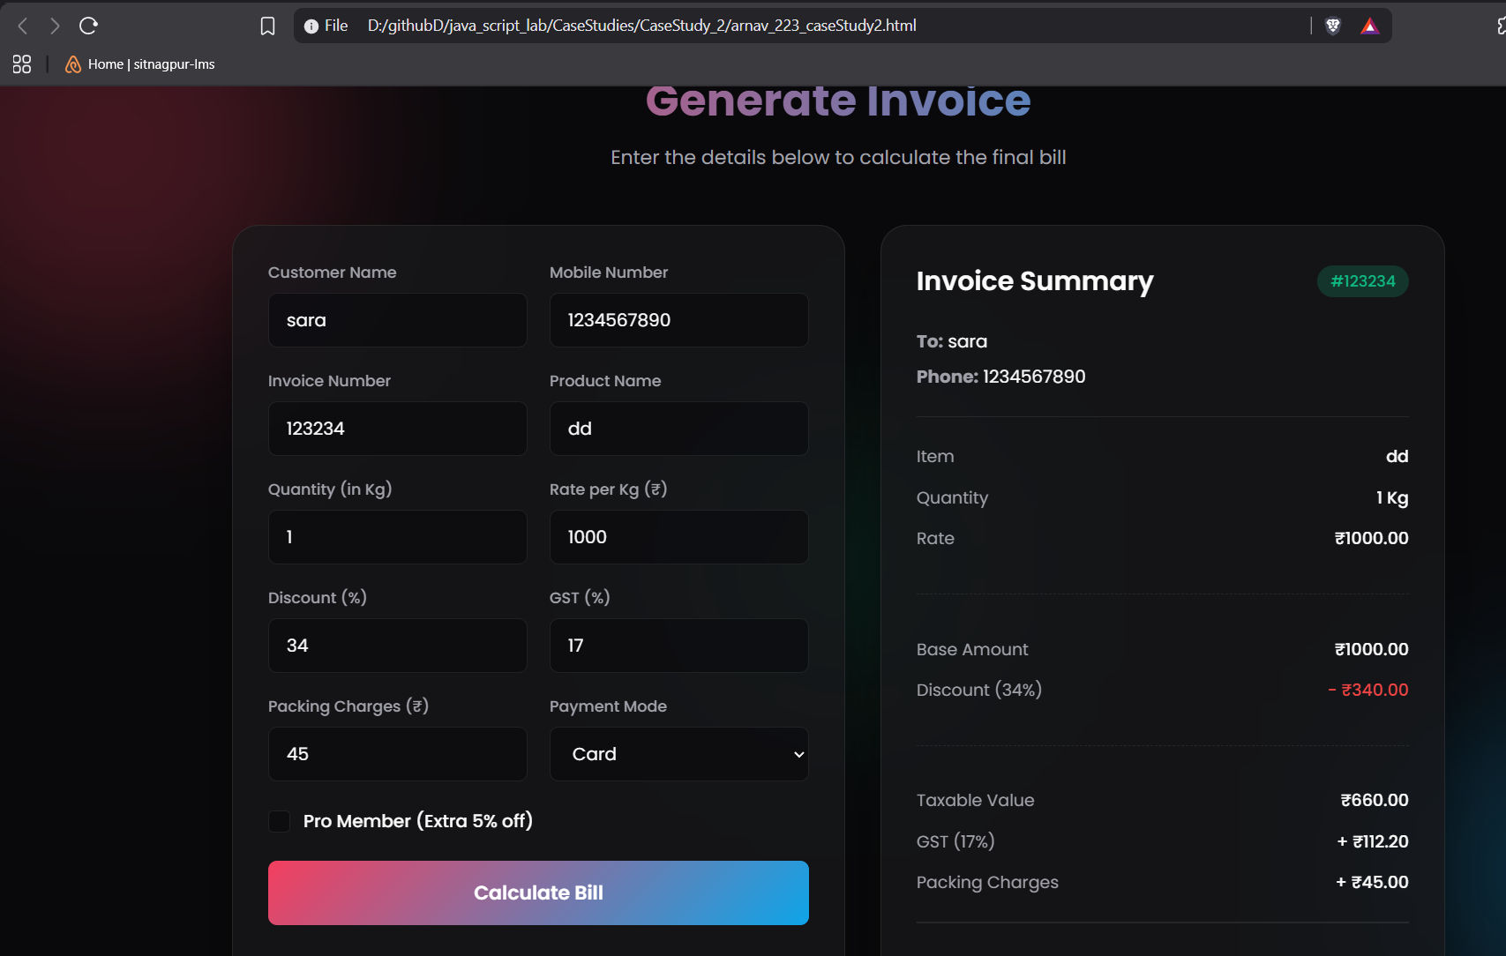

Result/Conclusion:
Hence, we have successfully developed the Premium Bill Calculator webpage. Through this case study, we practically learned how to declare variables using var, let, and const, utilize various primitive data types (such as strings, numbers, and booleans), and perform type coercion and explicit type conversions in JavaScript to compute the final bill amount and dynamically display the generated invoice.

Experiment 3
1. Experiment Title
Implement control structures and form validation; create a grading system based on user-entered marks.

2. Software/Tools Required
- Visual Studio Code (VS Code)
- Google Chrome / Mozilla Firefox / Microsoft Edge
- HTML5
- CSS3
- JavaScript
- Windows Operating System

3. Experiment Program Code
The experiment consists of the following files:
- jashchauhan_242.html
- styles.css
- script.js

<!DOCTYPE html>
<html lang="en">
<head>
<meta charset="UTF-8">
<meta name="viewport" content="width=device-width, initial-scale=1.0">
<title>Exp 3: Academic Analytics Portal</title>
<style>
@import url('https://fonts.googleapis.com/css2?family=Outfit:wght@400;500;600;700&display=swap');

body {
font-family: 'Outfit', sans-serif;
background-color: #f8fafc;
color: #1e293b;
margin: 0;
padding: 40px 20px;
}

.portal-container {
max-width: 1000px;
margin: 0 auto;
}

.portal-header {
display: flex;
justify-content: space-between;
align-items: center;
margin-bottom: 30px;
border-bottom: 2px solid #e2e8f0;
padding-bottom: 20px;
}

.portal-header h1 {
margin: 0;
font-size: 1.8em;
color: #0f172a;
}

.portal-header span {
background: #e0f2fe;
color: #0369a1;
padding: 6px 14px;
border-radius: 20px;
font-size: 0.85em;
font-weight: 600;
}

/* Top KPI Metric Cards */
.metrics-grid {
display: grid;
grid-template-columns: repeat(4, 1fr);
gap: 15px;
margin-bottom: 30px;
}

.metric-card {
background: #ffffff;
border: 1px solid #e2e8f0;
border-radius: 14px;
padding: 20px;
box-shadow: 0 4px 6px -1px rgba(0,0,0,0.02);
text-align: center;
}

.metric-label {
font-size: 0.8em;
color: #64748b;
text-transform: uppercase;
letter-spacing: 0.5px;
margin-bottom: 8px;
font-weight: 600;
}

.metric-value {
font-size: 1.8em;
font-weight: 700;
color: #0f172a;
}

/* Form Area */
.panel {
background: #ffffff;
border: 1px solid #e2e8f0;
border-radius: 16px;
padding: 30px;
margin-bottom: 30px;
box-shadow: 0 10px 15px -3px rgba(0,0,0,0.03);
}

.panel h3 {
margin: 0 0 20px 0;
font-size: 1.1em;
color: #334155;
}

.input-grid {
display: grid;
grid-template-columns: repeat(auto-fit, minmax(160px, 1fr));
gap: 15px;
margin-bottom: 25px;
}

.field label {
display: block;
font-size: 0.8em;
font-weight: 600;
color: #475569;
margin-bottom: 6px;
}

.field input {
width: 100%;
padding: 10px 12px;
border: 1.5px solid #cbd5e1;
border-radius: 8px;
font-size: 0.95em;
font-family: inherit;
box-sizing: border-box;
outline: none;
}

.field input:focus {
border-color: #0284c7;
box-shadow: 0 0 0 3px rgba(2, 132, 199, 0.1);
}

.btn-action {
background: #0284c7;
color: white;
border: none;
padding: 12px 25px;
border-radius: 8px;
font-weight: 600;
cursor: pointer;
transition: background 0.2s;
}

.btn-action:hover {
background: #0369a1;
}

/* Analytics Table */
table {
width: 100%;
border-collapse: collapse;
margin-top: 10px;
}

th {
text-align: left;
padding: 12px;
font-size: 0.8em;
text-transform: uppercase;
color: #64748b;
border-bottom: 2px solid #e2e8f0;
}

td {
padding: 14px 12px;
border-bottom: 1px solid #f1f5f9;
font-size: 0.95em;
}

.status-pill {
padding: 4px 10px;
border-radius: 12px;
font-size: 0.8em;
font-weight: 600;
}

.pill-pass {
background: #dcfce7;
color: #166534;
}

.pill-fail {
background: #fee2e2;
color: #991b1b;
}

#analyticsPanel {
display: none;
}
</style>
</head>
<body>

<div class="portal-container">
<div class="portal-header">
<h1>Academic Analytics Portal</h1>
<span>EXP_03 :: CONTROL STRUCTURES</span>
</div>

<!-- Metric KPI Cards -->
<div class="metrics-grid">
<div class="metric-card">
<div class="metric-label">Total Score</div>
<div class="metric-value" id="kpiTotal">--/500</div>
</div>
<div class="metric-card">
<div class="metric-label">Percentage</div>
<div class="metric-value" id="kpiPerc">0.0%</div>
</div>
<div class="metric-card">
<div class="metric-label">Grade Assigned</div>
<div class="metric-value" id="kpiGrade" style="color: #0284c7;">--</div>
</div>
<div class="metric-card">
<div class="metric-label">Final Status</div>
<div class="metric-value" id="kpiStatus">--</div>
</div>
</div>

<!-- Input Form -->
<div class="panel">
<h3>Enter Student Evaluation Data</h3>

<div class="input-grid" style="grid-template-columns: 2fr 1fr; margin-bottom: 15px;">
<div class="field">
<label>Student Name</label>
<input type="text" id="sName" placeholder="e.g. Arnav band">
</div>
<div class="field">
<label>Roll Number</label>
<input type="text" id="rNo" placeholder="e.g. 223">
</div>
</div>

<div class="input-grid">
<div class="field">
<label>Maths</label>
<input type="number" class="sub-mark" min="0" max="100">
</div>
<div class="field">
<label>JavaScript</label>
<input type="number" class="sub-mark" min="0" max="100">
</div>
<div class="field">
<label>Python</label>
<input type="number" class="sub-mark" min="0" max="100">
</div>
<div class="field">
<label>Physics</label>
<input type="number" class="sub-mark" min="0" max="100">
</div>
<div class="field">
<label>C Language</label>
<input type="number" class="sub-mark" min="0" max="100">
</div>
</div>

<button class="btn-action" onclick="runAnalytics()">Compute Evaluation</button>
</div>

<!-- Analytical Breakdown Table -->
<div class="panel" id="analyticsPanel">
<h3>Subject Performance Breakdown</h3>
<table>
<thead>
<tr>
<th>Subject Name</th>
<th>Marks Obtained</th>
<th>Max Marks</th>
<th>Evaluation Status</th>
</tr>
</thead>
<tbody id="breakdownBody">
<!-- Dynamic Rows -->
</tbody>
</table>
</div>
</div>

<script>
function runAnalytics() {
const name = document.getElementById('sName').value;
const roll = document.getElementById('rNo').value;
const inputs = document.querySelectorAll('.sub-mark');
const subjects = ['Maths', 'JavaScript', 'Python', 'Physics', 'C Language'];

// Concept: if-else (Form Validation)
if (!name.trim() || !roll.trim()) {
alert("Please input both Student Name and Roll Number.");
return;
}

let total = 0;
let hasFailed = false;
let marks = [];

// Concept: for loop (Scoping & Validation)
for (let i = 0; i < inputs.length; i++) {
let val = Number(inputs[i].value);
if (inputs[i].value === "" || val < 0 || val > 100) {
alert(`Invalid mark entry for ${subjects[i]}. Must be between 0 and 100.`);
return;
}
marks.push(val);
total += val;
if (val < 35) hasFailed = true;
}

let percentage = (total / 500) * 100;
let grade = "";

// Concept: switch statement (Grading Logic)
switch (true) {
case (percentage >= 90): grade = "O (Outst.)"; break;
case (percentage >= 80): grade = "A+"; break;
case (percentage >= 70): grade = "A"; break;
case (percentage >= 60): grade = "B+"; break;
case (percentage >= 50): grade = "B"; break;
case (percentage >= 35): grade = "C"; break;
default: grade = "F"; break;
}

if (hasFailed) grade = "F (Backlog)";
let finalStatus = hasFailed ? "FAIL" : "PASS";

// Concept: while loop (Counting Distinctions)
let distinctions = 0;
let idx = 0;
while (idx < marks.length) {
if (marks[idx] >= 75) distinctions++;
idx++;
}
console.log(`[SYSTEM LOG]: Student achieved distinction in ${distinctions} subject(s).`);

// DOM Update: KPI Cards
document.getElementById('kpiTotal').innerText = `${total}/500`;
document.getElementById('kpiPerc').innerText = `${percentage.toFixed(1)}%`;
document.getElementById('kpiGrade').innerText = grade;

const statusCard = document.getElementById('kpiStatus');
statusCard.innerText = finalStatus;
statusCard.style.color = hasFailed ? "#ef4444" : "#16a34a";

// DOM Update: Table Rows
let tableHTML = "";
for (let i = 0; i < subjects.length; i++) {
let isPass = marks[i] >= 35;
tableHTML += `
<tr>
<td style="font-weight: 600;">${subjects[i]}</td>
<td>${marks[i]}</td>
<td>100</td>
<td><span class="status-pill ${isPass ? 'pill-pass' : 'pill-fail'}">${isPass ? 'PASS' : 'FAIL'}</span></td>
</tr>
`;
}
document.getElementById('breakdownBody').innerHTML = tableHTML;
document.getElementById('analyticsPanel').style.display = 'block';
}
</script>

</body>
</html>
Output:
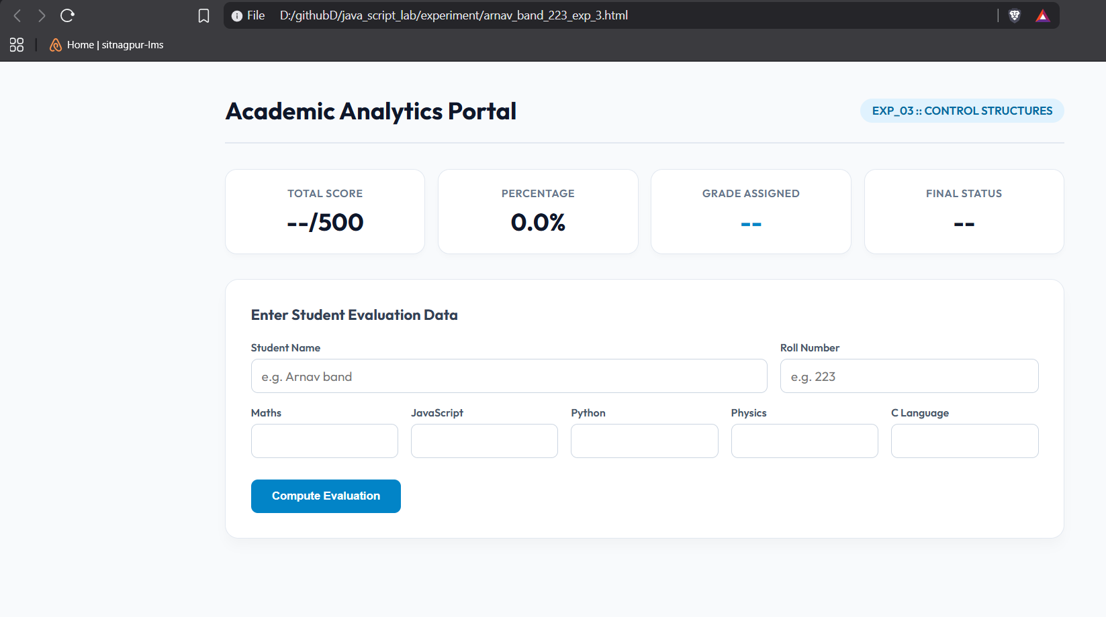

Case Study 3
1. Case Study Title
Write a Javascript program that accepts students marks and displays the scholarship category.

2. Case Study Program Code
The case study consists of the following files:

• jashchauhan_242.html – Displays the Scholarship Eligibility Checker webpage, containing an input form for students to enter their marks and a section outlining the various scholarship criteria.

• script.js – Processes the entered marks, validates the input, and utilizes if-else conditional statements to determine the corresponding scholarship category (Not Eligible, Bronze, Silver, Gold, Platinum). It dynamically updates the UI to show the correct result and corresponding custom SVG icon.

• style.css – Contains the styling rules for the layout, typography, animations, and overall visual presentation of the eligibility checker application.

<!DOCTYPE html>
<html lang="en">
<head>
<meta charset="UTF-8">
<meta name="viewport" content="width=device-width, initial-scale=1.0">
<meta name="description" content="Scholarship Eligibility Checker - Enter your marks to find your scholarship category">
<title>Scholarship Eligibility Checker</title>

<!-- Updated Font: Montserrat -->
<link rel="preconnect" href="https://fonts.googleapis.com">
<link rel="preconnect" href="https://fonts.gstatic.com" crossorigin>
<link href="https://fonts.googleapis.com/css2?family=Montserrat:wght@400;500;600;700;800&display=swap" rel="stylesheet">

<style>
/* ===== Reset & Base ===== */
*,
*::before,
*::after {
margin: 0;
padding: 0;
box-sizing: border-box;
}

:root {
/* Updated Color Palette */
--bg-primary: #0f172a; /* Deep Slate */
--bg-card: rgba(30, 41, 59, 0.5); /* Transparent Slate */
--bg-card-hover: rgba(30, 41, 59, 0.8);
--text-primary: #f8fafc;
--text-secondary: #94a3b8;
--border-color: rgba(148, 163, 184, 0.15);
--white: #ffffff;
--primary-accent: #3b82f6; /* Vibrant Blue */
--shadow-glow: 0 10px 40px rgba(0, 0, 0, 0.3);

/* Scholarship tier colors */
--not-eligible: #f43f5e;
--bronze: #d97706;
--silver: #94a3b8;
--gold: #fbbf24;
--platinum: #e2e8f0;
}

body {
font-family: 'Montserrat', system-ui, -apple-system, sans-serif;
background-color: var(--bg-primary);
color: var(--text-primary);
min-height: 100vh;
display: flex;
justify-content: center;
align-items: flex-start;
padding: 40px 20px;
overflow-x: hidden;
position: relative;
}

/* ===== Colorful Background Glow ===== */
.background-orbs {
position: fixed;
inset: 0;
overflow: hidden;
pointer-events: none;
z-index: 0;
}

.orb {
position: absolute;
border-radius: 50%;
filter: blur(100px);
opacity: 0.15;
animation: float 24s ease-in-out infinite;
}

.orb-1 {
width: 500px;
height: 500px;
top: -10%;
right: -10%;
background: linear-gradient(135deg, #3b82f6, #8b5cf6); /* Blue to Purple */
}

.orb-2 {
width: 400px;
height: 400px;
bottom: -5%;
left: -5%;
background: linear-gradient(135deg, #ec4899, #f43f5e); /* Pink to Rose */
animation-delay: -8s;
}

.orb-3 {
width: 300px;
height: 300px;
top: 40%;
left: 50%;
background: linear-gradient(135deg, #10b981, #3b82f6); /* Emerald to Blue */
animation-delay: -16s;
}

@keyframes float {
0%, 100% { transform: translate(0, 0) scale(1); }
25% { transform: translate(40px, -30px) scale(1.05); }
50% { transform: translate(-20px, 20px) scale(0.95); }
75% { transform: translate(30px, 40px) scale(1.03); }
}

/* ===== Container ===== */
.container {
position: relative;
z-index: 1;
width: 100%;
max-width: 600px;
}

/* ===== Header ===== */
.header {
text-align: center;
margin-bottom: 32px;
}

.logo {
display: flex;
align-items: center;
justify-content: center;
gap: 14px;
margin-bottom: 10px;
}

.logo-icon {
display: flex;
align-items: center;
animation: bounce 2.5s ease-in-out infinite;
}

.logo-icon svg {
width: 42px;
height: 42px;
}

@keyframes bounce {
0%, 100% { transform: translateY(0); }
50% { transform: translateY(-5px); }
}

.header h1 {
font-size: 2rem;
font-weight: 800;
color: var(--white);
letter-spacing: -0.03em;
}

.subtitle {
color: var(--text-secondary);
font-size: 0.95rem;
font-weight: 500;
}

/* ===== Main Card ===== */
.main-card {
background: var(--bg-card);
border: 1px solid var(--border-color);
border-radius: 20px;
padding: 36px 32px;
backdrop-filter: blur(20px);
-webkit-backdrop-filter: blur(20px);
box-shadow: var(--shadow-glow);
margin-bottom: 28px;
}

/* ===== Input Section ===== */
.input-section {
display: flex;
flex-direction: column;
gap: 16px;
}

.input-label {
font-size: 0.8rem;
font-weight: 700;
text-transform: uppercase;
letter-spacing: 0.1em;
color: var(--text-secondary);
}

.input-wrapper {
position: relative;
display: flex;
align-items: center;
}

.input-wrapper input {
width: 100%;
padding: 16px 80px 16px 20px;
font-size: 1.6rem;
font-weight: 700;
font-family: 'Montserrat', sans-serif;
color: var(--text-primary);
background: rgba(15, 23, 42, 0.6);
border: 2px solid var(--border-color);
border-radius: 14px;
outline: none;
transition: border-color 0.3s ease, box-shadow 0.3s ease;
-moz-appearance: textfield;
}

.input-wrapper input::-webkit-outer-spin-button,
.input-wrapper input::-webkit-inner-spin-button {
-webkit-appearance: none;
margin: 0;
}

.input-wrapper input::placeholder {
color: rgba(255, 255, 255, 0.15);
font-weight: 600;
}

.input-wrapper input:focus {
border-color: var(--primary-accent);
box-shadow: 0 0 0 4px rgba(59, 130, 246, 0.2);
}

.input-suffix {
position: absolute;
right: 20px;
color: var(--text-secondary);
font-size: 1.1rem;
font-weight: 600;
pointer-events: none;
}

/* ===== Button ===== */
#checkBtn {
display: flex;
align-items: center;
justify-content: center;
gap: 10px;
width: 100%;
padding: 16px;
font-size: 1.05rem;
font-weight: 700;
font-family: 'Montserrat', sans-serif;
color: var(--white);
background: linear-gradient(135deg, #3b82f6, #2563eb);
border: none;
border-radius: 14px;
cursor: pointer;
transition: transform 0.2s ease, box-shadow 0.2s ease;
}

#checkBtn:hover {
transform: translateY(-2px);
box-shadow: 0 8px 25px rgba(59, 130, 246, 0.4);
}

#checkBtn:active {
transform: translateY(0);
}

/* ===== Result Section ===== */
.result-section {
margin-top: 28px;
display: none;
}

.result-section.visible {
display: block;
animation: slideUp 0.5s cubic-bezier(0.16, 1, 0.3, 1);
}

@keyframes slideUp {
from { opacity: 0; transform: translateY(20px); }
to { opacity: 1; transform: translateY(0); }
}

.result-card {
text-align: center;
padding: 32px 24px;
border-radius: 16px;
border: 1px solid var(--border-color);
background: rgba(15, 23, 42, 0.4);
position: relative;
overflow: hidden;
}

.result-card::before {
content: '';
position: absolute;
top: 0;
left: 0;
right: 0;
height: 4px;
}

.result-card.not-eligible::before { background: var(--not-eligible); }
.result-card.bronze::before { background: var(--bronze); }
.result-card.silver::before { background: var(--silver); }
.result-card.gold::before { background: var(--gold); }
.result-card.platinum::before { background: var(--platinum); }

.result-icon {
margin-bottom: 16px;
display: flex;
justify-content: center;
animation: popIn 0.4s cubic-bezier(0.16, 1, 0.3, 1) 0.15s both;
}

.result-icon svg {
width: 64px;
height: 64px;
}

@keyframes popIn {
from { opacity: 0; transform: scale(0.5); }
to { opacity: 1; transform: scale(1); }
}

.result-title {
font-size: 1.5rem;
font-weight: 800;
margin-bottom: 6px;
letter-spacing: -0.01em;
}

.result-card.not-eligible .result-title { color: var(--not-eligible); }
.result-card.bronze .result-title { color: var(--bronze); }
.result-card.silver .result-title { color: var(--silver); }
.result-card.gold .result-title { color: var(--gold); }
.result-card.platinum .result-title { color: var(--platinum); }

.result-marks {
font-size: 1rem;
color: var(--text-secondary);
margin-bottom: 8px;
font-weight: 600;
}

.result-message {
font-size: 0.95rem;
color: var(--text-primary);
line-height: 1.5;
font-weight: 500;
}

/* ===== Criteria Section ===== */
.criteria-section {
margin-bottom: 40px;
}

.criteria-heading {
font-size: 0.85rem;
font-weight: 700;
text-transform: uppercase;
letter-spacing: 0.1em;
color: var(--text-secondary);
margin-bottom: 16px;
text-align: center;
}

.criteria-grid {
display: flex;
flex-direction: column;
gap: 8px;
}

.criteria-item {
display: flex;
align-items: center;
gap: 14px;
padding: 14px 20px;
background: var(--bg-card);
border: 1px solid var(--border-color);
border-radius: 12px;
backdrop-filter: blur(10px);
transition: transform 0.2s ease, background 0.2s ease;
position: relative;
overflow: hidden;
}

.criteria-item:hover {
transform: translateX(4px);
background: var(--bg-card-hover);
}

.criteria-bar {
position: absolute;
left: 0;
top: 0;
bottom: 0;
width: 4px;
}

.criteria-item.not-eligible .criteria-bar { background: var(--not-eligible); }
.criteria-item.bronze .criteria-bar { background: var(--bronze); }
.criteria-item.silver .criteria-bar { background: var(--silver); }
.criteria-item.gold .criteria-bar { background: var(--gold); }
.criteria-item.platinum .criteria-bar { background: var(--platinum); }

.criteria-icon {
display: flex;
align-items: center;
flex-shrink: 0;
}

.criteria-icon svg {
width: 24px;
height: 24px;
}

.criteria-range {
font-size: 0.95rem;
font-weight: 700;
color: var(--text-primary);
min-width: 80px;
}

.criteria-label {
font-size: 0.9rem;
font-weight: 600;
}

.criteria-item.not-eligible .criteria-label { color: var(--not-eligible); }
.criteria-item.bronze .criteria-label { color: var(--bronze); }
.criteria-item.silver .criteria-label { color: var(--silver); }
.criteria-item.gold .criteria-label { color: var(--gold); }
.criteria-item.platinum .criteria-label { color: var(--platinum); }

/* ===== Shake Animation ===== */
@keyframes shake {
0%, 100% { transform: translateX(0); }
20% { transform: translateX(-8px); }
40% { transform: translateX(8px); }
60% { transform: translateX(-4px); }
80% { transform: translateX(4px); }
}

.shake {
animation: shake 0.4s ease;
}

/* ===== Responsive ===== */
@media (max-width: 480px) {
body { padding: 24px 16px; }
.header h1 { font-size: 1.5rem; }
.main-card { padding: 28px 20px; border-radius: 16px; }
.input-wrapper input { font-size: 1.3rem; padding: 14px 70px 14px 16px; }
.result-icon svg { width: 48px; height: 48px; }
.result-title { font-size: 1.3rem; }
}
</style>
</head>
<body>
<div class="background-orbs">
<div class="orb orb-1"></div>
<div class="orb orb-2"></div>
<div class="orb orb-3"></div>
</div>

<div class="container">
<header class="header">
<div class="logo">
<span class="logo-icon">
<!-- Graduation Cap -->
<svg viewBox="0 0 48 48" fill="none" xmlns="http://www.w3.org/2000/svg">
<path d="M24 6L2 18L24 30L46 18L24 6Z" fill="#e8e8ed" stroke="#ffffff" stroke-width="1"/>
<path d="M12 24V36L24 42L36 36V24L24 30L12 24Z" fill="#b0b0be" stroke="#d0d0d8" stroke-width="0.5"/>
<line x1="40" y1="18" x2="40" y2="38" stroke="#d0d0d8" stroke-width="1.5" stroke-linecap="round"/>
<path d="M37 38C37 36.3 38.3 35 40 35C41.7 35 43 36.3 43 38C43 39.7 41.7 42 40 42C38.3 42 37 39.7 37 38Z" fill="#d0d0d8"/>
</svg>
</span>
<h1>Scholarship Eligibility</h1>
</div>
<p class="subtitle">Enter your marks to discover your scholarship category</p>
</header>

<main class="main-card" id="mainCard">
<div class="input-section">
<label for="marksInput" class="input-label">Enter Your Marks</label>
<div class="input-wrapper">
<input
type="number"
id="marksInput"
min="0"
max="100"
placeholder="0 – 100"
autocomplete="off"
>
<span class="input-suffix">/ 100</span>
</div>
<button id="checkBtn" onclick="checkScholarship()">
<span>Check Eligibility</span>
<svg width="20" height="20" viewBox="0 0 24 24" fill="none" stroke="currentColor" stroke-width="2.5" stroke-linecap="round" stroke-linejoin="round">
<path d="M5 12h14M12 5l7 7-7 7"/>
</svg>
</button>
</div>

<div class="result-section" id="resultSection">
<div class="result-card" id="resultCard">
<div class="result-icon" id="resultIcon"></div>
<h2 class="result-title" id="resultTitle"></h2>
<p class="result-marks" id="resultMarks"></p>
<p class="result-message" id="resultMessage"></p>
</div>
</div>
</main>

<section class="criteria-section">
<h2 class="criteria-heading">Scholarship Criteria</h2>
<div class="criteria-grid">
<div class="criteria-item not-eligible">
<div class="criteria-bar"></div>
<div class="criteria-icon">
<!-- Shield with X -->
<svg viewBox="0 0 24 24" fill="none" xmlns="http://www.w3.org/2000/svg">
<path d="M12 2L4 6V12C4 16.42 7.4 20.56 12 22C16.6 20.56 20 16.42 20 12V6L12 2Z" fill="#2a1215" stroke="#ef4444" stroke-width="1.5"/>
<path d="M9.5 9.5L14.5 14.5M14.5 9.5L9.5 14.5" stroke="#ef4444" stroke-width="2" stroke-linecap="round"/>
</svg>
</div>
<div class="criteria-range">Below 50</div>
<div class="criteria-label">Not Eligible</div>
</div>
<div class="criteria-item bronze">
<div class="criteria-bar"></div>
<div class="criteria-icon">
<!-- Bronze Medal -->
<svg viewBox="0 0 24 24" fill="none" xmlns="http://www.w3.org/2000/svg">
<path d="M8 2H16L14.5 7H9.5L8 2Z" fill="#a0522d"/>
<path d="M10 2L8 7" stroke="#8b4513" stroke-width="0.5"/>
<path d="M14 2L16 7" stroke="#8b4513" stroke-width="0.5"/>
<circle cx="12" cy="14.5" r="7" fill="#cd7f32" stroke="#a0622a" stroke-width="0.8"/>
<circle cx="12" cy="14.5" r="5.2" fill="none" stroke="#daa06d" stroke-width="0.6"/>
<path d="M10 13L11.5 15L14.5 11.5" stroke="#fff" stroke-width="1.5" stroke-linecap="round" stroke-linejoin="round"/>
</svg>
</div>
<div class="criteria-range">50 – 69</div>
<div class="criteria-label">Bronze</div>
</div>
<div class="criteria-item silver">
<div class="criteria-bar"></div>
<div class="criteria-icon">
<!-- Silver Medal -->
<svg viewBox="0 0 24 24" fill="none" xmlns="http://www.w3.org/2000/svg">
<path d="M8 2H16L14.5 7H9.5L8 2Z" fill="#8a8a98"/>
<path d="M10 2L8 7" stroke="#707080" stroke-width="0.5"/>
<path d="M14 2L16 7" stroke="#707080" stroke-width="0.5"/>
<circle cx="12" cy="14.5" r="7" fill="#c0c0c0" stroke="#a8a8b0" stroke-width="0.8"/>
<circle cx="12" cy="14.5" r="5.2" fill="none" stroke="#d8d8e0" stroke-width="0.6"/>
<path d="M10 13L11.5 15L14.5 11.5" stroke="#fff" stroke-width="1.5" stroke-linecap="round" stroke-linejoin="round"/>
</svg>
</div>
<div class="criteria-range">70 – 84</div>
<div class="criteria-label">Silver</div>
</div>
<div class="criteria-item gold">
<div class="criteria-bar"></div>
<div class="criteria-icon">
<!-- Gold Medal -->
<svg viewBox="0 0 24 24" fill="none" xmlns="http://www.w3.org/2000/svg">
<path d="M8 2H16L14.5 7H9.5L8 2Z" fill="#daa520"/>
<path d="M10 2L8 7" stroke="#b8860b" stroke-width="0.5"/>
<path d="M14 2L16 7" stroke="#b8860b" stroke-width="0.5"/>
<circle cx="12" cy="14.5" r="7" fill="#ffd700" stroke="#daa520" stroke-width="0.8"/>
<circle cx="12" cy="14.5" r="5.2" fill="none" stroke="#ffe44d" stroke-width="0.6"/>
<path d="M10 13L11.5 15L14.5 11.5" stroke="#fff" stroke-width="1.5" stroke-linecap="round" stroke-linejoin="round"/>
</svg>
</div>
<div class="criteria-range">85 – 94</div>
<div class="criteria-label">Gold</div>
</div>
<div class="criteria-item platinum">
<div class="criteria-bar"></div>
<div class="criteria-icon">
<!-- Diamond/Trophy -->
<svg viewBox="0 0 24 24" fill="none" xmlns="http://www.w3.org/2000/svg">
<path d="M5 4H19L21 8L12 20L3 8L5 4Z" fill="#e5e4e2" stroke="#c8c8c6" stroke-width="0.8"/>
<path d="M3 8H21" stroke="#d0d0ce" stroke-width="0.6"/>
<path d="M12 20L8.5 8L10 4" stroke="#c8c8c6" stroke-width="0.5"/>
<path d="M12 20L15.5 8L14 4" stroke="#c8c8c6" stroke-width="0.5"/>
<path d="M8.5 8L10 4H14L15.5 8" fill="#f0efed" stroke="none"/>
</svg>
</div>
<div class="criteria-range">95 – 100</div>
<div class="criteria-label">Platinum</div>
</div>
</div>
</section>
</div>

<script>
// Scholarship Eligibility Checker
// Detailed custom SVG icons for each scholarship tier
const ICONS = {
'not-eligible': `
<svg viewBox="0 0 64 64" fill="none" xmlns="http://www.w3.org/2000/svg">
<!-- Shield body -->
<path d="M32 4L8 16V32C8 44.84 18.8 56.12 32 60C45.2 56.12 56 44.84 56 32V16L32 4Z" fill="#2a1215" stroke="#ef4444" stroke-width="2.5"/>
<!-- Inner shield highlight -->
<path d="M32 10L14 19V32C14 42.2 22.4 51.2 32 54.4C41.6 51.2 50 42.2 50 32V19L32 10Z" fill="#1f0a0d" stroke="#ef4444" stroke-width="0.5" opacity="0.4"/>
<!-- X mark -->
<path d="M23 23L41 41" stroke="#ef4444" stroke-width="4.5" stroke-linecap="round"/>
<path d="M41 23L23 41" stroke="#ef4444" stroke-width="4.5" stroke-linecap="round"/>
<!-- Corner accents -->
<circle cx="32" cy="14" r="1.5" fill="#ef4444" opacity="0.5"/>
</svg>`,

'bronze': `
<svg viewBox="0 0 64 64" fill="none" xmlns="http://www.w3.org/2000/svg">
<!-- Ribbon -->
<path d="M22 4H42L38 18H26L22 4Z" fill="#a0522d"/>
<path d="M26 4L22 18" stroke="#8b4513" stroke-width="0.8"/>
<path d="M32 4V18" stroke="#8b4513" stroke-width="0.5" opacity="0.4"/>
<path d="M38 4L42 18" stroke="#8b4513" stroke-width="0.8"/>
<!-- Medal body -->
<circle cx="32" cy="38" r="20" fill="#cd7f32" stroke="#a0622a" stroke-width="2"/>
<!-- Inner ring -->
<circle cx="32" cy="38" r="15" fill="none" stroke="#daa06d" stroke-width="1.2"/>
<!-- Star in center -->
<polygon points="32,25 35,33 43,33 37,38 39,46 32,42 25,46 27,38 21,33 29,33" fill="#e8a848" stroke="#b8762a" stroke-width="0.5"/>
<!-- Shine -->
<path d="M22 28C24 24 28 22 32 22" stroke="#e8c088" stroke-width="1" stroke-linecap="round" opacity="0.6"/>
</svg>`,

'silver': `
<svg viewBox="0 0 64 64" fill="none" xmlns="http://www.w3.org/2000/svg">
<!-- Ribbon -->
<path d="M22 4H42L38 18H26L22 4Z" fill="#8a8a98"/>
<path d="M26 4L22 18" stroke="#707080" stroke-width="0.8"/>
<path d="M32 4V18" stroke="#707080" stroke-width="0.5" opacity="0.4"/>
<path d="M38 4L42 18" stroke="#707080" stroke-width="0.8"/>
<!-- Medal body -->
<circle cx="32" cy="38" r="20" fill="#c0c0c0" stroke="#a8a8b0" stroke-width="2"/>
<!-- Inner ring -->
<circle cx="32" cy="38" r="15" fill="none" stroke="#d8d8e0" stroke-width="1.2"/>
<!-- Star in center -->
<polygon points="32,25 35,33 43,33 37,38 39,46 32,42 25,46 27,38 21,33 29,33" fill="#d8d8e0" stroke="#a0a0a8" stroke-width="0.5"/>
<!-- Shine -->
<path d="M22 28C24 24 28 22 32 22" stroke="#e8e8f0" stroke-width="1" stroke-linecap="round" opacity="0.7"/>
</svg>`,

'gold': `
<svg viewBox="0 0 64 64" fill="none" xmlns="http://www.w3.org/2000/svg">
<!-- Ribbon -->
<path d="M22 4H42L38 18H26L22 4Z" fill="#daa520"/>
<path d="M26 4L22 18" stroke="#b8860b" stroke-width="0.8"/>
<path d="M32 4V18" stroke="#b8860b" stroke-width="0.5" opacity="0.4"/>
<path d="M38 4L42 18" stroke="#b8860b" stroke-width="0.8"/>
<!-- Medal body -->
<circle cx="32" cy="38" r="20" fill="#ffd700" stroke="#daa520" stroke-width="2"/>
<!-- Inner ring -->
<circle cx="32" cy="38" r="15" fill="none" stroke="#ffe44d" stroke-width="1.2"/>
<!-- Star in center -->
<polygon points="32,25 35,33 43,33 37,38 39,46 32,42 25,46 27,38 21,33 29,33" fill="#ffe866" stroke="#d4a800" stroke-width="0.5"/>
<!-- Shine -->
<path d="M22 28C24 24 28 22 32 22" stroke="#fff4a0" stroke-width="1" stroke-linecap="round" opacity="0.8"/>
</svg>`,

'platinum': `
<svg viewBox="0 0 64 64" fill="none" xmlns="http://www.w3.org/2000/svg">
<!-- Diamond top facets -->
<path d="M12 20H52L32 56L12 20Z" fill="#e5e4e2" stroke="#c8c8c6" stroke-width="1.5"/>
<!-- Top edge -->
<path d="M8 20L16 8H48L56 20H8Z" fill="#f0efed" stroke="#d0d0ce" stroke-width="1"/>
<!-- Center facets -->
<path d="M8 20L32 56L24 20Z" fill="#d8d7d5"/>
<path d="M56 20L32 56L40 20Z" fill="#d8d7d5"/>
<!-- Top inner facets -->
<path d="M16 8L24 20H8Z" fill="#e0dfdd"/>
<path d="M48 8L40 20H56Z" fill="#e0dfdd"/>
<path d="M16 8H48L40 20H24Z" fill="#f5f4f2"/>
<!-- Center vertical line -->
<path d="M32 56L32 20" stroke="#c8c8c6" stroke-width="0.6"/>
<path d="M32 20L16 8" stroke="#c8c8c6" stroke-width="0.5"/>
<path d="M32 20L48 8" stroke="#c8c8c6" stroke-width="0.5"/>
<!-- Sparkle highlights -->
<circle cx="28" cy="16" r="1" fill="#fff" opacity="0.8"/>
<circle cx="38" cy="14" r="0.7" fill="#fff" opacity="0.6"/>
<path d="M20 26L22 24" stroke="#fff" stroke-width="0.8" stroke-linecap="round" opacity="0.5"/>
</svg>`
};

function checkScholarship() {
const input = document.getElementById('marksInput');
const resultSection = document.getElementById('resultSection');
const resultCard = document.getElementById('resultCard');
const resultIcon = document.getElementById('resultIcon');
const resultTitle = document.getElementById('resultTitle');
const resultMarks = document.getElementById('resultMarks');
const resultMessage = document.getElementById('resultMessage');

const marks = parseFloat(input.value);

// Validate input
if (isNaN(marks) || marks < 0 || marks > 100) {
input.classList.add('shake');
setTimeout(() => input.classList.remove('shake'), 400);
resultSection.classList.remove('visible');
alert('Please enter valid marks between 0 and 100.');
return;
}

let category, message, cssClass;

if (marks < 50) {
category = 'Not Eligible';
message = 'Score below 50. Keep working hard — you can improve!';
cssClass = 'not-eligible';
} else if (marks >= 50 && marks <= 69) {
category = 'Bronze Scholarship';
message = 'Great start! You\'ve earned a Bronze Scholarship.';
cssClass = 'bronze';
} else if (marks >= 70 && marks <= 84) {
category = 'Silver Scholarship';
message = 'Impressive performance! You\'ve earned a Silver Scholarship.';
cssClass = 'silver';
} else if (marks >= 85 && marks <= 94) {
category = 'Gold Scholarship';
message = 'Outstanding! You\'ve earned a Gold Scholarship.';
cssClass = 'gold';
} else if (marks >= 95 && marks <= 100) {
category = 'Platinum Scholarship';
message = 'Exceptional! You\'ve earned the prestigious Platinum Scholarship!';
cssClass = 'platinum';
}

// Update the result card
resultCard.className = 'result-card ' + cssClass;
resultIcon.innerHTML = ICONS[cssClass];
resultTitle.textContent = category;
resultMarks.textContent = 'Your Marks: ' + marks + ' / 100';
resultMessage.textContent = message;

// Show result with animation
resultSection.classList.remove('visible');
// Force reflow to restart animation
void resultSection.offsetWidth;
resultSection.classList.add('visible');
}

// Allow pressing Enter to check
document.getElementById('marksInput').addEventListener('keydown', function (e) {
if (e.key === 'Enter') {
checkScholarship();
}
});
</script>
</body>
</html>

Output:
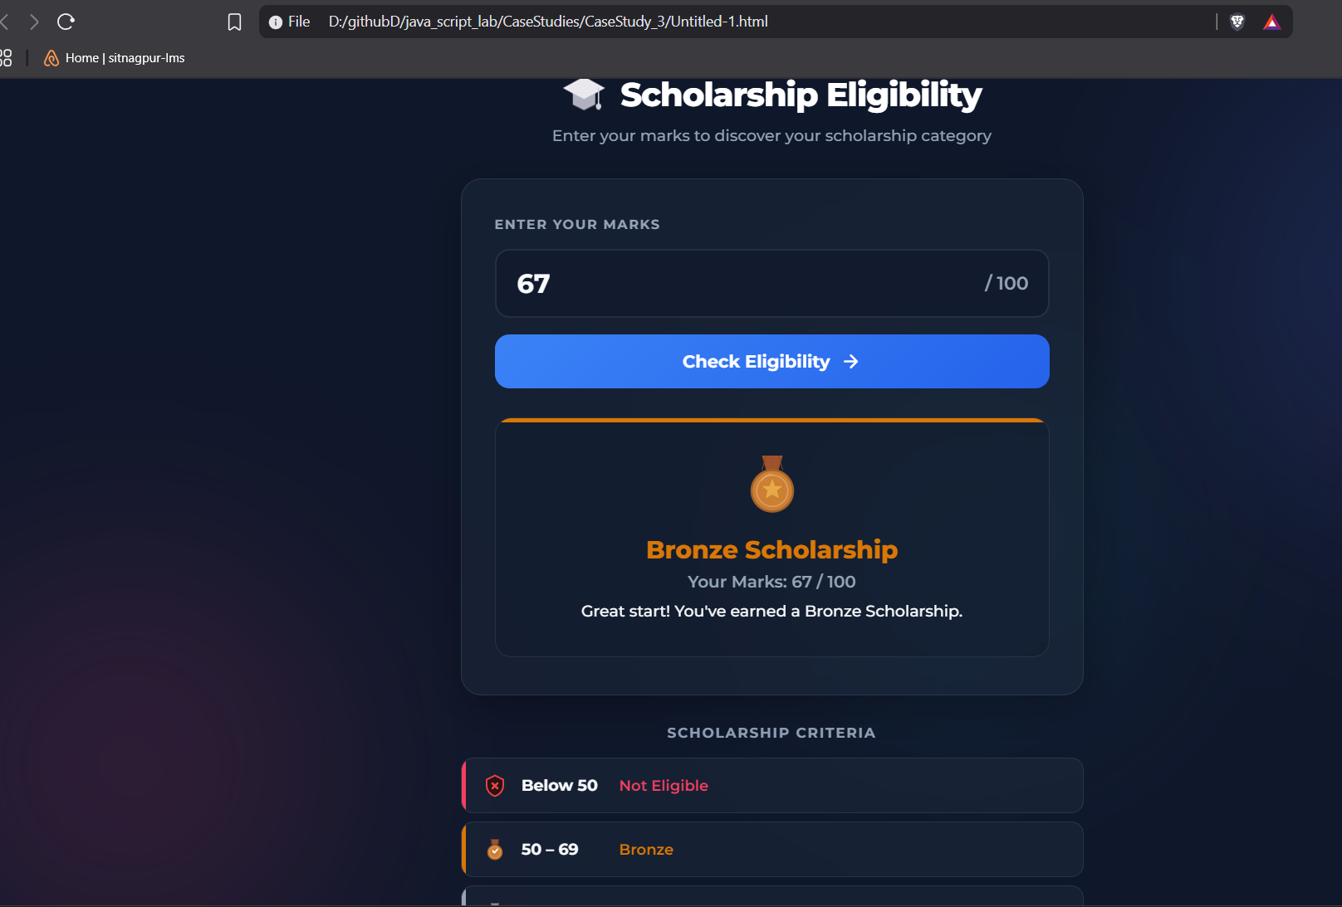

Result / Conclusion:
Hence, we have successfully developed the Scholarship Eligibility Checker webpage. Through this case study, we practically learned how to implement control structures, specifically if-else conditional statements in JavaScript, to evaluate user input, make logical decisions, and dynamically update the webpage's UI to display the appropriate scholarship category based on the provided marks.

Experiment 4
1. Experiment Title
Use function types, scope, and closures; apply try-catch; build a palindrome checker.

2. Software/Tools Required
- Visual Studio Code (VS Code)
- Google Chrome / Mozilla Firefox / Microsoft Edge
- HTML5
- CSS3
- JavaScript
- Windows Operating System

3. Experiment Program Code
The experiment consists of the following files:
- jash_chauhan_242.html
- styles.css
- script.js

<!DOCTYPE html>
<html lang="en">
<head>
<meta charset="UTF-8">
<meta name="viewport" content="width=device-width, initial-scale=1.0">
<title>Advanced Palindrome Checker</title>
<style>
:root {
--primary: #6366F1;
--primary-hover: #4F46E5;
--secondary: #EC4899;
--bg-gradient: linear-gradient(135deg, #e0e7ff 0%, #fce7f3 100%);
--card-bg: rgba(255, 255, 255, 0.85);
--text-main: #1F2937;
--text-muted: #6B7280;
}

body {
font-family: 'Inter', system-ui, -apple-system, sans-serif;
background: var(--bg-gradient);
min-height: 100vh;
display: flex;
justify-content: center;
align-items: center;
margin: 0;
padding: 20px;
box-sizing: border-box;
}

.card {
background: var(--card-bg);
backdrop-filter: blur(12px);
-webkit-backdrop-filter: blur(12px);
padding: 40px 30px;
border-radius: 20px;
border: 1px solid rgba(255, 255, 255, 0.5);
box-shadow: 0 20px 40px rgba(0,0,0,0.08);
width: 100%;
max-width: 450px;
text-align: center;
transition: transform 0.3s ease;
}

.card:hover {
transform: translateY(-2px);
}

h2 {
margin-top: 0;
margin-bottom: 8px;
background: linear-gradient(to right, var(--primary), var(--secondary));
-webkit-background-clip: text;
-webkit-text-fill-color: transparent;
font-size: 28px;
font-weight: 800;
}

.subtitle {
color: var(--text-muted);
font-size: 14px;
margin-bottom: 24px;
}

.input-group {
display: flex;
gap: 10px;
margin-bottom: 20px;
}

input[type="text"] {
flex: 1;
padding: 14px 16px;
font-size: 16px;
border: 2px solid #E5E7EB;
border-radius: 12px;
transition: all 0.3s ease;
outline: none;
background: rgba(255, 255, 255, 0.9);
}

input[type="text"]:focus {
border-color: var(--primary);
box-shadow: 0 0 0 4px rgba(99, 102, 241, 0.15);
}

.btn-group {
display: flex;
gap: 10px;
margin-bottom: 24px;
}

button {
flex: 1;
padding: 14px 24px;
font-size: 16px;
border: none;
border-radius: 12px;
cursor: pointer;
font-weight: 600;
transition: all 0.2s ease;
}

#checkBtn {
background-color: var(--primary);
color: white;
box-shadow: 0 4px 12px rgba(99, 102, 241, 0.3);
}

#checkBtn:hover {
background-color: var(--primary-hover);
transform: translateY(-1px);
box-shadow: 0 6px 16px rgba(99, 102, 241, 0.4);
}

#clearBtn {
background-color: #F3F4F6;
color: var(--text-main);
flex: 0.4;
}

#clearBtn:hover {
background-color: #E5E7EB;
}

button:active {
transform: scale(0.96) !important;
}

/* Styling for the new Options Section */
.options-panel {
display: flex;
justify-content: space-between;
background: rgba(255,255,255,0.6);
padding: 12px 16px;
border-radius: 12px;
margin-bottom: 24px;
font-size: 14px;
color: var(--text-main);
border: 1px solid #E5E7EB;
}

.checkbox-label {
display: flex;
align-items: center;
gap: 8px;
cursor: pointer;
user-select: none;
}

.checkbox-label input[type="checkbox"] {
accent-color: var(--primary);
width: 16px;
height: 16px;
cursor: pointer;
}

/* Animated Result Box */
.message {
font-weight: 500;
padding: 16px;
border-radius: 12px;
transition: all 0.3s cubic-bezier(0.4, 0, 0.2, 1);
font-size: 15px;
line-height: 1.5;
opacity: 0;
transform: scale(0.95);
}

.message.show {
opacity: 1;
transform: scale(1);
}

.error {
background: #FEF2F2;
color: #991B1B;
border: 1px solid #F87171;
box-shadow: 0 4px 12px rgba(239, 68, 68, 0.1);
}
.success {
background: #F0FDF4;
color: #166534;
border: 1px solid #4ADE80;
box-shadow: 0 4px 12px rgba(34, 197, 94, 0.1);
}
.neutral {
background: #F8FAFC;
color: #475569;
border: 1px dashed #CBD5E1;
opacity: 1;
transform: scale(1);
}

.stats {
margin-top: 24px;
font-size: 13px;
color: var(--text-muted);
text-transform: uppercase;
letter-spacing: 0.5px;
font-weight: 600;
}
</style>
</head>
<body>

<div class="card">
<h2>Palindrome Pro</h2>
<div class="subtitle">Check words, phrases, or numbers</div>

<div class="options-panel">
<label class="checkbox-label">
<input type="checkbox" id="optCaseSensitive"> Case Sensitive
</label>
<label class="checkbox-label">
<input type="checkbox" id="optKeepPunct"> Keep Punctuation
</label>
</div>

<div class="input-group">
<input type="text" id="wordInput" placeholder="Enter text here..." autocomplete="off">
</div>

<div class="btn-group">
<button id="checkBtn">Analyze Text</button>
<button id="clearBtn">Clear</button>
</div>

<div id="result" class="message neutral">Awaiting input...</div>
<div id="stats" class="stats">Total checks: 0</div>
</div>

<script>
const inputEl = document.getElementById('wordInput');
const resultEl = document.getElementById('result');
const statsEl = document.getElementById('stats');

// New option elements
const optCaseSensitive = document.getElementById('optCaseSensitive');
const optKeepPunct = document.getElementById('optKeepPunct');

const createAnalyzer = function() {
let checksPerformed = 0;

// Updated cleanText to accept user options
const cleanText = (str, isCaseSensitive, keepPunctuation) => {
let processed = str;

if (!keepPunctuation) {
// Remove anything that isn't a letter or number
processed = processed.replace(/[^A-Za-z0-9]/g, '');
}

if (!isCaseSensitive) {
processed = processed.toLowerCase();
}

return processed;
};

return {
check: function(text, options) {
checksPerformed++;
updateStats(checksPerformed);

try {
if (!text || text.trim() === '') {
throw new Error("Whoops! The input cannot be blank.");
}
if (text.length < 2) {
throw new Error("Please enter at least 2 characters.");
}

const cleaned = cleanText(text, options.isCaseSensitive, options.keepPunctuation);
const reversed = cleaned.split('').reverse().join('');

if (cleaned === reversed) {
return {
isPalindrome: true,
msg: `🎉 <strong>Yes!</strong><br>"${text}" is a palindrome.`
};
} else {
return {
isPalindrome: false,
msg: `❌ <strong>No.</strong><br>"${text}" is not a palindrome.`
};
}

} catch (error) {
return { isError: true, msg: error.message };
}
}
};
};

const analyzer = createAnalyzer();

function updateStats(count) {
statsEl.textContent = `Total checks: ${count}`;
}

// Animation helper
function displayResult(result) {
// Briefly remove the 'show' class to reset the animation
resultEl.classList.remove('show');

setTimeout(() => {
resultEl.innerHTML = result.msg;
if (result.isError) {
resultEl.className = 'message error show';
} else if (result.isPalindrome) {
resultEl.className = 'message success show';
} else {
resultEl.className = 'message error show'; // Use error style for non-palindromes to make it pop
}
}, 50); // Tiny delay to allow DOM to register the class removal
}

// Event Listeners
inputEl.addEventListener('keypress', (e) => {
if (e.key === 'Enter') {
document.getElementById('checkBtn').click();
}
});

document.getElementById('checkBtn').addEventListener('click', () => {
const userInput = inputEl.value;

// Gather current options from checkboxes
const currentOptions = {
isCaseSensitive: optCaseSensitive.checked,
keepPunctuation: optKeepPunct.checked
};

const result = analyzer.check(userInput, currentOptions);
displayResult(result);
});

// Clear functionality
document.getElementById('clearBtn').addEventListener('click', () => {
inputEl.value = '';
inputEl.focus();
resultEl.className = 'message neutral';
resultEl.textContent = 'Awaiting input...';
});
</script>
</body>
</html>

Output:
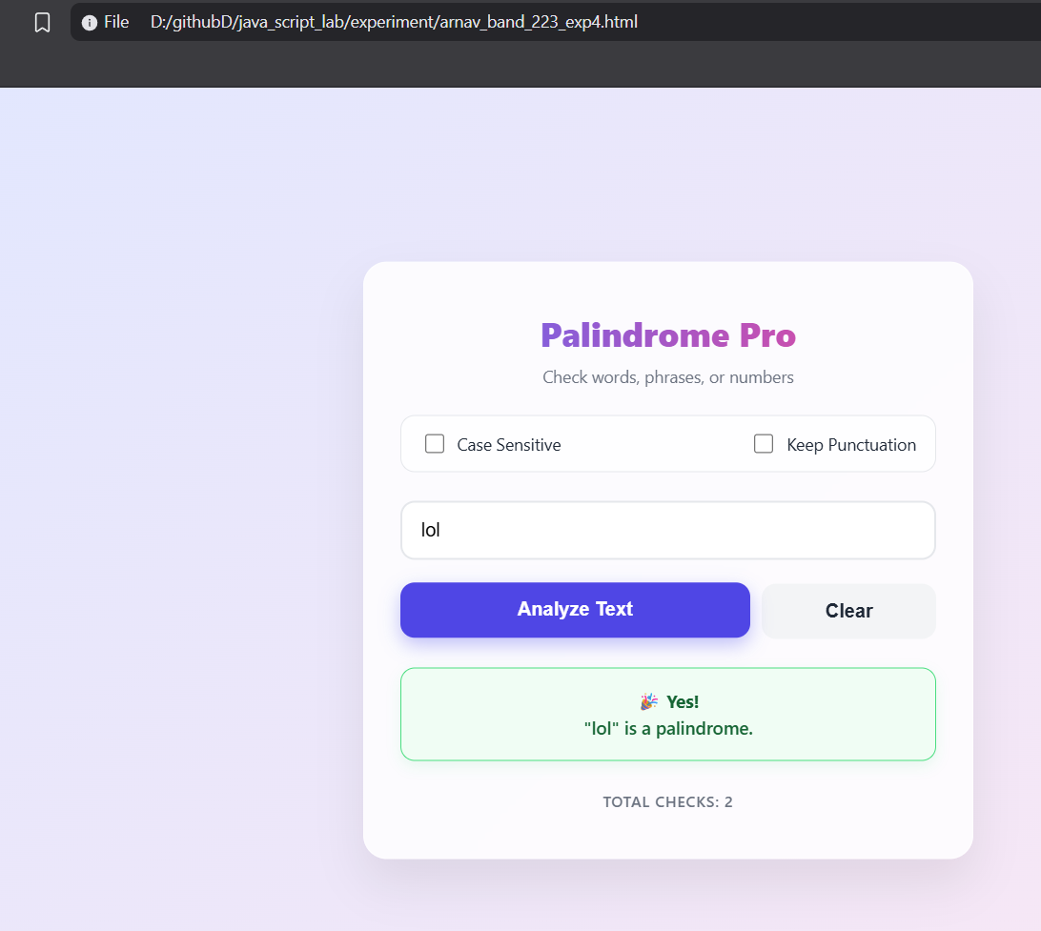

Case Study 4
1. Case Study Title
Real-Time Case Study: ATM Card PIN Verification Using JavaScript Functions to verify whether a customer's PIN is a palindrome. Use function declaration, function expression, arrow function, and demonstrate scope and closure concepts.

2. Case Study Program Code
The case study consists of the following files:

- jashchauhan_242.html – Displays the ATM interface webpage containing a digital screen and a keypad to securely enter the PIN.

• script.js – Implements the PIN verification logic using function declarations, function expressions, and arrow functions, while demonstrating scope and closures to securely track failed attempts.

• style.css – Contains the styling rules to create a realistic, responsive ATM layout with premium visual elements.

<!DOCTYPE html>
<html lang="en">
<head>
<meta charset="UTF-8">
<meta name="viewport" content="width=device-width, initial-scale=1.0">
<title>ATM PIN Verification</title>
<!-- Updated Fonts: Space Mono for the screen and Outfit for general UI -->
<link href="https://fonts.googleapis.com/css2?family=Outfit:wght@400;500;600&family=Space+Mono:wght@400;700&display=swap" rel="stylesheet">

<style>
/* ==========================================
Updated CSS Styling (Dark/Neon Theme)
========================================== */
:root {
/* Dark metallic ATM body */
--atm-bg: #2a2a35;
--atm-shadow: #1c1c23;
--atm-highlight: #383847;

/* Neon Screen */
--screen-bg: #09090c;
--screen-text: #00ffcc; /* Neon Cyan */
--screen-text-error: #ff2a5f; /* Neon Pink/Red */
--screen-text-success: #00ff66; /* Neon Green */

/* Dark Keypad */
--key-bg: #363645;
--key-text: #ffffff;
--btn-cancel: #e63946;
--btn-clear: #f4a261;
--btn-enter: #2a9d8f;
}

* {
margin: 0;
padding: 0;
box-sizing: border-box;
}

body {
font-family: 'Outfit', sans-serif;
background-color: #121216; /* Deep dark background */
display: flex;
justify-content: center;
align-items: center;
min-height: 100vh;
padding: 20px;
}

.atm-container {
background: var(--atm-bg);
padding: 40px;
border-radius: 25px;
/* Dark Neumorphism shadows */
box-shadow:
12px 12px 24px var(--atm-shadow),
-12px -12px 24px var(--atm-highlight);
width: 100%;
max-width: 500px;
}

.atm-machine {
display: flex;
flex-direction: column;
gap: 30px;
}

/* --- Screen Styling --- */
.atm-screen {
background: var(--screen-bg);
padding: 20px;
border-radius: 12px;
border: 4px solid #1a1a24;
box-shadow: inset 0 0 25px rgba(0, 255, 204, 0.05);
position: relative;
height: 260px;
display: flex;
flex-direction: column;
overflow: hidden;
}

/* Scanline effect */
.atm-screen::after {
content: " ";
display: block;
position: absolute;
top: 0;
left: 0;
bottom: 0;
right: 0;
background: linear-gradient(rgba(18, 16, 16, 0) 50%, rgba(0, 0, 0, 0.4) 50%), linear-gradient(90deg, rgba(255, 0, 0, 0.03), rgba(0, 255, 0, 0.01), rgba(0, 0, 255, 0.03));
z-index: 2;
background-size: 100% 3px, 3px 100%;
pointer-events: none;
}

.bank-logo {
font-family: 'Space Mono', monospace;
color: #4a6c72;
font-size: 1.1rem;
text-transform: uppercase;
letter-spacing: 3px;
text-align: center;
margin-bottom: 20px;
}

.screen-content {
font-family: 'Space Mono', monospace;
color: var(--screen-text);
flex-grow: 1;
display: flex;
flex-direction: column;
align-items: center;
justify-content: center;
text-align: center;
text-shadow: 0 0 8px rgba(0, 255, 204, 0.6);
z-index: 1;
}

.welcome-text {
font-size: 1.6rem;
font-weight: 700;
margin-bottom: 10px;
letter-spacing: 2px;
}

.instruction {
font-size: 0.95rem;
margin-bottom: 25px;
opacity: 0.85;
}

.pin-display {
display: flex;
gap: 12px;
height: 30px;
margin-bottom: 20px;
}

.pin-dot {
width: 18px;
height: 18px;
background-color: var(--screen-text);
border-radius: 50%;
box-shadow: 0 0 12px var(--screen-text);
animation: pulse-glow 1s infinite alternate;
}

@keyframes pulse-glow {
0% { opacity: 0.6; transform: scale(0.9); }
100% { opacity: 1; transform: scale(1.1); }
}

.message-area {
font-size: 0.85rem;
min-height: 40px;
line-height: 1.5;
transition: color 0.3s ease;
max-width: 90%;
}

.msg-error {
color: var(--screen-text-error);
text-shadow: 0 0 8px rgba(255, 42, 95, 0.7);
}

.msg-success {
color: var(--screen-text-success);
text-shadow: 0 0 8px rgba(0, 255, 102, 0.7);
}

/* --- Keypad Styling --- */
.atm-keypad {
display: grid;
grid-template-columns: repeat(4, 1fr);
gap: 18px;
background: #23232c;
padding: 25px;
border-radius: 15px;
border: 1px solid #383847;
box-shadow: inset 0 0 15px rgba(0,0,0,0.5);
}

.key {
background: var(--key-bg);
border: none;
border-radius: 10px;
height: 65px;
font-size: 1.6rem;
font-weight: 600;
font-family: 'Space Mono', monospace;
color: var(--key-text);
cursor: pointer;
box-shadow:
4px 4px 10px rgba(0,0,0,0.3),
-2px -2px 8px rgba(255,255,255,0.05);
transition: all 0.1s ease;
display: flex;
justify-content: center;
align-items: center;
}

.key:active {
box-shadow:
inset 4px 4px 8px rgba(0,0,0,0.4),
inset -2px -2px 6px rgba(255,255,255,0.02);
transform: scale(0.96);
color: var(--screen-text);
}

.action-key {
font-family: 'Outfit', sans-serif;
font-size: 0.8rem;
font-weight: 700;
letter-spacing: 1px;
color: white;
text-shadow: 1px 1px 2px rgba(0,0,0,0.6);
}

.cancel { background: var(--btn-cancel); }
.clear { background: var(--btn-clear); }
.enter { background: var(--btn-enter); }

.cancel:active { background: #b02a36; }
.clear:active { background: #c8814a; }
.enter:active { background: #1f7a6f; }

.empty-key {
visibility: hidden;
}

/* --- Card Slot --- */
.card-slot {
align-self: flex-end;
width: 140px;
height: 45px;
background: #1f1f27;
border-radius: 8px;
display: flex;
flex-direction: column;
align-items: center;
justify-content: center;
gap: 6px;
box-shadow:
inset 2px 2px 6px rgba(0,0,0,0.6),
inset -1px -1px 4px rgba(255,255,255,0.05);
border: 1px solid #333342;
}

.slot-opening {
width: 110px;
height: 6px;
background: #050505;
border-radius: 3px;
box-shadow: inset 0 2px 5px rgba(0,0,0,1);
}

.card-indicator {
width: 50px;
height: 3px;
background: var(--screen-text-success);
border-radius: 2px;
box-shadow: 0 0 8px var(--screen-text-success);
animation: indicator-blink 1.5s infinite;
}

@keyframes indicator-blink {
0% { opacity: 0.2; }
50% { opacity: 1; }
100% { opacity: 0.2; }
}

/* Responsive */
@media (max-width: 480px) {
.atm-container {
padding: 25px;
}
.atm-keypad {
gap: 12px;
padding: 15px;
}
.key {
height: 55px;
font-size: 1.3rem;
}
.action-key {
font-size: 0.65rem;
}
.atm-screen {
height: 230px;
}
}
</style>
</head>
<body>
<div class="atm-container">
<div class="atm-machine">
<div class="atm-screen">
<div class="bank-logo">SecureBank</div>
<div id="screen-content" class="screen-content">
<p class="welcome-text">WELCOME</p>
<p class="instruction">PLEASE ENTER YOUR PIN</p>
<div class="pin-display" id="pin-display">
<!-- Dots will appear here -->
</div>
<div class="message-area" id="message-area"></div>
</div>
</div>

<div class="atm-keypad">
<button class="key num-key" data-val="1">1</button>
<button class="key num-key" data-val="2">2</button>
<button class="key num-key" data-val="3">3</button>
<button class="key action-key cancel" id="btn-cancel">CANCEL</button>

<button class="key num-key" data-val="4">4</button>
<button class="key num-key" data-val="5">5</button>
<button class="key num-key" data-val="6">6</button>
<button class="key action-key clear" id="btn-clear">CLEAR</button>

<button class="key num-key" data-val="7">7</button>
<button class="key num-key" data-val="8">8</button>
<button class="key num-key" data-val="9">9</button>
<button class="key action-key enter" id="btn-enter">ENTER</button>

<button class="key empty-key"></button>
<button class="key num-key" data-val="0">0</button>
<button class="key empty-key"></button>
<button class="key empty-key"></button>
</div>

<div class="card-slot">
<div class="slot-opening"></div>
<div class="card-indicator"></div>
</div>
</div>
</div>

<script>
// ==========================================
// JavaScript Logic: ATM Card PIN Verification
// ==========================================

// --- 1. Function Declaration (Scope: Global) ---
// Reverses a string
function reverseString(str) {
return str.split('').reverse().join('');
}

// --- 2. Function Expression (Scope: Global) ---
// Checks if original and reversed strings are identical
const isPalindrome = function(original, reversed) {
return original === reversed;
};

// --- 3. Arrow Function & 4. Closure (Scope: Global & Local) ---
// Factory function demonstrating closure to keep track of secure attempts
const createATMSystem = () => {
// Scope: Local variables to createATMSystem
let attempts = 0;
const MAX_ATTEMPTS = 3;

// The returned arrow function creates a closure, retaining access to 'attempts' and 'MAX_ATTEMPTS'
return (pin) => {
attempts++;

if (attempts > MAX_ATTEMPTS) {
return {
status: 'BLOCKED',
message: 'CARD BLOCKED. TOO MANY FAILED ATTEMPTS.'
};
}

const reversedPin = reverseString(pin);
const valid = isPalindrome(pin, reversedPin);

if (valid) {
// Reset attempts on success
attempts = 0;
return {
status: 'SUCCESS',
message: 'SECURITY VERIFIED: PIN IS PALINDROME. ACCESS GRANTED.'
};
} else {
return {
status: 'ERROR',
message: `INVALID PIN. ATTEMPT ${attempts} OF ${MAX_ATTEMPTS}.`
};
}
};
};

// Initialize the secure verifier instance (closure is active)
const verifyPin = createATMSystem();

// ==========================================
// UI Interaction Logic
// ==========================================
document.addEventListener("DOMContentLoaded", () => {
let currentPin = "";

// DOM Elements
const pinDisplay = document.getElementById("pin-display");
const messageArea = document.getElementById("message-area");
const numKeys = document.querySelectorAll(".num-key");
const btnClear = document.getElementById("btn-clear");
const btnCancel = document.getElementById("btn-cancel");
const btnEnter = document.getElementById("btn-enter");

// Update the visual dots on the ATM screen
function updateDisplay() {
pinDisplay.innerHTML = "";
for (let i = 0; i < currentPin.length; i++) {
const dot = document.createElement("div");
dot.className = "pin-dot";
pinDisplay.appendChild(dot);
}
}

// Display messages on the screen
function showMessage(msg, type) {
messageArea.textContent = msg;
messageArea.className = `message-area ${type === 'error' ? 'msg-error' : (type === 'success' ? 'msg-success' : '')}`;

// Clear success/error message after 3 seconds, unless it's a block message
if (!msg.includes("BLOCKED") && !msg.includes("GRANTED")) {
setTimeout(() => {
messageArea.textContent = "";
messageArea.className = "message-area";
}, 3000);
}
}

// Number pad click events
numKeys.forEach(key => {
key.addEventListener("click", () => {
// Max 6 digits PIN
if (currentPin.length < 6) {
currentPin += key.getAttribute("data-val");
updateDisplay();
}
});
});

// Clear key (removes last entered digit)
btnClear.addEventListener("click", () => {
currentPin = currentPin.slice(0, -1);
updateDisplay();
});

// Cancel key (clears entire input)
btnCancel.addEventListener("click", () => {
currentPin = "";
updateDisplay();
showMessage("OPERATION CANCELLED", "error");
});

// Enter key (Submits PIN for verification)
btnEnter.addEventListener("click", () => {
if (currentPin.length === 0) {
showMessage("PLEASE ENTER A PIN", "error");
return;
}

// Execute PIN Verification using our closure
const result = verifyPin(currentPin);

if (result.status === 'BLOCKED') {
showMessage(result.message, "error");
// Visually disable keypad
document.querySelectorAll(".key").forEach(btn => {
btn.style.opacity = "0.4";
btn.style.pointerEvents = "none";
});
currentPin = "";
updateDisplay();
} else if (result.status === 'SUCCESS') {
showMessage(result.message, "success");
currentPin = "";
updateDisplay();
} else {
showMessage(result.message, "error");
currentPin = "";
updateDisplay();
}
});
});
</script>
</body>
</html>

Output:
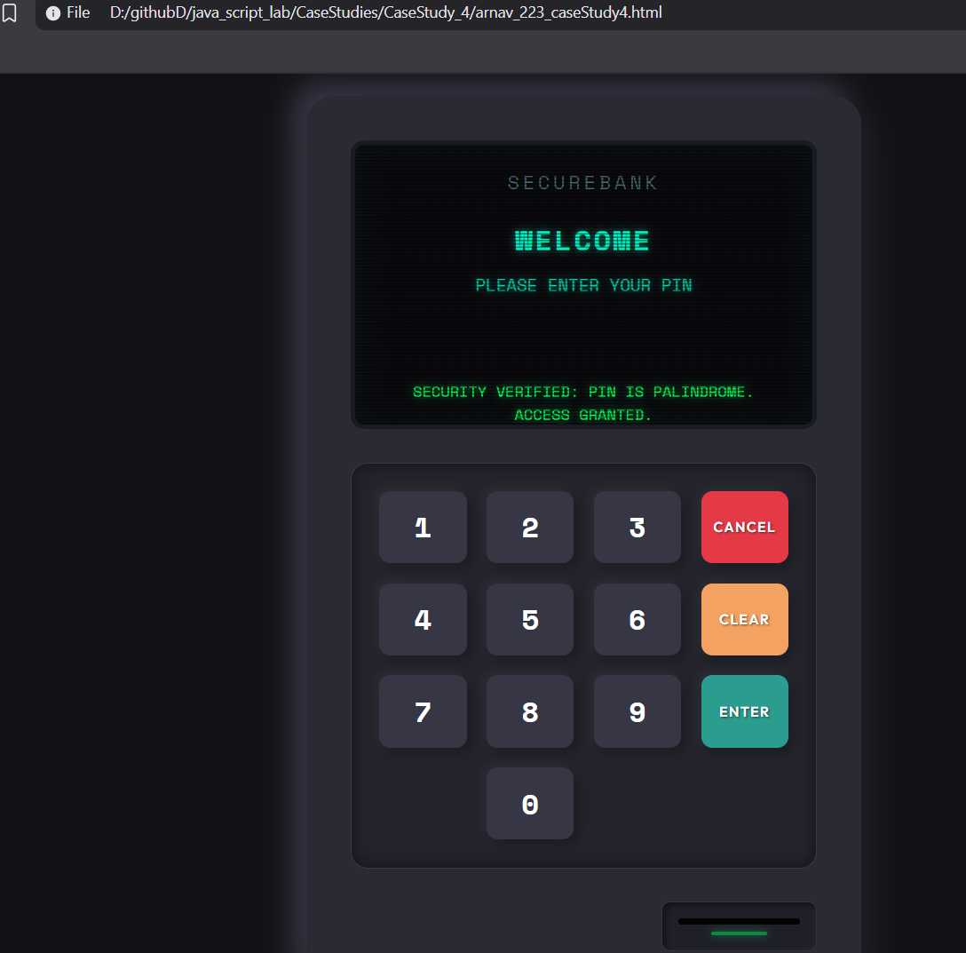
Result/Conclusion:
Case Study 4 successfully demonstrates how to use closures in JavaScript to securely maintain private data (like tracking failed PIN attempts) without exposing it to the global scope. It provides a functional ATM interface that validates palindromic PINs and securely blocks the user after 3 invalid attempts.

Experiment 5
1. Experiment Title
Apply array methods and object handling; create a cart total calculator with discount logic.

2. Software/Tools Required
- Visual Studio Code (VS Code)
- Google Chrome / Mozilla Firefox / Microsoft Edge
- HTML5
- CSS3
- JavaScript
- Windows Operating System

3. Experiment Program Code
The experiment consists of the following files:
- Jashchauhan_242.html
- styles.css
- script.js
<!DOCTYPE html>
<html lang="en">

<head>
<meta charset="UTF-8">
<meta name="viewport" content="width=device-width, initial-scale=1.0">
<title>Cart Total Calculator</title>

<!-- Font Awesome Icons -->
<link rel="stylesheet" href="https://cdnjs.cloudflare.com/ajax/libs/font-awesome/6.5.2/css/all.min.css">

<style>
* {
margin: 0;
padding: 0;
box-sizing: border-box;
font-family: Arial, Helvetica, sans-serif;
}

body {
background: #f5f5f5;
display: flex;
justify-content: center;
align-items: flex-start;
min-height: 100vh;
padding: 40px 20px;
}

.container {
width: 800px;
background: white;
padding: 28px;
border: 1px solid #ddd;
border-radius: 14px;
}

h2 {
font-size: 24px;
margin-bottom: 20px;
}

h2 i {
margin-right: 6px;
}

/* ─── Add-Item Form ─── */

.form-row {
display: flex;
gap: 10px;
margin-bottom: 12px;
flex-wrap: wrap;
}

.form-row input,
.form-row select {
padding: 11px 13px;
font-size: 15px;
border: 1px solid #ccc;
border-radius: 10px;
outline: none;
}

.form-row input:focus,
.form-row select:focus {
border-color: #222;
}

#item-name {
flex: 2;
min-width: 140px;
}

#item-price {
flex: 1;
min-width: 100px;
}

#item-qty {
width: 70px;
}

#item-category {
flex: 1;
min-width: 120px;
cursor: pointer;
}

/* ─── Buttons ─── */

button {
background: #111;
color: white;
border: none;
padding: 11px 18px;
border-radius: 10px;
cursor: pointer;
font-size: 15px;
transition: .3s;
white-space: nowrap;
}

button:hover {
background: #333;
}

/* ─── Discount Row ─── */

.discount-row {
display: flex;
gap: 10px;
margin-bottom: 8px;
}

.discount-row input {
flex: 1;
padding: 11px 13px;
font-size: 15px;
border: 1px solid #ccc;
border-radius: 10px;
outline: none;
}

.discount-row input:focus {
border-color: #222;
}

#apply-discount-btn {
background: #7c3aed;
}

#apply-discount-btn:hover {
background: #6d28d9;
}

.discount-msg {
font-size: 14px;
min-height: 20px;
margin-bottom: 14px;
padding-left: 2px;
}

.discount-msg.success {
color: #16a34a;
}

.discount-msg.error {
color: #ef4444;
}

/* ─── Table ─── */

.table-wrap {
margin-bottom: 18px;
}

table {
width: 100%;
border-collapse: collapse;
}

thead th {
text-align: left;
padding: 10px 12px;
font-size: 14px;
color: #555;
border-bottom: 2px solid #e5e5e5;
}

tbody td {
padding: 10px 12px;
font-size: 15px;
border-bottom: 1px solid #f0f0f0;
}

tbody tr:hover {
background: #fafafa;
}

.category-badge {
display: inline-block;
padding: 3px 10px;
border-radius: 20px;
font-size: 12px;
font-weight: 600;
text-transform: uppercase;
letter-spacing: .3px;
}

.badge-electronics {
background: #dbeafe;
color: #1d4ed8;
}

.badge-clothing {
background: #fce7f3;
color: #be185d;
}

.badge-grocery {
background: #dcfce7;
color: #15803d;
}

.badge-general {
background: #f3f4f6;
color: #374151;
}

.delete-btn {
background: none;
color: #ef4444;
padding: 6px 10px;
font-size: 16px;
}

.delete-btn:hover {
background: #fef2f2;
color: #dc2626;
}

.empty-msg {
text-align: center;
color: #999;
padding: 32px 0;
font-size: 16px;
}

.empty-msg i {
margin-right: 6px;
}

/* ─── Summary ─── */

.summary {
background: #fafafa;
border: 1px solid #e5e5e5;
border-radius: 12px;
padding: 18px 22px;
margin-bottom: 18px;
}

.summary-line {
display: flex;
justify-content: space-between;
padding: 7px 0;
font-size: 15px;
color: #444;
}

.discount-line {
color: #16a34a;
}

.total-line {
border-top: 2px solid #e5e5e5;
margin-top: 6px;
padding-top: 12px;
font-size: 20px;
font-weight: 700;
color: #111;
}

/* ─── Filter Section ─── */

.filter-section {
display: flex;
align-items: center;
gap: 8px;
flex-wrap: wrap;
margin-bottom: 14px;
}

.filter-label {
font-size: 14px;
color: #555;
margin-right: 4px;
}

.filter-btn {
background: #f3f4f6;
color: #333;
padding: 7px 14px;
font-size: 13px;
border-radius: 8px;
}

.filter-btn:hover {
background: #e5e7eb;
}

.filter-btn.active {
background: #111;
color: white;
}

/* ─── Highlight Box ─── */

.highlight {
background: #fffbeb;
border: 1px solid #fbbf24;
border-radius: 12px;
padding: 14px 18px;
font-size: 15px;
color: #92400e;
}

.highlight i {
margin-right: 6px;
color: #f59e0b;
}

/* ─── Utility ─── */

.hidden {
display: none !important;
}
</style>
</head>

<body>

<div class="container">
<h2><i class="fa-solid fa-cart-shopping"></i> Cart Total Calculator</h2>

<!-- Add Item Form -->
<div class="form-row">
<input type="text" id="item-name" placeholder="Item name">
<input type="number" id="item-price" placeholder="Price (₹)" min="0" step="0.01">
<input type="number" id="item-qty" placeholder="Qty" min="1" value="1">
<select id="item-category">
<option value="general">General</option>
<option value="electronics">Electronics</option>
<option value="clothing">Clothing</option>
<option value="grocery">Grocery</option>
</select>
<button onclick="addItem()" id="add-btn">
<i class="fa-solid fa-plus"></i> Add
</button>
</div>

<!-- Discount Code -->
<div class="discount-row">
<input type="text" id="discount-code" placeholder="Discount code (e.g. SAVE10, FLAT50, ELEC20)">
<button onclick="applyDiscount()" id="apply-discount-btn">
<i class="fa-solid fa-tag"></i> Apply
</button>
</div>

<div id="discount-msg" class="discount-msg"></div>

<!-- Cart Table -->
<div class="table-wrap">
<table id="cart-table">
<thead>
<tr>
<th>#</th>
<th>Item</th>
<th>Category</th>
<th>Price (₹)</th>
<th>Qty</th>
<th>Subtotal (₹)</th>
<th></th>
</tr>
</thead>
<tbody id="cart-body">
<!-- Rows rendered by JS -->
</tbody>
</table>

<p id="empty-msg" class="empty-msg">
<i class="fa-solid fa-basket-shopping"></i> Your cart is empty. Add items above.
</p>
</div>

<!-- Summary -->
<div id="summary" class="summary hidden">
<div class="summary-line">
<span>Items in cart</span>
<span id="total-items">0</span>
</div>
<div class="summary-line">
<span>Total quantity</span>
<span id="total-qty">0</span>
</div>
<div class="summary-line">
<span>Subtotal</span>
<span id="subtotal">₹0.00</span>
</div>
<div class="summary-line discount-line hidden" id="discount-summary">
<span id="discount-label">Discount</span>
<span id="discount-amount">−₹0.00</span>
</div>
<div class="summary-line total-line">
<span>Grand Total</span>
<span id="grand-total">₹0.00</span>
</div>
</div>

<!-- Filter Buttons -->
<div id="filter-section" class="filter-section hidden">
<span class="filter-label">Filter by category:</span>
<button class="filter-btn active" onclick="filterByCategory('all')">All</button>
<button class="filter-btn" onclick="filterByCategory('electronics')">Electronics</button>
<button class="filter-btn" onclick="filterByCategory('clothing')">Clothing</button>
<button class="filter-btn" onclick="filterByCategory('grocery')">Grocery</button>
<button class="filter-btn" onclick="filterByCategory('general')">General</button>
</div>

<!-- Most Expensive Item -->
<div id="highlight" class="highlight hidden"></div>
</div>

<script>
// ============================================================
// Experiment 05 – Cart Total Calculator with Discount Logic
// Demonstrates: Array methods (map, filter, reduce, find,
// forEach, findIndex) and Object handling
// ============================================================

// ─── Cart state (array of item objects) ───

let cart = [];
let nextId = 1;

// Active discount object (null when none applied)
let activeDiscount = null;

// Current category filter
let activeFilter = "all";

// ─── Discount code definitions (array of objects) ───

const discountCodes = [
{
code: "SAVE10",
type: "percent",
value: 10,
label: "10% off entire cart",
},
{
code: "FLAT50",
type: "flat",
value: 50,
label: "₹50 flat off",
},
{
code: "ELEC20",
type: "category-percent",
value: 20,
category: "electronics",
label: "20% off Electronics items",
},
];

// ──────────────────────────────────────────────────────────
// Add Item (Object creation + Array.push)
// ──────────────────────────────────────────────────────────

function addItem() {

try {

const name = document.getElementById("item-name").value.trim();
const price = parseFloat(document.getElementById("item-price").value);
const qty = parseInt(document.getElementById("item-qty").value, 10);
const category = document.getElementById("item-category").value;

if (!name) throw "Please enter an item name.";
if (isNaN(price) || price <= 0) throw "Please enter a valid price.";
if (isNaN(qty) || qty < 1) throw "Quantity must be at least 1.";

// Create an item object
const item = {
id: nextId++,
name: name,
price: price,
qty: qty,
category: category,
};

// Array.push – add item to cart
cart.push(item);

// Clear inputs
document.getElementById("item-name").value = "";
document.getElementById("item-price").value = "";
document.getElementById("item-qty").value = 1;

renderCart();

} catch (error) {
alert(error);
}
}

// ──────────────────────────────────────────────────────────
// Remove Item (Array.findIndex + Array.splice)
// ──────────────────────────────────────────────────────────

function removeItem(id) {

// Array.findIndex – locate item by id
const index = cart.findIndex(function (item) {
return item.id === id;
});

if (index !== -1) {
// Array.splice – remove one element at index
cart.splice(index, 1);
renderCart();
}
}

// ──────────────────────────────────────────────────────────
// Apply Discount (Array.find on discountCodes)
// ──────────────────────────────────────────────────────────

function applyDiscount() {

const input = document.getElementById("discount-code").value.trim().toUpperCase();
const msgEl = document.getElementById("discount-msg");

if (!input) {
msgEl.className = "discount-msg error";
msgEl.textContent = "Please enter a discount code.";
return;
}

// Array.find – search for matching code object
const found = discountCodes.find(function (d) {
return d.code === input;
});

if (!found) {
activeDiscount = null;
msgEl.className = "discount-msg error";
msgEl.textContent = 'Invalid code "' + input + '". Try SAVE10, FLAT50, or ELEC20.';
} else {
activeDiscount = found;
msgEl.className = "discount-msg success";
msgEl.textContent = 'Code "' + found.code + '" applied — ' + found.label + "!";
}

renderCart();
}

// ──────────────────────────────────────────────────────────
// Calculate Discount (Array.filter + Array.reduce)
// ──────────────────────────────────────────────────────────

function calculateDiscount(subtotal) {

if (!activeDiscount) return 0;

if (activeDiscount.type === "percent") {
// Percentage off entire subtotal
return subtotal * (activeDiscount.value / 100);
}

if (activeDiscount.type === "flat") {
// Flat amount off (cannot exceed subtotal)
return Math.min(activeDiscount.value, subtotal);
}

if (activeDiscount.type === "category-percent") {

// Array.filter – pick items matching the discount category
const eligible = cart.filter(function (item) {
return item.category === activeDiscount.category;
});

// Array.reduce – sum subtotals of eligible items
const eligibleTotal = eligible.reduce(function (sum, item) {
return sum + item.price * item.qty;
}, 0);

return eligibleTotal * (activeDiscount.value / 100);
}

return 0;
}

// ──────────────────────────────────────────────────────────
// Filter by Category (Array.filter)
// ──────────────────────────────────────────────────────────

function filterByCategory(category) {

activeFilter = category;

// Update active button
var btns = document.querySelectorAll(".filter-btn");
btns.forEach(function (btn) {
btn.classList.remove("active");
});

// Find the clicked button using event-less approach
var allBtns = document.querySelectorAll(".filter-btn");
allBtns.forEach(function (btn) {
if (btn.textContent.trim().toLowerCase() === category) {
btn.classList.add("active");
}
});

renderCart();
}

// ──────────────────────────────────────────────────────────
// Render Cart (Array.forEach, Array.map, Array.filter,
// Array.reduce, Object destructuring-style
// property access)
// ──────────────────────────────────────────────────────────

function renderCart() {

var tbody = document.getElementById("cart-body");
var emptyMsg = document.getElementById("empty-msg");
var summaryEl = document.getElementById("summary");
var filterSection = document.getElementById("filter-section");
var highlightEl = document.getElementById("highlight");
var table = document.getElementById("cart-table");

// Decide which items to show (Array.filter)
var displayItems;
if (activeFilter === "all") {
displayItems = cart;
} else {
displayItems = cart.filter(function (item) {
return item.category === activeFilter;
});
}

// Empty state
if (cart.length === 0) {
table.classList.add("hidden");
emptyMsg.classList.remove("hidden");
summaryEl.classList.add("hidden");
filterSection.classList.add("hidden");
highlightEl.classList.add("hidden");
return;
}

table.classList.remove("hidden");
emptyMsg.classList.add("hidden");
summaryEl.classList.remove("hidden");
filterSection.classList.remove("hidden");

// ── Build table rows (Array.map to create HTML strings) ──

var rowsHtml = displayItems.map(function (item, index) {

var subtotal = item.price * item.qty;

return (
"<tr>" +
"<td>" + (index + 1) + "</td>" +
"<td>" + escapeHtml(item.name) + "</td>" +
'<td><span class="category-badge badge-' + item.category + '">' +
item.category +
"</span></td>" +
"<td>" + item.price.toFixed(2) + "</td>" +
"<td>" + item.qty + "</td>" +
"<td>" + subtotal.toFixed(2) + "</td>" +
'<td><button class="delete-btn" onclick="removeItem(' + item.id + ')">' +
'<i class="fa-solid fa-trash"></i></button></td>' +
"</tr>"
);

}).join("");

tbody.innerHTML = rowsHtml;

// ── Summary calculations ──

// Array.reduce – total subtotal of ALL cart items
var subtotal = cart.reduce(function (sum, item) {
return sum + item.price * item.qty;
}, 0);

// Array.reduce – total quantity
var totalQty = cart.reduce(function (sum, item) {
return sum + item.qty;
}, 0);

var discountAmt = calculateDiscount(subtotal);
var grandTotal = subtotal - discountAmt;

document.getElementById("total-items").textContent = cart.length;
document.getElementById("total-qty").textContent = totalQty;
document.getElementById("subtotal").textContent = "₹" + subtotal.toFixed(2);
document.getElementById("grand-total").textContent = "₹" + grandTotal.toFixed(2);

// Show / hide discount line
var discountSummary = document.getElementById("discount-summary");
if (discountAmt > 0) {
discountSummary.classList.remove("hidden");
document.getElementById("discount-label").textContent =
"Discount (" + activeDiscount.label + ")";
document.getElementById("discount-amount").textContent =
"−₹" + discountAmt.toFixed(2);
} else {
discountSummary.classList.add("hidden");
}

// ── Highlight most expensive item (Array.reduce as max-finder) ──

var mostExpensive = cart.reduce(function (max, item) {
return item.price * item.qty > max.price * max.qty ? item : max;
}, cart[0]);

highlightEl.classList.remove("hidden");
highlightEl.innerHTML =
'<i class="fa-solid fa-crown"></i> Most expensive item: <strong>' +
escapeHtml(mostExpensive.name) +
"</strong> — ₹" +
(mostExpensive.price * mostExpensive.qty).toFixed(2);
}

// ─── Helper: escape HTML to prevent XSS ───

function escapeHtml(text) {
var div = document.createElement("div");
div.appendChild(document.createTextNode(text));
return div.innerHTML;
}
</script>
</body>
</html>

OUTPUT:
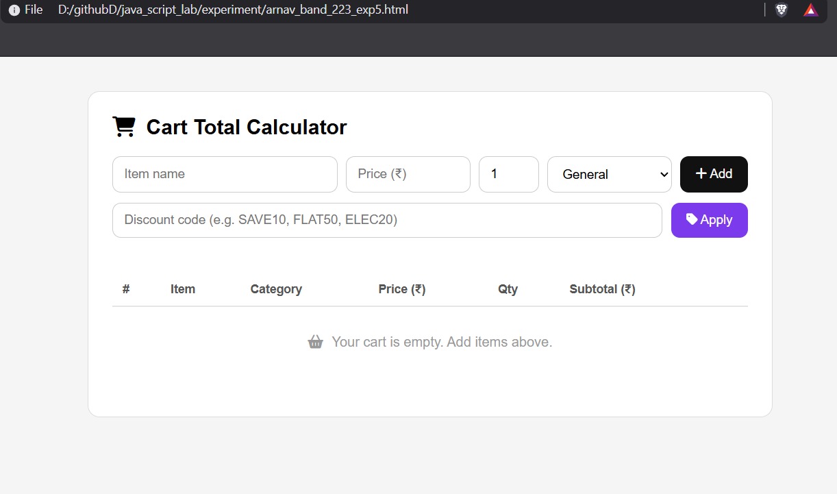
Case Study No.: 5

AIM:
To Study the Functioning of Arrays and Loops in JavaScript.
Create an array of numbers and find the maximum and minimum value using JavaScript loops and array methods.
<!DOCTYPE html>
<html lang="en">
<head>
<meta charset="UTF-8">
<meta name="viewport" content="width=device-width, initial-scale=1.0">
<meta name="description" content="Interactive demonstration of JavaScript Arrays and Loops — array manipulation, higher-order methods, and a max/min case study.">
<title>Arrays & Loops in JavaScript</title>
<link rel="preconnect" href="https://fonts.googleapis.com">
<link rel="preconnect" href="https://fonts.gstatic.com" crossorigin>
<!-- Updated Fonts: Ubuntu and Fira Code for a sleek developer aesthetic -->
<link href="https://fonts.googleapis.com/css2?family=Fira+Code:wght@400;500;600;700&family=Ubuntu:wght@400;500;700;accent&display=swap" rel="stylesheet">

<style>
/* ============================================================
Arrays & Loops Practical — Dark Developer CSS
============================================================ */

/* ── Design tokens ──────────────────────────────────────────── */
:root {
--bg: #0d1117; /* Deep GitHub Dark background */
--surface: #161b22; /* Slightly lighter surface */
--surface-hover: #21262d;
--border: #30363d;
--border-strong: #8b949e;
--text: #c9d1d9; /* Off-white text */
--text-muted: #8b949e;
--text-dim: #6e7681;

/* Vibrant Accents */
--accent: #39ff14; /* Neon Green */
--accent-glow: rgba(57, 255, 20, 0.15);
--green: #2ea043;
--green-glow: rgba(46, 160, 67, 0.25);
--red: #f85149;
--red-glow: rgba(248, 81, 73, 0.25);
--orange: #d29922;
--orange-glow: rgba(210, 153, 34, 0.2);
--cyan: #58a6ff;
--cyan-glow: rgba(88, 166, 255, 0.25);
--purple: #bc8cff;

--font: 'Ubuntu', -apple-system, BlinkMacSystemFont, sans-serif;
--mono: 'Fira Code', monospace;
--radius: 12px;
--radius-sm: 6px;
--shadow: 0 12px 32px rgba(0, 0, 0, 0.4);
--ease: cubic-bezier(0.4, 0, 0.2, 1);
}

/* ── Reset ──────────────────────────────────────────────────── */
*, *::before, *::after { box-sizing: border-box; margin: 0; padding: 0; }

body {
font-family: var(--font);
background: var(--bg);
color: var(--text);
min-height: 100vh;
line-height: 1.6;
overflow-x: hidden;
-webkit-font-smoothing: antialiased;
}

/* ── Ambient orbs ───────────────────────────────────────────── */
.bg-canvas {
position: fixed; inset: 0; z-index: -1; overflow: hidden; pointer-events: none;
background: radial-gradient(circle at 50% 0%, #161b22 0%, #0d1117 70%);
}

.orb {
position: absolute; border-radius: 50%; filter: blur(140px); opacity: 0.12;
}

.orb-a {
width: 600px; height: 600px;
background: radial-gradient(circle, var(--accent), transparent 70%);
top: -150px; left: -100px;
animation: drift 20s ease-in-out infinite alternate;
}

.orb-b {
width: 500px; height: 500px;
background: radial-gradient(circle, var(--cyan), transparent 70%);
bottom: -150px; right: -100px;
animation: drift 25s ease-in-out infinite alternate-reverse;
}

.orb-c {
width: 400px; height: 400px;
background: radial-gradient(circle, var(--purple), transparent 70%);
top: 40%; left: 40%;
opacity: 0.08;
animation: drift 30s ease-in-out infinite alternate;
}

@keyframes drift {
0% { transform: translate(0, 0) scale(1); }
100% { transform: translate(50px, -40px) scale(1.1); }
}

/* ── Page wrapper ───────────────────────────────────────────── */
.page-wrapper {
max-width: 900px;
margin: 0 auto;
padding: 3rem 1.25rem 4rem;
}

/* ── Header ─────────────────────────────────────────────────── */
.page-header {
text-align: center;
margin-bottom: 3.5rem;
}

.chip {
display: inline-flex; align-items: center; gap: 8px;
padding: 6px 16px;
background: rgba(57, 255, 20, 0.05);
border: 1px solid rgba(57, 255, 20, 0.3);
border-radius: 20px;
font-size: 0.85rem; font-weight: 700;
color: var(--accent);
margin-bottom: 1.5rem;
letter-spacing: 0.05em;
text-transform: uppercase;
}

.dot {
width: 8px; height: 8px;
background: var(--accent); border-radius: 50%;
box-shadow: 0 0 10px var(--accent);
animation: pulse 2s infinite;
}

@keyframes pulse {
0%, 100% { opacity: 1; transform: scale(1); }
50% { opacity: 0.4; transform: scale(0.8); }
}

.page-header h1 {
font-size: clamp(2.2rem, 5vw, 3.5rem);
font-weight: 700;
letter-spacing: -0.02em;
color: #ffffff;
margin-bottom: 0.75rem;
text-shadow: 0 0 20px rgba(255, 255, 255, 0.1);
}

.lead {
color: var(--text-muted);
font-size: 1.1rem;
max-width: 600px; margin: 0 auto;
}

/* ── Section cards ──────────────────────────────────────────── */
.section-card {
background: var(--surface);
border: 1px solid var(--border);
border-radius: var(--radius);
padding: 2.25rem;
margin-bottom: 2.5rem;
box-shadow: var(--shadow);
backdrop-filter: blur(10px);
-webkit-backdrop-filter: blur(10px);
transition: border-color 0.3s var(--ease), transform 0.3s var(--ease);
}

.section-card:hover {
border-color: var(--border-strong);
}

.section-card.highlight {
border-color: rgba(88, 166, 255, 0.3);
background: rgba(88, 166, 255, 0.03);
}

/* Section header */
.section-header {
display: flex; align-items: flex-start; gap: 18px;
margin-bottom: 2rem;
}

.section-number {
flex-shrink: 0;
width: 48px; height: 48px;
display: flex; align-items: center; justify-content: center;
border-radius: var(--radius-sm);
background: #21262d;
border: 1px solid var(--border);
color: var(--accent); font-weight: 700; font-size: 1.2rem;
text-transform: uppercase;
box-shadow: inset 0 0 10px rgba(57, 255, 20, 0.05);
}

.section-number.star {
color: var(--cyan);
box-shadow: inset 0 0 10px rgba(88, 166, 255, 0.05);
}

.section-header h2 {
font-size: 1.5rem; font-weight: 700;
color: #ffffff;
margin-bottom: 0.25rem;
}

.section-sub {
color: var(--text-muted);
font-size: 0.95rem;
}

.section-sub code {
background: rgba(255, 255, 255, 0.05);
color: var(--cyan);
padding: 2px 8px;
border-radius: 4px;
font-family: var(--mono);
font-size: 0.85rem;
font-weight: 500;
border: 1px solid rgba(255,255,255,0.1);
}

/* ── Array visual ───────────────────────────────────────────── */
.tiny-label {
font-size: 0.75rem; font-weight: 700; text-transform: uppercase;
letter-spacing: 0.08em; color: var(--text-dim);
display: block; margin-bottom: 10px;
}

.array-display-wrapper {
margin-bottom: 2rem;
}

.array-visual, .cs-array-visual {
display: flex; flex-wrap: wrap; gap: 10px;
padding: 20px;
background: #0d1117;
border: 1px solid var(--border);
border-radius: var(--radius-sm);
min-height: 64px;
align-items: center;
box-shadow: inset 0 2px 10px rgba(0,0,0,0.5);
}

.arr-item {
display: inline-flex; align-items: center; justify-content: center;
min-width: 48px; height: 48px;
padding: 0 14px;
background: #21262d;
border: 1px solid var(--border);
border-radius: var(--radius-sm);
font-family: var(--mono); font-weight: 600; font-size: 1.1rem;
color: var(--text);
animation: popIn 0.3s var(--ease);
transition: all 0.2s var(--ease);
}

.arr-item.highlight-new {
border-color: var(--green);
background: rgba(46, 160, 67, 0.1);
color: var(--accent);
box-shadow: 0 0 15px var(--green-glow);
}

.arr-item.highlight-remove {
border-color: var(--red);
background: rgba(248, 81, 73, 0.1);
color: #ff7b72;
box-shadow: 0 0 15px var(--red-glow);
animation: fadeOut 0.4s var(--ease) forwards;
}

.arr-item.highlight-slice {
border-color: var(--cyan);
background: rgba(88, 166, 255, 0.1);
color: #79c0ff;
box-shadow: 0 0 15px var(--cyan-glow);
}

@keyframes popIn {
0% { transform: scale(0.8) translateY(10px); opacity: 0; }
100% { transform: scale(1) translateY(0); opacity: 1; }
}

@keyframes fadeOut {
0% { transform: scale(1); opacity: 1; }
100% { transform: scale(0.8) translateY(-10px); opacity: 0; }
}

/* ── Control buttons grid ───────────────────────────────────── */
.controls-grid {
display: grid;
grid-template-columns: repeat(auto-fill, minmax(130px, 1fr));
gap: 12px;
margin-bottom: 2rem;
}

.ctrl-btn {
display: flex; flex-direction: column; align-items: center; justify-content: center;
gap: 6px;
padding: 16px 10px;
border: 1px solid var(--border);
border-radius: var(--radius-sm);
background: #21262d;
color: var(--text);
font-family: var(--font);
font-weight: 500; font-size: 0.85rem;
cursor: pointer;
transition: all 0.2s var(--ease);
}

.ctrl-btn .ctrl-icon {
font-size: 1.3rem; font-family: var(--mono); color: var(--text-dim);
transition: color 0.2s;
}

.ctrl-btn:hover {
background: #30363d;
border-color: var(--border-strong);
transform: translateY(-2px);
box-shadow: 0 8px 16px rgba(0,0,0,0.3);
}

.ctrl-btn.push:hover { border-color: var(--green); color: #fff; }
.ctrl-btn.push:hover .ctrl-icon { color: var(--green); }

.ctrl-btn.pop:hover { border-color: var(--red); color: #fff; }
.ctrl-btn.pop:hover .ctrl-icon { color: var(--red); }

.ctrl-btn.unshift:hover { border-color: var(--cyan); color: #fff; }
.ctrl-btn.unshift:hover .ctrl-icon { color: var(--cyan); }

.ctrl-btn.shift:hover { border-color: var(--orange); color: #fff; }
.ctrl-btn.shift:hover .ctrl-icon { color: var(--orange); }

.ctrl-btn.splice:hover { border-color: var(--purple); color: #fff; }
.ctrl-btn.splice:hover .ctrl-icon { color: var(--purple); }

.ctrl-btn.slice:hover { border-color: var(--cyan); color: #fff; }
.ctrl-btn.slice:hover .ctrl-icon { color: var(--cyan); }

.ctrl-btn.reset:hover { border-color: var(--text); color: #fff; }
.ctrl-btn.reset:hover .ctrl-icon { color: #fff; }

/* ── Console box ────────────────────────────────────────────── */
.console-box {
border-radius: var(--radius-sm);
overflow: hidden;
border: 1px solid var(--border);
background: #000000;
box-shadow: 0 10px 30px rgba(0,0,0,0.5);
}

.console-header {
display: flex; align-items: center; gap: 8px;
padding: 12px 16px;
background: #161b22;
border-bottom: 1px solid var(--border);
}

.console-dot {
width: 12px; height: 12px; border-radius: 50%;
}
.console-dot.red { background: #ff5f56; }
.console-dot.yellow { background: #ffbd2e; }
.console-dot.green { background: #27c93f; }

.console-title {
margin-left: 8px;
font-family: var(--mono);
font-size: 0.75rem; font-weight: 600;
color: var(--text-muted);
letter-spacing: 0.05em;
}

.console-body {
padding: 16px;
font-family: var(--mono);
font-size: 0.85rem;
color: var(--accent); /* Terminal Green */
max-height: 240px;
overflow-y: auto;
line-height: 1.8;
}

.console-body::-webkit-scrollbar { width: 6px; }
.console-body::-webkit-scrollbar-track { background: #000; }
.console-body::-webkit-scrollbar-thumb { background: #30363d; border-radius: 6px; }

.console-line {
margin: 0; white-space: pre-wrap; word-break: break-all;
}

.console-line.dim { color: var(--text-dim); }
.console-line.info { color: var(--cyan); }
.console-line.warn { color: var(--orange); }
.console-line.error { color: #ff7b72; }

/* ── Method grid (Section B) ────────────────────────────────── */
.method-grid {
display: grid;
grid-template-columns: repeat(auto-fill, minmax(260px, 1fr));
gap: 16px;
}

.method-card {
background: #21262d;
border: 1px solid var(--border);
border-radius: var(--radius-sm);
padding: 22px;
display: flex; flex-direction: column; gap: 12px;
transition: border-color 0.3s var(--ease), transform 0.2s var(--ease);
}

.method-card:hover {
border-color: var(--cyan);
transform: translateY(-3px);
box-shadow: 0 8px 24px rgba(0,0,0,0.4);
}

.method-card h3 {
font-family: var(--mono);
font-size: 1.1rem; font-weight: 700;
color: var(--cyan);
}

.method-desc {
font-size: 0.9rem;
color: var(--text-muted);
flex-grow: 1;
}

.run-btn {
align-self: flex-start;
padding: 8px 24px;
border: 1px solid rgba(88, 166, 255, 0.4);
border-radius: 4px;
background: rgba(88, 166, 255, 0.1);
color: var(--cyan);
font-family: var(--mono);
font-weight: 600; font-size: 0.85rem;
cursor: pointer;
transition: all 0.2s var(--ease);
}

.run-btn:hover {
background: var(--cyan);
color: #000;
box-shadow: 0 0 15px var(--cyan-glow);
}

.method-output {
background: #0d1117;
border: 1px solid var(--border);
border-radius: 4px;
padding: 14px;
font-family: var(--mono);
font-size: 0.85rem;
color: var(--text);
min-height: 50px;
white-space: pre-wrap;
word-break: break-all;
overflow-x: auto;
}

/* ── Case Study ─────────────────────────────────────────────── */
.case-study-body {
display: flex; flex-direction: column; gap: 1.5rem;
}

.cs-array-visual .arr-item {
background: rgba(88, 166, 255, 0.05);
border-color: rgba(88, 166, 255, 0.3);
color: #c9d1d9;
}

.run-case {
align-self: flex-start;
padding: 14px 32px;
font-size: 0.95rem;
background: var(--cyan);
border: none;
color: #000;
border-radius: var(--radius-sm);
box-shadow: 0 4px 15px var(--cyan-glow);
}

.run-case:hover {
background: #79c0ff;
box-shadow: 0 8px 25px var(--cyan-glow);
transform: translateY(-2px);
}

.cs-result-grid {
display: grid;
grid-template-columns: 1fr 1fr;
gap: 16px;
}

.cs-result-card {
display: flex; flex-direction: column; align-items: center; justify-content: center;
gap: 8px;
padding: 28px 20px;
border-radius: var(--radius-sm);
border: 1px solid var(--border);
background: #21262d;
animation: popIn 0.4s var(--ease);
}

.cs-result-card.max {
border-color: rgba(46, 160, 67, 0.4);
background: linear-gradient(180deg, rgba(46, 160, 67, 0.1) 0%, #21262d 100%);
}

.cs-result-card.min {
border-color: rgba(248, 81, 73, 0.4);
background: linear-gradient(180deg, rgba(248, 81, 73, 0.1) 0%, #21262d 100%);
}

.cs-label {
font-size: 0.8rem; font-weight: 700; text-transform: uppercase;
letter-spacing: 0.1em;
color: var(--text-muted);
}

.cs-value {
font-family: var(--mono);
font-size: 2.5rem; font-weight: 700;
}

.cs-result-card.max .cs-value { color: var(--accent); text-shadow: 0 0 15px rgba(57, 255, 20, 0.4); }
.cs-result-card.min .cs-value { color: #ff7b72; text-shadow: 0 0 15px rgba(248, 81, 73, 0.4); }

.cs-console { margin-top: 0.5rem; }

/* ── Responsive ─────────────────────────────────────────────── */
@media (max-width: 640px) {
.page-wrapper { padding: 2rem 1rem 3rem; }
.section-card { padding: 1.5rem; }
.controls-grid { grid-template-columns: repeat(2, 1fr); }
.method-grid { grid-template-columns: 1fr; }
.cs-result-grid { grid-template-columns: 1fr; }
}
</style>
</head>
<body>

<!-- Ambient background -->
<div class="bg-canvas">
<div class="orb orb-a"></div>
<div class="orb orb-b"></div>
<div class="orb orb-c"></div>
</div>

<div class="page-wrapper">
<!-- Page Header -->
<header class="page-header">
<div class="chip">
<span class="dot"></span>
JavaScript Practical
</div>
<h1 id="page-title">Arrays &amp; Loops</h1>
<p class="lead">To study the functioning of Arrays and Loops in JavaScript</p>
</header>

<!-- ═══════════════════════════════════════════
SECTION A – Array Manipulation
═══════════════════════════════════════════ -->
<section class="section-card" id="section-manipulation">
<div class="section-header">
<span class="section-number">a</span>
<div>
<h2>Array Manipulation</h2>
<p class="section-sub">Create and manipulate arrays: <code>push</code>, <code>pop</code>, <code>shift</code>, <code>unshift</code>, <code>splice</code>, <code>slice</code></p>
</div>
</div>

<!-- Live array display -->
<div class="array-display-wrapper">
<label class="tiny-label">Current Array</label>
<div class="array-visual" id="array-visual">
<!-- filled by JS -->
</div>
</div>

<!-- Control buttons -->
<div class="controls-grid">
<button class="ctrl-btn push" id="btn-push" title="push()">
<span class="ctrl-icon">→]</span>
<span>push()</span>
</button>
<button class="ctrl-btn pop" id="btn-pop" title="pop()">
<span class="ctrl-icon">[←</span>
<span>pop()</span>
</button>
<button class="ctrl-btn unshift" id="btn-unshift" title="unshift()">
<span class="ctrl-icon">[→</span>
<span>unshift()</span>
</button>
<button class="ctrl-btn shift" id="btn-shift" title="shift()">
<span class="ctrl-icon">←]</span>
<span>shift()</span>
</button>
<button class="ctrl-btn splice" id="btn-splice" title="splice()">
<span class="ctrl-icon">✂</span>
<span>splice()</span>
</button>
<button class="ctrl-btn slice" id="btn-slice" title="slice()">
<span class="ctrl-icon">📋</span>
<span>slice()</span>
</button>
<button class="ctrl-btn reset" id="btn-reset" title="Reset array">
<span class="ctrl-icon">↺</span>
<span>Reset</span>
</button>
</div>

<!-- Console-style log -->
<div class="console-box">
<div class="console-header">
<span class="console-dot red"></span>
<span class="console-dot yellow"></span>
<span class="console-dot green"></span>
<span class="console-title">~/dev/console</span>
</div>
<div class="console-body" id="console-a">
<p class="console-line dim">// Click any method above to see the output here</p>
</div>
</div>
</section>

<!-- ═══════════════════════════════════════════
SECTION B – Higher-Order Methods
═══════════════════════════════════════════ -->
<section class="section-card" id="section-methods">
<div class="section-header">
<span class="section-number">b</span>
<div>
<h2>Array Methods</h2>
<p class="section-sub">Use array methods: <code>map()</code>, <code>filter()</code>, <code>reduce()</code>, <code>forEach()</code></p>
</div>
</div>

<div class="method-grid">
<!-- forEach -->
<div class="method-card" id="method-foreach">
<h3>forEach()</h3>
<p class="method-desc">Iterates over each element and logs it.</p>
<button class="run-btn" id="btn-foreach">Run</button>
<pre class="method-output" id="out-foreach"></pre>
</div>
<!-- map -->
<div class="method-card" id="method-map">
<h3>map()</h3>
<p class="method-desc">Doubles every element and returns a new array.</p>
<button class="run-btn" id="btn-map">Run</button>
<pre class="method-output" id="out-map"></pre>
</div>
<!-- filter -->
<div class="method-card" id="method-filter">
<h3>filter()</h3>
<p class="method-desc">Keeps only elements greater than 15.</p>
<button class="run-btn" id="btn-filter">Run</button>
<pre class="method-output" id="out-filter"></pre>
</div>
<!-- reduce -->
<div class="method-card" id="method-reduce">
<h3>reduce()</h3>
<p class="method-desc">Calculates the sum of all elements.</p>
<button class="run-btn" id="btn-reduce">Run</button>
<pre class="method-output" id="out-reduce"></pre>
</div>
</div>
</section>

<!-- ═══════════════════════════════════════════
CASE STUDY – Max & Min Finder
═══════════════════════════════════════════ -->
<section class="section-card highlight" id="section-case-study">
<div class="section-header">
<span class="section-number star">★</span>
<div>
<h2>Case Study</h2>
<p class="section-sub">Create an array of numbers and find the maximum and minimum value.</p>
</div>
</div>

<div class="case-study-body">
<div class="cs-array-row">
<label class="tiny-label">Array</label>
<div class="cs-array-visual" id="cs-array-visual">
<!-- filled by JS -->
</div>
</div>

<button class="run-btn run-case" id="btn-run-case">Find Max & Min</button>

<div class="cs-result-grid" id="cs-results" style="display:none;">
<div class="cs-result-card max">
<span class="cs-label">Maximum Value</span>
<span class="cs-value" id="cs-max">—</span>
</div>
<div class="cs-result-card min">
<span class="cs-label">Minimum Value</span>
<span class="cs-value" id="cs-min">—</span>
</div>
</div>

<!-- Console output for case study -->
<div class="console-box cs-console">
<div class="console-header">
<span class="console-dot red"></span>
<span class="console-dot yellow"></span>
<span class="console-dot green"></span>
<span class="console-title">~/dev/output</span>
</div>
<div class="console-body" id="console-cs">
<p class="console-line dim">// Click "Find Max & Min" to see the result</p>
</div>
</div>
</div>
</section>
</div>

<script>
// ============================================================
// Arrays & Loops Practical – JavaScript
// ============================================================

// ── Source array for Section A ──────────────────────────────
const INITIAL_ARRAY = [25, 10, 45, 5, 30, 15];
let arr = [...INITIAL_ARRAY];

// ── Source array for Case Study ─────────────────────────────
const CS_ARRAY = [25, 10, 45, 5, 30, 15];

// ── DOM references ──────────────────────────────────────────
const arrayVisual = document.getElementById('array-visual');
const consoleA = document.getElementById('console-a');

const csArrayVisual = document.getElementById('cs-array-visual');
const consoleCS = document.getElementById('console-cs');
const csResults = document.getElementById('cs-results');
const csMaxEl = document.getElementById('cs-max');
const csMinEl = document.getElementById('cs-min');

// ── Render helpers ──────────────────────────────────────────

function renderArray(container, data, highlightIndices = [], highlightClass = '') {
container.innerHTML = '';
if (data.length === 0) {
container.innerHTML = '<span style="color:var(--text-dim);font-size:0.85rem;">[ empty ]</span>';
return;
}
data.forEach((val, i) => {
const el = document.createElement('span');
el.className = 'arr-item';
if (highlightIndices.includes(i) && highlightClass) {
el.classList.add(highlightClass);
}
el.textContent = val;
container.appendChild(el);
});
}

function logToConsole(target, message, type = '') {
const p = document.createElement('p');
p.className = `console-line ${type}`;
p.textContent = message;
target.appendChild(p);
target.scrollTop = target.scrollHeight;
}

function clearConsole(target) {
target.innerHTML = '';
}

// ── Initial renders ─────────────────────────────────────────
renderArray(arrayVisual, arr);
renderArray(csArrayVisual, CS_ARRAY);

// ════════════════════════════════════════════════════════════
// SECTION A – Array Manipulation
// ════════════════════════════════════════════════════════════

// push()
document.getElementById('btn-push').addEventListener('click', () => {
const val = Math.floor(Math.random() * 50) + 1;
clearConsole(consoleA);
logToConsole(consoleA, `// push(${val})`, 'dim');
logToConsole(consoleA, `Before: [${arr.join(', ')}]`);
arr.push(val);
logToConsole(consoleA, `After: [${arr.join(', ')}]`);
logToConsole(consoleA, `→ Added ${val} to the end. Length is now ${arr.length}.`, 'info');
renderArray(arrayVisual, arr, [arr.length - 1], 'highlight-new');
});

// pop()
document.getElementById('btn-pop').addEventListener('click', () => {
clearConsole(consoleA);
if (arr.length === 0) {
logToConsole(consoleA, '⚠ Array is empty, nothing to pop.', 'warn');
return;
}
logToConsole(consoleA, '// pop()', 'dim');
logToConsole(consoleA, `Before: [${arr.join(', ')}]`);
const removed = arr.pop();
logToConsole(consoleA, `After: [${arr.join(', ')}]`);
logToConsole(consoleA, `→ Removed ${removed} from the end.`, 'error');
renderArray(arrayVisual, arr);
});

// unshift()
document.getElementById('btn-unshift').addEventListener('click', () => {
const val = Math.floor(Math.random() * 50) + 1;
clearConsole(consoleA);
logToConsole(consoleA, `// unshift(${val})`, 'dim');
logToConsole(consoleA, `Before: [${arr.join(', ')}]`);
arr.unshift(val);
logToConsole(consoleA, `After: [${arr.join(', ')}]`);
logToConsole(consoleA, `→ Added ${val} to the beginning. Length is now ${arr.length}.`, 'info');
renderArray(arrayVisual, arr, [0], 'highlight-new');
});

// shift()
document.getElementById('btn-shift').addEventListener('click', () => {
clearConsole(consoleA);
if (arr.length === 0) {
logToConsole(consoleA, '⚠ Array is empty, nothing to shift.', 'warn');
return;
}
logToConsole(consoleA, '// shift()', 'dim');
logToConsole(consoleA, `Before: [${arr.join(', ')}]`);
const removed = arr.shift();
logToConsole(consoleA, `After: [${arr.join(', ')}]`);
logToConsole(consoleA, `→ Removed ${removed} from the beginning.`, 'error');
renderArray(arrayVisual, arr);
});

// splice()
document.getElementById('btn-splice').addEventListener('click', () => {
clearConsole(consoleA);
if (arr.length < 2) {
logToConsole(consoleA, '⚠ Array too short for splice demo (need >= 2 items).', 'warn');
return;
}
const startIdx = 1;
const deleteCount = 1;
const insertVal = Math.floor(Math.random() * 50) + 1;
logToConsole(consoleA, `// splice(${startIdx}, ${deleteCount}, ${insertVal})`, 'dim');
logToConsole(consoleA, `Before: [${arr.join(', ')}]`);
const spliced = arr.splice(startIdx, deleteCount, insertVal);
logToConsole(consoleA, `After: [${arr.join(', ')}]`);
logToConsole(consoleA, `→ Removed [${spliced.join(', ')}] at index ${startIdx}, inserted ${insertVal}.`, 'info');
renderArray(arrayVisual, arr, [startIdx], 'highlight-new');
});

// slice()
document.getElementById('btn-slice').addEventListener('click', () => {
clearConsole(consoleA);
if (arr.length < 3) {
logToConsole(consoleA, '⚠ Array too short for slice demo (need >= 3 items).', 'warn');
return;
}
const start = 1;
const end = 4;
logToConsole(consoleA, `// slice(${start}, ${end})`, 'dim');
logToConsole(consoleA, `Original: [${arr.join(', ')}]`);
const sliced = arr.slice(start, Math.min(end, arr.length));
logToConsole(consoleA, `Sliced: [${sliced.join(', ')}]`);
logToConsole(consoleA, `→ Extracted elements from index ${start} to ${Math.min(end, arr.length) - 1} (original unchanged).`, 'info');
// highlight the sliced range
const indices = [];
for (let i = start; i < Math.min(end, arr.length); i++) indices.push(i);
renderArray(arrayVisual, arr, indices, 'highlight-slice');
});

// Reset
document.getElementById('btn-reset').addEventListener('click', () => {
arr = [...INITIAL_ARRAY];
clearConsole(consoleA);
logToConsole(consoleA, '↺ Array reset to initial values.', 'dim');
renderArray(arrayVisual, arr);
});

// ════════════════════════════════════════════════════════════
// SECTION B – Higher-Order Methods
// ════════════════════════════════════════════════════════════

const methodArr = [25, 10, 45, 5, 30, 15];

// forEach()
document.getElementById('btn-foreach').addEventListener('click', () => {
const out = document.getElementById('out-foreach');
let lines = [];
lines.push(`Array: [${methodArr.join(', ')}]\n`);
methodArr.forEach((val, idx) => {
lines.push(`Index ${idx} → ${val}`);
});
out.textContent = lines.join('\n');
});

// map()
document.getElementById('btn-map').addEventListener('click', () => {
const out = document.getElementById('out-map');
const doubled = methodArr.map(val => val * 2);
let lines = [];
lines.push(`Original: [${methodArr.join(', ')}]`);
lines.push(`Doubled: [${doubled.join(', ')}]`);
out.textContent = lines.join('\n');
});

// filter()
document.getElementById('btn-filter').addEventListener('click', () => {
const out = document.getElementById('out-filter');
const filtered = methodArr.filter(val => val > 15);
let lines = [];
lines.push(`Original: [${methodArr.join(', ')}]`);
lines.push(`filter(x => x > 15)`);
lines.push(`Result: [${filtered.join(', ')}]`);
out.textContent = lines.join('\n');
});

// reduce()
document.getElementById('btn-reduce').addEventListener('click', () => {
const out = document.getElementById('out-reduce');
const sum = methodArr.reduce((acc, val) => acc + val, 0);
let lines = [];
lines.push(`Array: [${methodArr.join(', ')}]`);
lines.push(`reduce((acc, val) => acc + val, 0)`);
lines.push(`Sum = ${sum}`);
out.textContent = lines.join('\n');
});

// ════════════════════════════════════════════════════════════
// CASE STUDY – Max & Min Finder
// ════════════════════════════════════════════════════════════

document.getElementById('btn-run-case').addEventListener('click', () => {
const numbers = CS_ARRAY;

// Find max and min using reduce
const maxVal = numbers.reduce((max, val) => val > max ? val : max, numbers[0]);
const minVal = numbers.reduce((min, val) => val < min ? val : min, numbers[0]);

// Show result cards
csResults.style.display = 'grid';
csMaxEl.textContent = maxVal;
csMinEl.textContent = minVal;

// Highlight max and min in the array visual
const maxIdx = numbers.indexOf(maxVal);
const minIdx = numbers.indexOf(minVal);
csArrayVisual.innerHTML = '';
numbers.forEach((val, i) => {
const el = document.createElement('span');
el.className = 'arr-item';
if (i === maxIdx) {
el.style.borderColor = 'var(--green)';
el.style.background = 'rgba(46, 160, 67, 0.15)';
el.style.color = 'var(--accent)';
el.style.boxShadow = '0 0 15px var(--green-glow)';
} else if (i === minIdx) {
el.style.borderColor = 'var(--red)';
el.style.background = 'rgba(248, 81, 73, 0.15)';
el.style.color = '#ff7b72';
el.style.boxShadow = '0 0 15px var(--red-glow)';
}
el.textContent = val;
csArrayVisual.appendChild(el);
});

// Console output – matching the expected output from the slide
clearConsole(consoleCS);
logToConsole(consoleCS, `Array: [${numbers.join(', ')}]`);
logToConsole(consoleCS, `Maximum Value: ${maxVal} Minimum Value: ${minVal}`);
});
</script>
</body>
</html>
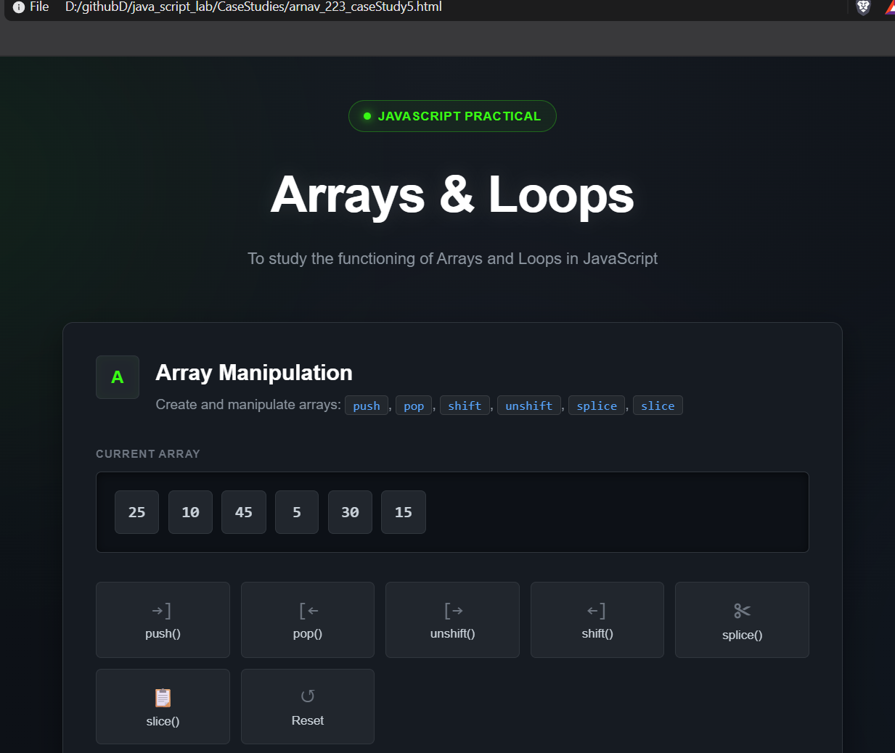

Experiment No. 6

AIM:-
Use string functions and regex for email validation, data extraction, and text analysis.

Software / Tools Required
- Google Chrome — Web browser used for execution and testing.
Visual Studio Code (VS Code) — Code editor used for writing HTML, CSS

<!DOCTYPE html>
<html lang="en">
<head>
<meta charset="UTF-8">
<meta name="viewport" content="width=device-width, initial-scale=1.0">
<meta name="description" content="Unified 3-in-1 Interactive demonstration of JavaScript String functions and Regular Expressions.">
<title>3-in-1 Text Analyzer | Strings & Regex</title>
<link rel="preconnect" href="https://fonts.googleapis.com">
<link rel="preconnect" href="https://fonts.gstatic.com" crossorigin>
<link href="https://fonts.googleapis.com/css2?family=Fira+Code:wght@400;500;600;700&family=Ubuntu:wght@400;500;700&display=swap" rel="stylesheet">

<style>
/* ============================================================
Unified 3-in-1 Practical — Dark Developer CSS
============================================================ */

:root {
--bg: #0d1117;
--surface: #161b22;
--border: #30363d;
--border-strong: #8b949e;
--text: #c9d1d9;
--text-muted: #8b949e;
--text-dim: #6e7681;

--accent: #39ff14; /* Neon Green */
--accent-glow: rgba(57, 255, 20, 0.15);
--cyan: #58a6ff;
--cyan-glow: rgba(88, 166, 255, 0.25);
--purple: #bc8cff;
--red: #ff7b72;

--font: 'Ubuntu', -apple-system, sans-serif;
--mono: 'Fira Code', monospace;
--radius: 12px;
--radius-sm: 6px;
--shadow: 0 12px 32px rgba(0, 0, 0, 0.4);
--ease: cubic-bezier(0.4, 0, 0.2, 1);
}

/* Light Theme Overrides */
body.light-theme {
--bg: #f6f8fa;
--surface: #ffffff;
--border: #d0d7de;
--border-strong: #afb8c1;
--text: #24292f;
--text-muted: #57606a;
--text-dim: #6e7781;
--shadow: 0 12px 32px rgba(0, 0, 0, 0.08);
--accent: #1a7f37;
--cyan: #0969da;
--purple: #8250df;
--red: #cf222e;
}

body.light-theme .bg-canvas {
background: radial-gradient(circle at 50% 0%, #ffffff 0%, #eaeef2 70%);
}

body.light-theme .page-header h1 {
color: #1f2328;
text-shadow: none;
}

body.light-theme textarea {
background: #f6f8fa;
color: #1f2328;
border-color: #d0d7de;
box-shadow: inset 0 2px 6px rgba(0,0,0,0.05);
}

body.light-theme .run-btn {
color: #ffffff;
background: #0969da;
}

body.light-theme .run-btn:hover {
background: #218bff;
}

body.light-theme .stat-card {
background: #f6f8fa;
border-color: #d0d7de;
}

body.light-theme .output-box {
background: #ffffff;
border-color: #d0d7de;
}

body.light-theme .output-header {
border-bottom-color: #d0d7de;
}

/* Theme Toggle Button */
.theme-toggle-btn {
position: fixed;
top: 20px;
right: 20px;
padding: 8px 16px;
font-family: var(--mono);
font-size: 0.85em;
background: var(--surface);
color: var(--cyan);
border: 1px solid var(--border);
border-radius: 20px;
cursor: pointer;
transition: all 0.2s var(--ease);
box-shadow: var(--shadow);
z-index: 1000;
}

body.light-theme .theme-toggle-btn {
background: #ffffff;
color: #0969da;
border-color: #d0d7de;
}

*, *::before, *::after { box-sizing: border-box; margin: 0; padding: 0; }

body {
font-family: var(--font);
background: var(--bg);
color: var(--text);
min-height: 100vh;
line-height: 1.6;
overflow-x: hidden;
-webkit-font-smoothing: antialiased;
transition: background 0.3s var(--ease), color 0.3s var(--ease);
}

/* Ambient Orbs */
.bg-canvas {
position: fixed; inset: 0; z-index: -1; overflow: hidden; pointer-events: none;
background: radial-gradient(circle at 50% 0%, #161b22 0%, #0d1117 70%);
}
.orb {
position: absolute; border-radius: 50%; filter: blur(140px); opacity: 0.12;
}
.orb-a {
width: 600px; height: 600px; background: radial-gradient(circle, var(--accent), transparent 70%);
top: -150px; left: -100px; animation: drift 20s ease-in-out infinite alternate;
}
.orb-b {
width: 500px; height: 500px; background: radial-gradient(circle, var(--cyan), transparent 70%);
bottom: -150px; right: -100px; animation: drift 25s ease-in-out infinite alternate-reverse;
}

@keyframes drift {
0% { transform: translate(0, 0) scale(1); }
100% { transform: translate(50px, -40px) scale(1.1); }
}

/* Page Layout */
.page-wrapper { max-width: 900px; margin: 0 auto; padding: 3rem 1.25rem 4rem; }

.page-header { text-align: center; margin-bottom: 3.5rem; }
.chip {
display: inline-flex; align-items: center; gap: 8px; padding: 6px 16px;
background: rgba(88, 166, 255, 0.05); border: 1px solid rgba(88, 166, 255, 0.3);
border-radius: 20px; font-size: 0.85rem; font-weight: 700; color: var(--cyan);
margin-bottom: 1.5rem; letter-spacing: 0.05em; text-transform: uppercase;
}
.dot {
width: 8px; height: 8px; background: var(--cyan); border-radius: 50%;
box-shadow: 0 0 10px var(--cyan); animation: pulse 2s infinite;
}
@keyframes pulse {
0%, 100% { opacity: 1; transform: scale(1); }
50% { opacity: 0.4; transform: scale(0.8); }
}
.page-header h1 {
font-size: clamp(2.2rem, 5vw, 3.5rem); font-weight: 700; color: #ffffff;
margin-bottom: 0.75rem; text-shadow: 0 0 20px rgba(255, 255, 255, 0.1);
}
.lead { color: var(--text-muted); font-size: 1.1rem; max-width: 600px; margin: 0 auto; }

/* Unified Card */
.section-card {
background: var(--surface); border: 1px solid var(--border); border-radius: var(--radius);
padding: 2.25rem; margin-bottom: 2.5rem; box-shadow: var(--shadow);
backdrop-filter: blur(10px); transition: border-color 0.3s var(--ease), background 0.3s var(--ease);
}
.section-card:hover { border-color: var(--border-strong); }

/* Inputs & Buttons */
.input-group { display: flex; flex-direction: column; gap: 10px; margin-bottom: 0.75rem; }
.header-row { display: flex; justify-content: space-between; align-items: flex-end; }
label { font-size: 0.85rem; font-weight: 700; text-transform: uppercase; color: var(--text-dim); letter-spacing: 0.05em; }

textarea {
width: 100%; padding: 16px; background: #0d1117; border: 1px solid var(--border);
border-radius: var(--radius-sm); color: var(--text); font-family: var(--mono); font-size: 0.95rem;
transition: all 0.2s var(--ease); box-shadow: inset 0 2px 6px rgba(0,0,0,0.3);
resize: vertical; min-height: 180px; margin-bottom: 1rem;
}
textarea:focus { outline: none; border-color: var(--cyan); box-shadow: 0 0 0 3px rgba(88, 166, 255, 0.15); }

.action-row {
display: flex; justify-content: space-between; align-items: flex-end; flex-wrap: wrap; gap: 15px; margin-bottom: 1.5rem;
}

.run-btn {
padding: 14px 32px; font-size: 1rem; background: var(--cyan);
border: none; color: #000; border-radius: var(--radius-sm); font-weight: 700;
cursor: pointer; box-shadow: 0 4px 15px var(--cyan-glow); transition: all 0.2s var(--ease);
}
.run-btn:hover { background: #79c0ff; box-shadow: 0 8px 25px var(--cyan-glow); transform: translateY(-2px); }

/* Real-time Stats Grid */
.stats-grid { display: flex; gap: 12px; flex-wrap: wrap; }
.stat-card {
background: #21262d; border: 1px solid var(--border); border-radius: var(--radius-sm);
padding: 10px 18px; text-align: center; flex: 1; min-width: 120px;
}
.stat-value { font-family: var(--mono); font-size: 1.5rem; font-weight: 700; color: var(--accent); }
.stat-label { font-size: 0.7rem; text-transform: uppercase; color: var(--text-muted); font-weight: 700; letter-spacing: 0.05em; }

/* Output Box */
.output-box {
padding: 20px; background: #000; border: 1px solid var(--border);
border-radius: var(--radius-sm); font-family: var(--mono); font-size: 0.9rem;
color: var(--text); min-height: 120px; white-space: pre-wrap; word-break: break-all;
}
.output-header { display: flex; align-items: center; gap: 8px; margin-bottom: 15px; border-bottom: 1px solid #30363d; padding-bottom: 10px; }
.console-dot { width: 12px; height: 12px; border-radius: 50%; }
.console-dot.red { background: #ff5f56; } .console-dot.yellow { background: #ffbd2e; } .console-dot.green { background: #27c93f; }

.highlight-green { color: var(--accent); }
.highlight-cyan { color: var(--cyan); }
.highlight-purple { color: var(--purple); }
.highlight-red { color: var(--red); }

.placeholder-text { color: var(--text-dim); }
.result-text { color: var(--text); }
</style>
</head>
<body>

<!-- THEME TOGGLE BUTTON -->
<button class="theme-toggle-btn" id="themeToggle" onclick="toggleTheme()">☀️ Light Mode</button>

<div class="bg-canvas">
<div class="orb orb-a"></div>
<div class="orb orb-b"></div>
</div>

<div class="page-wrapper">
<header class="page-header">
<div class="chip"><span class="dot"></span> 3-in-1 Unified Tool</div>
<h1 id="page-title">Super Text Analyzer</h1>
<p class="lead">Live text analysis, robust data extraction, and structural email validation all in one dashboard.</p>
</header>

<section class="section-card">
<div class="input-group">
<div class="header-row">
<label for="unified-input">Input Data (Auto-converts to lowercase)</label>
</div>
<!-- Default text is also provided in lowercase to match functionality -->
<textarea id="unified-input">hello! please verify the following contact details.
you can reach our lead dev at john.doe@code-workspace.com or hit up the generic inbox at contact@domain.org.
don't send mail to invalid@domain or missing-at-sign.com.
for phone support, call 1-800-555-0199 or our direct line 555.867.5309.
thanks!</textarea>
</div>

<div class="action-row">
<button class="run-btn" id="btn-process">Extract & Validate Data</button>

<!-- Real-time Text Analysis Stats -->
<div class="stats-grid">
<div class="stat-card">
<div class="stat-value" id="stat-words">0</div>
<div class="stat-label">Words</div>
</div>
<div class="stat-card">
<div class="stat-value" id="stat-chars">0</div>
<div class="stat-label">Chars</div>
</div>
<div class="stat-card">
<div class="stat-value" id="stat-spaces">0</div>
<div class="stat-label">No Spaces</div>
</div>
</div>
</div>

<!-- Output Console -->
<div class="output-box" id="unified-output">
<div class="output-header">
<span class="console-dot red"></span><span class="console-dot yellow"></span><span class="console-dot green"></span>
<span style="color: var(--text-muted); font-size: 0.8rem; font-weight: 600; letter-spacing: 0.05em;">~/dev/extraction-results</span>
</div>
<div id="output-content" class="placeholder-text">// CLICK "EXTRACT & VALIDATE DATA" TO SEE RESULTS HERE...</div>
</div>
</section>
</div>

<script>
// DOM Elements
const textInput = document.getElementById('unified-input');
const statWords = document.getElementById('stat-words');
const statChars = document.getElementById('stat-chars');
const statSpaces = document.getElementById('stat-spaces');
const btnProcess = document.getElementById('btn-process');
const outputContent = document.getElementById('output-content');

// ==========================================
// 1. Text Analysis & Lowercase enforcement
// ==========================================
function handleInput() {
// Preserve cursor position so jumping doesn't happen during typing
const start = textInput.selectionStart;
const end = textInput.selectionEnd;

// Force text to lowercase using .toLowerCase()
textInput.value = textInput.value.toLowerCase();

// Restore cursor position
textInput.setSelectionRange(start, end);

// Run stats
updateStats();
}

function updateStats() {
const text = textInput.value;

// Chars total
statChars.textContent = text.length;

// Chars without spaces
statSpaces.textContent = text.replace(/\s+/g, '').length;

// Word count
const trimmedText = text.trim();
if (trimmedText === '') {
statWords.textContent = '0';
} else {
statWords.textContent = trimmedText.split(/\s+/).length;
}
}

// Bind input handler
textInput.addEventListener('input', handleInput);

// Initial force format and stats load
handleInput();

// ==========================================
// 2 & 3. Data Extraction & Validation
// ==========================================
btnProcess.addEventListener('click', () => {
outputContent.className = 'result-text';

const text = textInput.value;

// Regex for lowercase extraction (input is already forced to lowercase)
const extractEmailRegex = /[a-z0-9._%+-]+@[a-z0-9.-]+\.[a-z]{2,}/g;
const phoneRegex = /\b(?:\d[ -.]?)?\(?\d{3}\)?[-.]?\d{3}[-.]?\d{4}\b/g;
const strictValidateRegex = /^[^\s@]+@[^\s@]+\.[^\s@]+$/;

const foundEmails = text.match(extractEmailRegex) || [];
const foundPhones = text.match(phoneRegex) || [];

let htmlOutput = ``;

// Process Phones (Forced to Uppercase)
htmlOutput += `<span class="highlight-cyan">► PHONE NUMBERS EXTRACTED (${foundPhones.length}):</span>\n`;
if (foundPhones.length > 0) {
foundPhones.forEach(phone => htmlOutput += ` ├─ ${phone.toUpperCase()}\n`);
} else {
htmlOutput += ` └─ (NONE FOUND)\n`;
}
htmlOutput += `\n`;

// Process Emails & Validate them (Forced to Uppercase)
htmlOutput += `<span class="highlight-purple">► EMAIL ADDRESSES EXTRACTED & VALIDATED (${foundEmails.length}):</span>\n`;
if (foundEmails.length > 0) {
const uniqueEmails = [...new Set(foundEmails)];

uniqueEmails.forEach(email => {
const isValid = strictValidateRegex.test(email);
// Use .toUpperCase() here to enforce the output rule
if(isValid) {
htmlOutput += ` ├─ [ <span class="highlight-green">VALID</span> ] ${email.toUpperCase()}\n`;
} else {
htmlOutput += ` ├─ [ <span class="highlight-red">INVALID</span> ] ${email.toUpperCase()}\n`;
}
});
} else {
htmlOutput += ` └─ (NONE FOUND)\n`;
}

// Output to virtual console
outputContent.innerHTML = htmlOutput;
});

// THEME SWITCH LOGIC
function applyTheme(theme) {
const toggleBtn = document.getElementById('themeToggle');
if (theme === 'light') {
document.body.classList.add('light-theme');
toggleBtn.textContent = '🌙 Dark Mode';
} else {
document.body.classList.remove('light-theme');
toggleBtn.textContent = '☀️ Light Mode';
}
}

function toggleTheme() {
const isLight = document.body.classList.contains('light-theme');
const newTheme = isLight ? 'dark' : 'light';
localStorage.setItem('exp6_theme', newTheme);
applyTheme(newTheme);
}

// Restore saved theme on load
window.addEventListener('DOMContentLoaded', () => {
const savedTheme = localStorage.getItem('exp6_theme') || 'dark';
applyTheme(savedTheme);
});
</script>
</body>
</html>
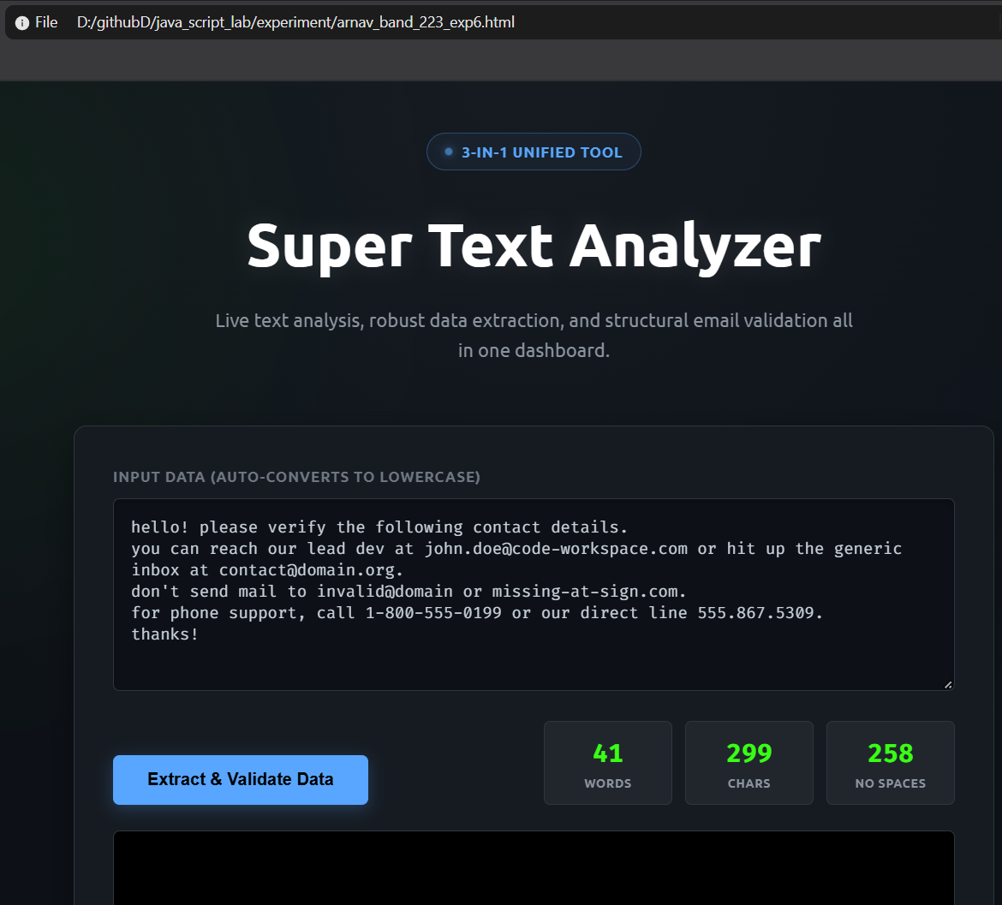

Case Study No.: 6

AIM:-
To Study and Implement String Operations, String Manipulation Methods, and Vowel Counting in JavaScript

<!DOCTYPE html>
<html lang="en">
<head>
<meta charset="UTF-8" />
<meta name="viewport" content="width=device-width, initial-scale=1.0"/>
<title>JavaScript Case Study</title>
<style>
/* Modern, Common Design Variables */
:root {
--primary-color: #0d6efd;
--primary-hover: #0b5ed7;
--bg-color: #f8f9fa;
--card-bg: #ffffff;
--text-main: #212529;
--text-muted: #6c757d;
--border-color: #dee2e6;
--success-color: #198754;
--error-color: #dc3545;
--font-family: system-ui, -apple-system, "Segoe UI", Roboto, "Helvetica Neue", Arial, sans-serif;
}

* {
box-sizing: border-box;
margin: 0;
padding: 0;
}

body {
font-family: var(--font-family);
background-color: var(--bg-color);
color: var(--text-main);
line-height: 1.6;
padding: 40px 20px;
}

.container {
max-width: 800px;
margin: 0 auto;
}

header {
text-align: center;
margin-bottom: 40px;
}

h1 {
font-weight: 600;
color: var(--text-main);
margin-bottom: 10px;
}

p.subtitle {
color: var(--text-muted);
}

/* Card Styling for Sections */
section {
background-color: var(--card-bg);
padding: 25px 30px;
margin-bottom: 30px;
border-radius: 10px;
border: 1px solid var(--border-color);
box-shadow: 0 4px 6px rgba(0, 0, 0, 0.05);
transition: transform 0.2s ease, box-shadow 0.2s ease;
}

section:hover {
box-shadow: 0 6px 12px rgba(0, 0, 0, 0.08);
}

h2 {
font-size: 1.25rem;
color: var(--primary-color);
margin-bottom: 20px;
border-bottom: 2px solid var(--bg-color);
padding-bottom: 10px;
}

/* Form Elements */
label {
display: block;
font-weight: 500;
margin-bottom: 5px;
color: var(--text-main);
}

input[type="text"],
input[type="email"],
textarea {
width: 100%;
padding: 10px 15px;
margin-bottom: 15px;
border: 1px solid var(--border-color);
border-radius: 6px;
font-family: inherit;
font-size: 1rem;
transition: border-color 0.3s ease, box-shadow 0.3s ease;
}

input:focus,
textarea:focus {
outline: none;
border-color: var(--primary-color);
box-shadow: 0 0 0 3px rgba(13, 110, 253, 0.25);
}

button {
background-color: var(--primary-color);
color: white;
font-weight: 500;
padding: 10px 20px;
font-size: 1rem;
border: none;
border-radius: 6px;
cursor: pointer;
transition: background-color 0.2s ease;
}

button:hover {
background-color: var(--primary-hover);
}

/* Result Output Styling */
.result-box {
margin-top: 15px;
padding: 12px 15px;
border-radius: 6px;
background-color: var(--bg-color);
border-left: 4px solid var(--primary-color);
font-weight: 500;
display: none; /* Hidden until triggered */
}

.result-box.active {
display: block;
}

.result-box.success {
border-left-color: var(--success-color);
background-color: #d1e7dd;
color: #0f5132;
}

.result-box.error {
border-left-color: var(--error-color);
background-color: #f8d7da;
color: #842029;
}
</style>
</head>
<body>

<div class="container">
<header>
<h1>JavaScript Case Study</h1>
<p class="subtitle">String Operations & Event Handling</p>
</header>

<!-- Section for reversing a string -->
<section>
<h2>1. Reverse a String</h2>
<label for="reverseInput">Enter text to reverse:</label>
<input type="text" id="reverseInput" placeholder="e.g., Hello World" />
<button onclick="reverseString()">Reverse String</button>
<div id="reverseResult" class="result-box"></div>
</section>

<!-- Section for counting vowels -->
<section>
<h2>2. Count Vowels in Paragraph</h2>
<label for="paragraph">Enter paragraph text:</label>
<textarea id="paragraph" rows="4" placeholder="Type a sentence or paragraph here..."></textarea>
<button onclick="countVowels()">Count Vowels</button>
<div id="vowelCount" class="result-box"></div>
</section>

<!-- Form for demonstrating event handling and validation -->
<section>
<h2>3. Form Event Handling & Validation</h2>
<form id="sampleForm">
<label for="name">Full Name:</label>
<input type="text" id="name" name="name" placeholder="John Doe" />

<label for="email">Email Address:</label>
<input type="email" id="email" name="email" placeholder="john@example.com" />

<button type="submit">Submit Form</button>
</form>
<div id="formMessage" class="result-box"></div>
</section>
</div>

<script>
// --- 1. String Operation: Reverse String ---
function reverseString() {
const input = document.getElementById('reverseInput').value;
const resultBox = document.getElementById('reverseResult');

if (input.trim() === '') {
resultBox.innerText = 'Please enter a string to reverse.';
resultBox.className = 'result-box active error';
return;
}

const reversed = input.split('').reverse().join('');
resultBox.innerText = 'Reversed: ' + reversed;
resultBox.className = 'result-box active';
}

// --- 2. String Operation: Count Vowels ---
function countVowels() {
const paragraph = document.getElementById('paragraph').value.toLowerCase();
const resultBox = document.getElementById('vowelCount');

if (paragraph.trim() === '') {
resultBox.innerText = 'Please enter some text to analyze.';
resultBox.className = 'result-box active error';
return;
}

const vowels = 'aeiou';
let count = 0;
for (let char of paragraph) {
if (vowels.includes(char)) {
count++;
}
}

resultBox.innerText = `Found ${count} vowel(s) in the text.`;
resultBox.className = 'result-box active';
}

// --- 3. Event Handling & Validation ---
const form = document.getElementById('sampleForm');
const nameInput = document.getElementById('name');
const emailInput = document.getElementById('email');
const formMessage = document.getElementById('formMessage');

// Focus Event Demonstration
nameInput.addEventListener('focus', function() {
console.log("Name field is focused.");
});

// Change Event Demonstration
emailInput.addEventListener('change', function() {
console.log("Email value changed to: " + this.value);
});

// Submit Event & Validation
form.addEventListener('submit', function(event) {
// Prevent default submission
event.preventDefault();

const name = nameInput.value.trim();
const email = emailInput.value.trim();

// Validate Empty Fields
if (name === '' || email === '') {
formMessage.innerText = 'Error: Both Name and Email fields are required.';
formMessage.className = 'result-box active error';
return;
}

// Validate Email Format (Basic Regex)
const emailPattern = /^[^\s@]+@[^\s@]+\.[^\s@]+$/;
if (!emailPattern.test(email)) {
formMessage.innerText = 'Error: Please enter a valid email address.';
formMessage.className = 'result-box active error';
return;
}

// Success State
formMessage.innerText = `Success! Thank you, ${name}. Your email (${email}) has been validated and received.`;
formMessage.className = 'result-box active success';

// Optional: Clear form after successful submit
form.reset();
});
</script>

</body>
</html>
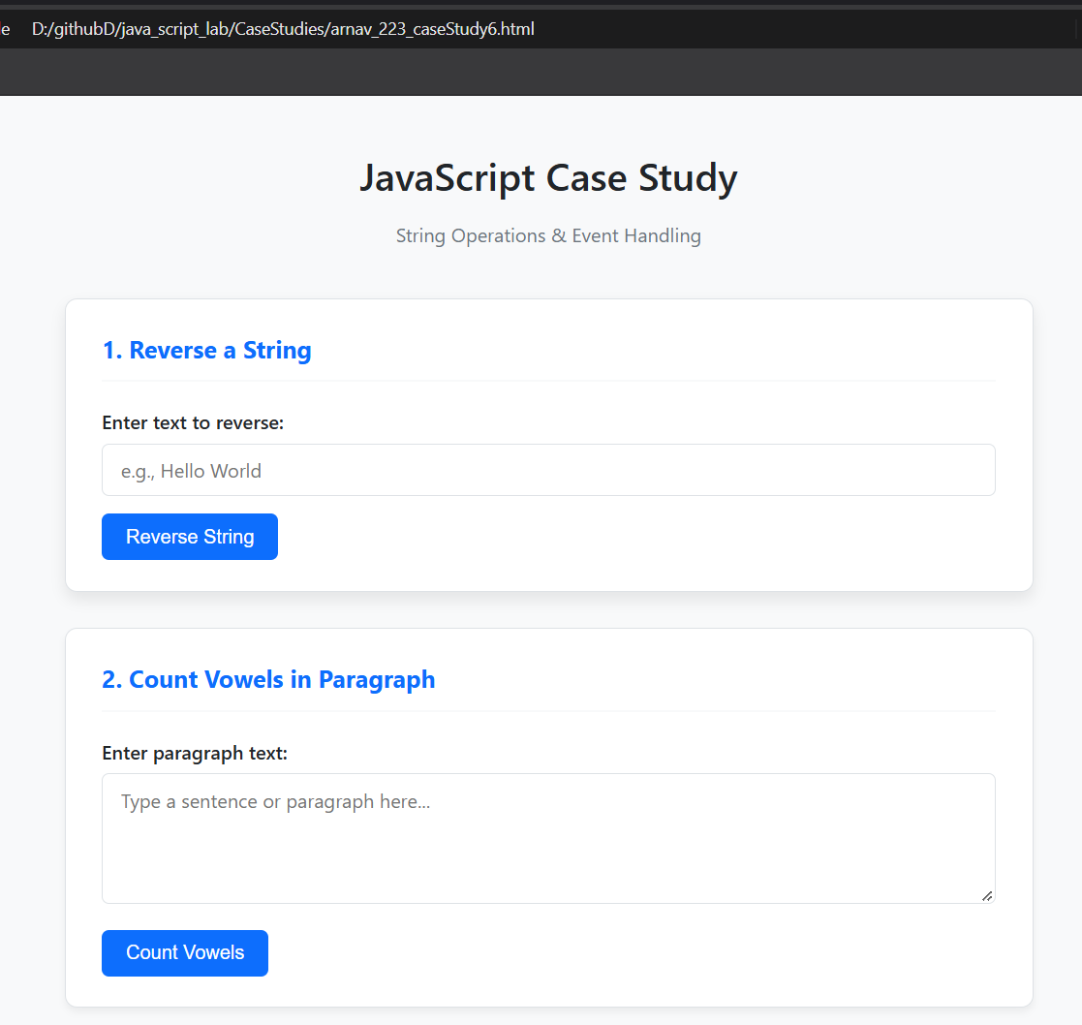

Experiment No. 7
AIM:-
Perform DOM traversal and updates; develop a to-do list app with add, edit, and delete features.
INDEX.HTML
<!DOCTYPE html>
<html lang="en">
<head>
<meta charset="UTF-8" />
<meta name="viewport" content="width=device-width, initial-scale=1.0" />
<title>Enhanced Task Manager</title>
<style>
:root {
--primary: #0284c7;
--primary-hover: #0369a1;
--bg: #f0f4f8;
--card-bg: #ffffff;
--text: #1e293b;
--text-muted: #64748b;
--border: #e2e8f0;
--edit: #f59e0b;
--edit-hover: #d97706;
--delete: #ef4444;
--delete-hover: #dc2626;
--success: #10b981;
}

/* Dark Theme CSS Variables */
body.dark-theme {
--primary: #38bdf8;
--primary-hover: #7dd3fc;
--bg: #0f172a;
--card-bg: #1e293b;
--text: #f8fafc;
--text-muted: #94a3b8;
--border: #334155;
}

body.dark-theme .input-section select {
background: #0f172a;
border-color: var(--border);
color: var(--text);
}

body.dark-theme .input-section input[type="text"] {
background: #0f172a;
border-color: var(--border);
color: var(--text);
}

body.dark-theme .input-section button {
background-color: var(--primary);
color: #0f172a;
}

body.dark-theme .input-section button:hover {
background-color: var(--primary-hover);
}

body.dark-theme .filter-btn.active {
background-color: rgba(56, 189, 248, 0.15);
color: var(--primary);
}

body.dark-theme .task-item {
background-color: #0f172a;
border-color: var(--border);
}

body.dark-theme .priority-High { background: #450a0a; color: #fca5a5; }
body.dark-theme .priority-Medium { background: #451a03; color: #fcd34d; }
body.dark-theme .priority-Low { background: #052e16; color: #86efac; }

body.dark-theme .inline-edit-input {
background: #1e293b;
color: var(--text);
border-color: var(--primary);
}

/* Theme Toggle Button */
.theme-toggle-btn {
position: fixed;
top: 20px;
right: 20px;
padding: 8px 16px;
font-size: 0.85rem;
font-weight: 600;
background: #ffffff;
color: #1e293b;
border: 1.5px solid #cbd5e1;
border-radius: 20px;
cursor: pointer;
transition: all 0.2s ease;
box-shadow: 0 4px 10px rgba(0, 0, 0, 0.05);
z-index: 1000;
}

body.dark-theme .theme-toggle-btn {
background: #1e293b;
color: #38bdf8;
border-color: #334155;
box-shadow: 0 4px 10px rgba(0, 0, 0, 0.3);
}

* {
box-sizing: border-box;
margin: 0;
padding: 0;
font-family: -apple-system, BlinkMacSystemFont, "Segoe UI", Roboto, sans-serif;
}

body {
background-color: var(--bg);
color: var(--text);
display: flex;
justify-content: center;
padding: 40px 16px;
min-height: 100vh;
transition: background-color 0.3s ease, color 0.3s ease;
}

.container {
background: var(--card-bg);
width: 100%;
max-width: 580px;
padding: 30px;
border-radius: 16px;
box-shadow: 0 10px 25px -5px rgba(0, 0, 0, 0.08);
height: fit-content;
}

h1 {
text-align: center;
color: var(--primary);
font-size: 1.75rem;
margin-bottom: 20px;
}

/* Input Controls */
.input-section {
display: flex;
gap: 8px;
margin-bottom: 16px;
flex-wrap: wrap;
}

.input-section input[type="text"] {
flex: 1;
min-width: 200px;
padding: 10px 14px;
border: 1px solid var(--border);
border-radius: 8px;
font-size: 0.95rem;
outline: none;
}

.input-section input[type="text"]:focus {
border-color: var(--primary);
box-shadow: 0 0 0 3px rgba(2, 132, 199, 0.15);
}

.input-section select {
padding: 10px;
border: 1px solid var(--border);
border-radius: 8px;
background: #fff;
font-size: 0.9rem;
color: var(--text);
outline: none;
cursor: pointer;
}

.input-section button {
padding: 10px 18px;
background-color: var(--primary);
color: #fff;
border: none;
border-radius: 8px;
font-weight: 600;
cursor: pointer;
transition: background-color 0.2s;
}

.input-section button:hover {
background-color: var(--primary-hover);
}

/* Filters & Summary */
.filter-bar {
display: flex;
justify-content: space-between;
align-items: center;
border-bottom: 1px solid var(--border);
padding-bottom: 12px;
margin-bottom: 16px;
font-size: 0.85rem;
color: var(--text-muted);
}

.filter-buttons {
display: flex;
gap: 6px;
}

.filter-btn {
background: none;
border: 1px solid transparent;
padding: 4px 10px;
border-radius: 6px;
cursor: pointer;
font-size: 0.85rem;
color: var(--text-muted);
}

.filter-btn.active {
background-color: #e0f2fe;
color: var(--primary);
font-weight: 600;
}

/* Task List */
#taskList {
list-style: none;
display: flex;
flex-direction: column;
gap: 10px;
}

.task-item {
display: flex;
align-items: center;
gap: 12px;
padding: 12px;
background-color: #f8fafc;
border: 1px solid var(--border);
border-radius: 8px;
transition: transform 0.15s, opacity 0.2s;
}

.task-item.completed {
opacity: 0.65;
}

.task-item.completed .task-text {
text-decoration: line-through;
color: var(--text-muted);
}

.task-item input[type="checkbox"] {
width: 18px;
height: 18px;
accent-color: var(--primary);
cursor: pointer;
}

.task-content {
flex: 1;
display: flex;
flex-direction: column;
gap: 4px;
}

.task-text {
font-size: 0.95rem;
word-break: break-word;
}

.priority-badge {
font-size: 0.7rem;
font-weight: 700;
text-transform: uppercase;
padding: 2px 6px;
border-radius: 4px;
width: fit-content;
}

.priority-High { background: #fee2e2; color: #b91c1c; }
.priority-Medium { background: #fef3c7; color: #b45309; }
.priority-Low { background: #dcfce7; color: #15803d; }

/* Action Buttons */
.actions {
display: flex;
gap: 6px;
}

.btn-edit, .btn-delete, .btn-save {
border: none;
padding: 6px 10px;
border-radius: 6px;
font-size: 0.8rem;
font-weight: 600;
cursor: pointer;
color: white;
}

.btn-edit { background-color: var(--edit); }
.btn-edit:hover { background-color: var(--edit-hover); }

.btn-delete { background-color: var(--delete); }
.btn-delete:hover { background-color: var(--delete-hover); }

.btn-save { background-color: var(--success); }

.inline-edit-input {
width: 100%;
padding: 6px 8px;
font-size: 0.95rem;
border: 1px solid var(--primary);
border-radius: 4px;
outline: none;
}

.empty-state {
text-align: center;
padding: 20px;
color: var(--text-muted);
font-size: 0.9rem;
}
</style>
</head>
<body>

<!-- THEME TOGGLE BUTTON -->
<button class="theme-toggle-btn" id="themeToggle" onclick="toggleTheme()">🌙 Dark Mode</button>

<div class="container">
<h1>To-Do List</h1>

<div class="input-section">
<input type="text" id="taskInput" placeholder="Enter a task..." />
<select id="priorityInput">
<option value="Low">Low</option>
<option value="Medium" selected>Medium</option>
<option value="High">High</option>
</select>
<button id="addBtn">Add</button>
</div>

<div class="filter-bar">
<div class="filter-buttons">
<button class="filter-btn active" data-filter="all">All</button>
<button class="filter-btn" data-filter="active">Active</button>
<button class="filter-btn" data-filter="completed">Completed</button>
</div>
<span id="taskStats">0 / 0 Done</span>
</div>

<ul id="taskList"></ul>
</div>

<script>
// State management with LocalStorage
let tasks = JSON.parse(localStorage.getItem('tasks')) || [];
let currentFilter = 'all';

// DOM References
const taskInput = document.getElementById('taskInput');
const priorityInput = document.getElementById('priorityInput');
const addBtn = document.getElementById('addBtn');
const taskList = document.getElementById('taskList');
const taskStats = document.getElementById('taskStats');
const filterButtons = document.querySelectorAll('.filter-btn');

// Save & Re-render
function updateState() {
localStorage.setItem('tasks', JSON.stringify(tasks));
renderTasks();
}

// Render list based on currentFilter
function renderTasks() {
taskList.innerHTML = '';

const filteredTasks = tasks.filter(task => {
if (currentFilter === 'active') return !task.completed;
if (currentFilter === 'completed') return task.completed;
return true;
});

if (filteredTasks.length === 0) {
taskList.innerHTML = `<li class="empty-state">No tasks to display</li>`;
} else {
filteredTasks.forEach(task => {
const li = document.createElement('li');
li.className = `task-item ${task.completed ? 'completed' : ''}`;
li.dataset.id = task.id;

li.innerHTML = `
<input type="checkbox" class="task-checkbox" ${task.completed ? 'checked' : ''}>
<div class="task-content">
<span class="priority-badge priority-${task.priority}">${task.priority}</span>
<span class="task-text">${task.text}</span>
</div>
<div class="actions">
<button class="btn-edit">Edit</button>
<button class="btn-delete">Delete</button>
</div>
`;
taskList.appendChild(li);
});
}

// Update counters
const total = tasks.length;
const completed = tasks.filter(t => t.completed).length;
taskStats.textContent = `${completed} / ${total} Done`;
}

// Add Task
function addTask() {
const text = taskInput.value.trim();
if (!text) return;

tasks.push({
id: Date.now().toString(),
text: text,
priority: priorityInput.value,
completed: false
});

taskInput.value = '';
updateState();
}

// Centralized Event Delegation for taskList
taskList.addEventListener('click', (e) => {
const target = e.target;
const taskItem = target.closest('.task-item');
if (!taskItem) return;

const taskId = taskItem.dataset.id;
const taskIndex = tasks.findIndex(t => t.id === taskId);

// Checkbox Toggle
if (target.classList.contains('task-checkbox')) {
tasks[taskIndex].completed = target.checked;
updateState();
}

// Delete Action
if (target.classList.contains('btn-delete')) {
tasks.splice(taskIndex, 1);
updateState();
}

// Edit / Save Action
if (target.classList.contains('btn-edit')) {
const textSpan = taskItem.querySelector('.task-text');
const isEditing = target.textContent === 'Save';

if (!isEditing) {
// Switch to Edit Mode
const currentText = tasks[taskIndex].text;
const input = document.createElement('input');
input.type = 'text';
input.value = currentText;
input.className = 'inline-edit-input';

textSpan.replaceWith(input);
input.focus();
target.textContent = 'Save';
target.className = 'btn-save';
} else {
// Save Edit
const editInput = taskItem.querySelector('.inline-edit-input');
const updatedText = editInput.value.trim();

if (updatedText) {
tasks[taskIndex].text = updatedText;
}
updateState();
}
}
});

// Filter Buttons Event
filterButtons.forEach(btn => {
btn.addEventListener('click', () => {
filterButtons.forEach(b => b.classList.remove('active'));
btn.classList.add('active');
currentFilter = btn.dataset.filter;
renderTasks();
});
});

// Enter Key Support
taskInput.addEventListener('keydown', (e) => {
if (e.key === 'Enter') addTask();
});

addBtn.addEventListener('click', addTask);

// THEME SWITCH LOGIC
function applyTheme(theme) {
const toggleBtn = document.getElementById('themeToggle');
if (theme === 'dark') {
document.body.classList.add('dark-theme');
toggleBtn.textContent = '☀️ Light Mode';
} else {
document.body.classList.remove('dark-theme');
toggleBtn.textContent = '🌙 Dark Mode';
}
}

function toggleTheme() {
const isDark = document.body.classList.contains('dark-theme');
const newTheme = isDark ? 'light' : 'dark';
localStorage.setItem('exp7_theme', newTheme);
applyTheme(newTheme);
}

// Restore saved theme on load
const savedTheme = localStorage.getItem('exp7_theme') || 'light';
applyTheme(savedTheme);

// Initial render
renderTasks();
</script>
</body>
</html>
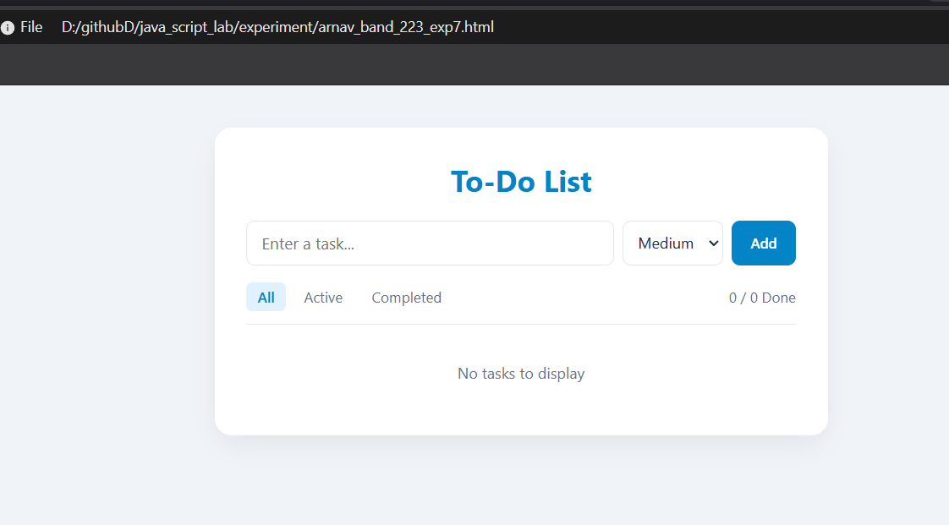

Case Study No.: 7
AIM:-
To Study and Implement Event Handling, Form Validation, and Dynamic DOM Manipulation in JavaScript

<!DOCTYPE html>
<html lang="en">
<head>
<meta charset="UTF-8">
<meta name="viewport" content="width=device-width, initial-scale=1.0">
<title>Event Handling Case Study</title>
<style>
* {
box-sizing: border-box;
}

body {
font-family: -apple-system, BlinkMacSystemFont, "Segoe UI", Roboto, Helvetica, Arial, sans-serif;
background-color: #eef2f6;
color: #333333;
padding: 40px 20px;
margin: 0;
line-height: 1.5;
}

.form-container {
background-color: #ffffff;
border: 1px solid #e2e8f0;
border-radius: 12px;
width: 100%;
max-width: 520px;
padding: 32px 28px;
margin: 0 auto;
box-shadow: 0 10px 25px -5px rgba(0, 0, 0, 0.05), 0 8px 10px -6px rgba(0, 0, 0, 0.01);
}

.mandatory-note {
color: #dc2626;
font-size: 0.85rem;
font-weight: 500;
margin-bottom: 24px;
}

.form-group {
display: flex;
align-items: center;
margin-bottom: 18px;
}

.form-group label {
width: 130px;
font-size: 0.9rem;
font-weight: 600;
color: #475569;
flex-shrink: 0;
}

.form-group input[type="text"],
.form-group input[type="password"] {
flex: 1;
padding: 8px 12px;
border: 1.5px solid #cbd5e1;
border-radius: 6px;
outline: none;
font-size: 0.9rem;
color: #1e293b;
transition: border-color 0.2s, box-shadow 0.2s, background-color 0.2s;
}

.form-group input:focus,
.form-group select:focus {
border-color: #2563eb;
background-color: #f8fafc;
box-shadow: 0 0 0 3px rgba(37, 99, 235, 0.15);
}

.dob-selects {
display: flex;
gap: 10px;
flex: 1;
}

.dob-selects select {
flex: 1;
padding: 8px 10px;
border: 1.5px solid #cbd5e1;
border-radius: 6px;
font-size: 0.9rem;
background-color: #ffffff;
color: #334155;
outline: none;
cursor: pointer;
transition: border-color 0.2s, box-shadow 0.2s;
}

.required-star {
color: #dc2626;
margin-left: 8px;
font-weight: 700;
width: 10px;
}

.terms-group {
margin-left: 130px;
margin-top: 20px;
margin-bottom: 24px;
display: flex;
align-items: center;
font-size: 0.88rem;
color: #475569;
}

.terms-group input {
margin: 0 10px 0 0;
width: 16px;
height: 16px;
cursor: pointer;
accent-color: #2563eb;
}

.terms-group label {
cursor: pointer;
}

.btn-group {
margin-left: 130px;
}

input[type="submit"] {
background-color: #2563eb;
color: #ffffff;
border: none;
border-radius: 6px;
padding: 10px 22px;
cursor: pointer;
font-size: 0.95rem;
font-weight: 600;
letter-spacing: 0.01em;
transition: background-color 0.2s, transform 0.1s;
}

input[type="submit"]:hover {
background-color: #1d4ed8;
}

input[type="submit"]:active {
transform: scale(0.98);
}

.error-message {
color: #dc2626;
font-size: 0.8rem;
font-weight: 500;
margin-left: 130px;
margin-top: -12px;
margin-bottom: 14px;
display: none;
}
</style>
</head>
<body>

<div class="form-container">
<div class="mandatory-note">* Mandatory to fill</div>

<form id="registrationForm" novalidate>
<!-- Firstname -->
<div class="form-group">
<label for="firstname">Firstname:</label>
<input type="text" id="firstname">
<span class="required-star">*</span>
</div>

<!-- Lastname -->
<div class="form-group">
<label for="lastname">Lastname:</label>
<input type="text" id="lastname">
<span class="required-star">*</span>
</div>

<!-- Birthday -->
<div class="form-group">
<label>Birthday:</label>
<div class="dob-selects">
<select id="dobDay">
<option value="">Day</option>
</select>
<select id="dobMonth">
<option value="">Month</option>
<option value="1">January</option>
<option value="2">February</option>
<option value="3">March</option>
<option value="4">April</option>
<option value="5">May</option>
<option value="6">June</option>
<option value="7">July</option>
<option value="8">August</option>
<option value="9">September</option>
<option value="10">October</option>
<option value="11">November</option>
<option value="12">December</option>
</select>
<select id="dobYear">
<option value="">Year</option>
</select>
</div>
<span class="required-star">*</span>
</div>

<!-- Username -->
<div class="form-group">
<label for="username">Username:</label>
<input type="text" id="username">
<span class="required-star">*</span>
</div>

<!-- E-mail -->
<div class="form-group">
<label for="email">E-mail:</label>
<input type="text" id="email">
<span class="required-star">*</span>
</div>
<div class="error-message" id="emailError">Please enter a valid email address.</div>

<!-- Website -->
<div class="form-group">
<label for="website">Website:</label>
<input type="text" id="website">
<span class="required-star">*</span>
</div>

<!-- Password -->
<div class="form-group">
<label for="password">Password:</label>
<input type="password" id="password">
<span class="required-star">*</span>
</div>

<!-- Re-password -->
<div class="form-group">
<label for="repassword">Re-password:</label>
<input type="password" id="repassword">
<span class="required-star">*</span>
</div>
<div class="error-message" id="passwordError">Passwords do not match!</div>

<!-- Terms Checkbox -->
<div class="terms-group">
<input type="checkbox" id="terms">
<label for="terms">I agree to the terms & conditions.</label>
</div>

<!-- Submit Button -->
<div class="btn-group">
<input type="submit" value="Sign up">
</div>
</form>
</div>

<script>
// --- Populate Dropdowns ---
const daySelect = document.getElementById('dobDay');
const yearSelect = document.getElementById('dobYear');

for (let i = 1; i <= 31; i++) {
let opt = document.createElement('option');
opt.value = i;
opt.innerHTML = i;
daySelect.appendChild(opt);
}

const currentYear = new Date().getFullYear();
for (let i = currentYear; i >= currentYear - 100; i--) {
let opt = document.createElement('option');
opt.value = i;
opt.innerHTML = i;
yearSelect.appendChild(opt);
}

// --- Form Event Listeners & Validation ---
const form = document.getElementById('registrationForm');
const emailInput = document.getElementById('email');
const passwordInput = document.getElementById('password');
const repasswordInput = document.getElementById('repassword');
const emailError = document.getElementById('emailError');
const passwordError = document.getElementById('passwordError');

repasswordInput.addEventListener('input', function() {
if (passwordInput.value && repasswordInput.value !== passwordInput.value) {
passwordError.style.display = 'block';
} else {
passwordError.style.display = 'none';
}
});

form.addEventListener('submit', function(event) {
event.preventDefault();

let hasError = false;

const mandatoryFields = [
document.getElementById('firstname'),
document.getElementById('lastname'),
document.getElementById('username'),
emailInput,
document.getElementById('website'),
passwordInput,
repasswordInput,
daySelect,
document.getElementById('dobMonth'),
yearSelect
];

let emptyFound = false;
mandatoryFields.forEach(field => {
if (field.value.trim() === "") {
emptyFound = true;
field.style.borderColor = "#dc2626";
} else {
field.style.borderColor = "#cbd5e1";
}
});

if (emptyFound) {
alert("Please fill out all mandatory fields highlighted in red.");
hasError = true;
}

const emailRegex = /^[^\s@]+@[^\s@]+\.[^\s@]+$/;
if (emailInput.value.trim() !== "" && !emailRegex.test(emailInput.value)) {
emailError.style.display = 'block';
emailInput.style.borderColor = "#dc2626";
hasError = true;
} else {
emailError.style.display = 'none';
}

if (passwordInput.value !== repasswordInput.value) {
passwordError.style.display = 'block';
repasswordInput.style.borderColor = "#dc2626";
hasError = true;
} else {
passwordError.style.display = 'none';
}

const termsCheckbox = document.getElementById('terms');
if (!termsCheckbox.checked) {
alert("You must agree to the terms and conditions to sign up.");
hasError = true;
}

if (!hasError) {
alert("Form submitted successfully!");
form.reset();
mandatoryFields.forEach(field => field.style.borderColor = "#cbd5e1");
}
});
</script>
</body>
</html>
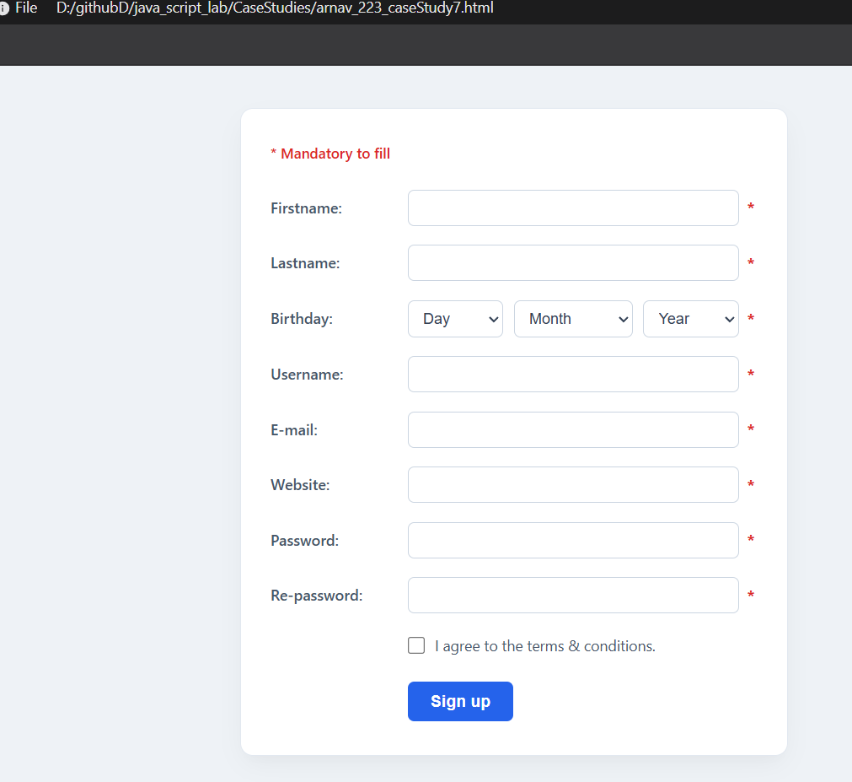
Experiment No. 8

Title
Access and validate form fields using events; design a gym admission form with live input checks.
Software / Tools Required
- Google Chrome — Web browser used for execution and testing.
- Visual Studio Code (VS Code) — Code editor used for writing HTML, CSS
<!DOCTYPE html>
<html lang="en">
<head>
<meta charset="UTF-8" />
<meta name="viewport" content="width=device-width, initial-scale=1.0" />
<title>Apex Fitness - Gym Admission Form</title>
<style>
:root {
--primary: #e63946;
--primary-hover: #c92a37;
--bg: #0f1016;
--card-bg: #1a1b23;
--text: #f1faee;
--text-muted: #8d99ae;
--success: #2ec4b6;
--error: #ff4d6d;
--border: #2b2c37;
--accent: #457b9d;
}

/* Light Theme Variables & Overrides */
body.light-theme {
--bg: #f4f6f9;
--card-bg: #ffffff;
--text: #1e293b;
--text-muted: #64748b;
--border: #cbd5e1;
--accent: #0284c7;
}

body.light-theme .form-container {
box-shadow: 0 15px 35px rgba(0, 0, 0, 0.08);
}

body.light-theme .form-header h1 {
color: #0f172a;
}

body.light-theme label {
color: #334155;
}

body.light-theme input,
body.light-theme select {
background: #f8fafc;
color: var(--text);
border-color: var(--border);
}

body.light-theme input:focus,
body.light-theme select:focus {
border-color: #64748b;
}

body.light-theme .bmi-card {
background: #f8fafc;
}

body.light-theme #bmiText {
color: #0f172a !important;
}

/* Theme Toggle Button */
.theme-toggle-btn {
position: fixed;
top: 20px;
right: 20px;
padding: 8px 16px;
font-size: 0.85rem;
font-weight: 600;
background: var(--card-bg);
color: var(--text);
border: 1.5px solid var(--border);
border-radius: 20px;
cursor: pointer;
transition: all 0.2s ease;
box-shadow: 0 4px 10px rgba(0, 0, 0, 0.3);
z-index: 1000;
}

body.light-theme .theme-toggle-btn {
box-shadow: 0 4px 10px rgba(0, 0, 0, 0.05);
}

* {
box-sizing: border-box;
margin: 0;
padding: 0;
font-family: 'Segoe UI', Roboto, Helvetica, Arial, sans-serif;
}

body {
background-color: var(--bg);
color: var(--text);
display: flex;
justify-content: center;
align-items: center;
min-height: 100vh;
padding: 2.5rem 1rem;
transition: background-color 0.3s ease, color 0.3s ease;
}

.form-container {
background: var(--card-bg);
border: 1px solid var(--border);
border-radius: 12px;
padding: 2.5rem;
width: 100%;
max-width: 650px;
box-shadow: 0 15px 35px rgba(0, 0, 0, 0.6);
}

.form-header {
margin-bottom: 2rem;
text-align: center;
}

.form-header h1 {
font-size: 1.85rem;
color: #fff;
margin-bottom: 0.4rem;
letter-spacing: 0.5px;
}

.form-header p {
color: var(--text-muted);
font-size: 0.95rem;
}

.section-title {
font-size: 0.95rem;
text-transform: uppercase;
letter-spacing: 1px;
color: var(--accent);
border-bottom: 1px solid var(--border);
padding-bottom: 0.4rem;
margin: 1.5rem 0 1rem 0;
}

.form-group {
margin-bottom: 1.2rem;
position: relative;
}

label {
display: block;
font-size: 0.85rem;
font-weight: 600;
margin-bottom: 0.4rem;
color: #edf2f4;
}

input, select {
width: 100%;
padding: 0.75rem 1rem;
border-radius: 6px;
background: #121318;
border: 1.5px solid var(--border);
color: var(--text);
font-size: 0.95rem;
outline: none;
transition: border-color 0.2s, box-shadow 0.2s;
}

input:focus, select:focus {
border-color: #5a6275;
}

.form-group.success input,
.form-group.success select {
border-color: var(--success);
}

.form-group.error input,
.form-group.error select {
border-color: var(--error);
}

.error-msg {
font-size: 0.75rem;
color: var(--error);
margin-top: 0.35rem;
display: none;
}

.form-group.error .error-msg {
display: block;
}

.row {
display: flex;
gap: 1rem;
}

.row .form-group {
flex: 1;
}

.bmi-card {
background: #121318;
border: 1.5px dashed var(--border);
border-radius: 8px;
padding: 1rem;
display: flex;
justify-content: space-between;
align-items: center;
margin-bottom: 1.2rem;
}

.bmi-card span {
font-size: 0.85rem;
color: var(--text-muted);
}

.bmi-badge {
font-size: 0.95rem;
font-weight: 700;
padding: 0.35rem 0.85rem;
border-radius: 4px;
background: var(--border);
color: var(--text-muted);
border: 1px solid transparent;
transition: all 0.2s ease-in-out;
}

.terms-group {
display: flex;
align-items: flex-start;
gap: 0.5rem;
margin-top: 1rem;
}

.terms-group input {
width: auto;
margin-top: 0.25rem;
cursor: pointer;
}

.terms-group label {
font-size: 0.82rem;
color: var(--text-muted);
font-weight: normal;
cursor: pointer;
}

button[type="submit"] {
width: 100%;
padding: 0.9rem;
background: var(--primary);
border: none;
border-radius: 6px;
color: white;
font-size: 1rem;
font-weight: 700;
text-transform: uppercase;
letter-spacing: 0.5px;
cursor: pointer;
margin-top: 1.5rem;
transition: background 0.2s;
}

button[type="submit"]:hover {
background: var(--primary-hover);
}

.banner {
display: none;
background-color: rgba(46, 196, 182, 0.15);
border: 1px solid var(--success);
color: var(--success);
padding: 0.75rem;
border-radius: 6px;
text-align: center;
font-size: 0.9rem;
margin-bottom: 1.25rem;
}
</style>
</head>
<body>

<!-- THEME TOGGLE BUTTON -->
<button class="theme-toggle-btn" id="themeToggle" onclick="toggleTheme()">☀️ Light Mode</button>

<div class="form-container">
<div class="form-header">
<h1>Apex Gym Admission</h1>
<p>Register your profile, calculate health stats, and pick your plan</p>
</div>

<div id="successBanner" class="banner">
Registration complete! Welcome to Apex Gym.
</div>

<form id="admissionForm" novalidate>
<div class="section-title">1. Personal Info</div>

<div class="form-group" id="nameGroup">
<label for="fullName">Full Name</label>
<input type="text" id="fullName" placeholder="e.g. Alex Morgan" />
<small class="error-msg">Please enter at least 3 letters.</small>
</div>

<div class="row">
<div class="form-group" id="emailGroup">
<label for="email">Email Address</label>
<input type="email" id="email" placeholder="alex@example.com" />
<small class="error-msg">Valid email required.</small>
</div>
<div class="form-group" id="phoneGroup">
<label for="phone">Phone Number</label>
<input type="tel" id="phone" placeholder="10-digit number" />
<small class="error-msg">Must be 10 digits.</small>
</div>
</div>

<div class="section-title">2. Physical Stats & BMI</div>

<div class="row">
<div class="form-group" id="heightGroup">
<label for="height">Height (cm)</label>
<input type="number" id="height" placeholder="e.g. 175" min="100" max="250" />
<small class="error-msg">Enter height (100–250 cm).</small>
</div>
<div class="form-group" id="weightGroup">
<label for="weight">Weight (kg)</label>
<input type="number" id="weight" placeholder="e.g. 70" min="30" max="250" />
<small class="error-msg">Enter weight (30–250 kg).</small>
</div>
</div>

<div class="bmi-card">
<div>
<span>Calculated Live BMI:</span>
<div id="bmiText" style="font-weight: 600; color: #fff; margin-top: 2px;">--</div>
</div>
<div id="bmiBadge" class="bmi-badge">Awaiting Data</div>
</div>

<div class="section-title">3. Membership & Preferences</div>

<div class="row">
<div class="form-group" id="goalGroup">
<label for="fitnessGoal">Primary Goal</label>
<select id="fitnessGoal">
<option value="">Select Primary Goal</option>
<option value="weight_loss">Weight Loss</option>
<option value="muscle_gain">Muscle Building</option>
<option value="endurance">Cardio & Endurance</option>
<option value="flexibility">Flexibility & Core</option>
</select>
<small class="error-msg">Please select a primary goal.</small>
</div>

<div class="form-group" id="slotGroup">
<label for="timeSlot">Preferred Time Slot</label>
<select id="timeSlot">
<option value="">Select Time Slot</option>
<option value="morning">Morning (06:00 AM – 10:00 AM)</option>
<option value="afternoon">Afternoon (12:00 PM – 04:00 PM)</option>
<option value="evening">Evening (05:00 PM – 10:00 PM)</option>
</select>
<small class="error-msg">Select a time slot.</small>
</div>
</div>

<div class="form-group" id="planGroup">
<label for="plan">Membership Plan</label>
<select id="plan">
<option value="">Select a membership plan</option>
<option value="monthly">Monthly Basic ($49 / mo)</option>
<option value="quarterly">Quarterly Pro ($129 / 3 mos)</option>
<option value="annual">Annual Elite ($449 / yr)</option>
</select>
<small class="error-msg">Please select a plan.</small>
</div>

<div class="section-title">4. Safety & Emergency Contact</div>

<div class="row">
<div class="form-group" id="emergencyNameGroup">
<label for="emergencyName">Contact Name</label>
<input type="text" id="emergencyName" placeholder="e.g. Jane Morgan" />
<small class="error-msg">Enter contact's name.</small>
</div>
<div class="form-group" id="emergencyPhoneGroup">
<label for="emergencyPhone">Emergency Phone</label>
<input type="tel" id="emergencyPhone" placeholder="10-digit number" />
<small class="error-msg">10-digit number required.</small>
</div>
</div>

<div class="terms-group">
<input type="checkbox" id="terms" />
<label for="terms">I accept the gym terms, liability release, and rules of conduct.</label>
</div>
<div class="form-group" id="termsGroup">
<small class="error-msg" style="margin-top: 0.2rem;">You must accept the terms.</small>
</div>

<button type="submit">Complete Registration</button>
</form>
</div>

<script>
// 1. Element Selectors
const form = document.getElementById('admissionForm');
const fullName = document.getElementById('fullName');
const email = document.getElementById('email');
const phone = document.getElementById('phone');
const height = document.getElementById('height');
const weight = document.getElementById('weight');
const fitnessGoal = document.getElementById('fitnessGoal');
const timeSlot = document.getElementById('timeSlot');
const plan = document.getElementById('plan');
const emergencyName = document.getElementById('emergencyName');
const emergencyPhone = document.getElementById('emergencyPhone');
const terms = document.getElementById('terms');

const bmiText = document.getElementById('bmiText');
const bmiBadge = document.getElementById('bmiBadge');
const successBanner = document.getElementById('successBanner');

// 2. Visual State Helper Functions
function setSuccess(element) {
const group = element.closest('.form-group');
if (group) {
group.classList.remove('error');
group.classList.add('success');
}
}

function setError(element) {
const group = element.closest('.form-group');
if (group) {
group.classList.remove('success');
group.classList.add('error');
}
}

// 3. BMI Live Calculator Logic
function calculateBMI() {
const hVal = parseFloat(height.value);
const wVal = parseFloat(weight.value);

if (!isNaN(hVal) && !isNaN(wVal) && hVal >= 100 && hVal <= 250 && wVal >= 30 && wVal <= 250) {
const heightInMeters = hVal / 100;
const bmi = (wVal / (heightInMeters * heightInMeters)).toFixed(1);

let category = '';
let badgeColor = '';

if (bmi < 18.5) {
category = 'Underweight';
badgeColor = '#e9c46a';
} else if (bmi <= 24.9) {
category = 'Normal Weight';
badgeColor = '#2ec4b6';
} else if (bmi <= 29.9) {
category = 'Overweight';
badgeColor = '#f4a261';
} else {
category = 'Obese';
badgeColor = '#ff4d6d';
}

bmiText.textContent = `${bmi} kg/m²`;
bmiBadge.textContent = category;
bmiBadge.style.color = badgeColor;
bmiBadge.style.borderColor = badgeColor;
bmiBadge.style.backgroundColor = 'rgba(255, 255, 255, 0.05)';
} else {
bmiText.textContent = '--';
bmiBadge.textContent = 'Awaiting Data';
bmiBadge.style.color = 'var(--text-muted)';
bmiBadge.style.borderColor = 'transparent';
bmiBadge.style.backgroundColor = 'var(--border)';
}
}

// 4. Field Validation Functions
function validateName() {
const ok = /^[A-Za-z\s]{3,}$/.test(fullName.value.trim());
ok ? setSuccess(fullName) : setError(fullName);
return ok;
}

function validateEmail() {
const ok = /^[^\s@]+@[^\s@]+\.[^\s@]+$/.test(email.value.trim());
ok ? setSuccess(email) : setError(email);
return ok;
}

function validatePhone() {
const ok = /^\d{10}$/.test(phone.value.trim());
ok ? setSuccess(phone) : setError(phone);
return ok;
}

function validateHeight() {
const val = parseFloat(height.value);
const ok = !isNaN(val) && val >= 100 && val <= 250;
ok ? setSuccess(height) : setError(height);
return ok;
}

function validateWeight() {
const val = parseFloat(weight.value);
const ok = !isNaN(val) && val >= 30 && val <= 250;
ok ? setSuccess(weight) : setError(weight);
return ok;
}

function validateGoal() {
const ok = fitnessGoal.value !== '';
ok ? setSuccess(fitnessGoal) : setError(fitnessGoal);
return ok;
}

function validateSlot() {
const ok = timeSlot.value !== '';
ok ? setSuccess(timeSlot) : setError(timeSlot);
return ok;
}

function validatePlan() {
const ok = plan.value !== '';
ok ? setSuccess(plan) : setError(plan);
return ok;
}

function validateEmergencyName() {
const ok = /^[A-Za-z\s]{2,}$/.test(emergencyName.value.trim());
ok ? setSuccess(emergencyName) : setError(emergencyName);
return ok;
}

function validateEmergencyPhone() {
const primaryPhoneVal = phone.value.trim();
const emergencyPhoneVal = emergencyPhone.value.trim();
const ok = /^\d{10}$/.test(emergencyPhoneVal) && emergencyPhoneVal !== primaryPhoneVal;
ok ? setSuccess(emergencyPhone) : setError(emergencyPhone);
return ok;
}

function validateTerms() {
const termsGroup = document.getElementById('termsGroup');
if (terms.checked) {
termsGroup.classList.remove('error');
return true;
} else {
termsGroup.classList.add('error');
return false;
}
}

// 5. Attach Live Event Listeners
fullName.addEventListener('input', validateName);
email.addEventListener('input', validateEmail);
phone.addEventListener('input', validatePhone);
emergencyName.addEventListener('input', validateEmergencyName);
emergencyPhone.addEventListener('input', validateEmergencyPhone);

// Height & Weight Listeners (Validation + BMI calculation)
['input', 'change', 'keyup'].forEach((event) => {
height.addEventListener(event, () => {
validateHeight();
calculateBMI();
});
weight.addEventListener(event, () => {
validateWeight();
calculateBMI();
});
});

fitnessGoal.addEventListener('change', validateGoal);
timeSlot.addEventListener('change', validateSlot);
plan.addEventListener('change', validatePlan);
terms.addEventListener('change', validateTerms);

// 6. Form Submission
form.addEventListener('submit', (e) => {
e.preventDefault();

const isValid = [
validateName(),
validateEmail(),
validatePhone(),
validateHeight(),
validateWeight(),
validateGoal(),
validateSlot(),
validatePlan(),
validateEmergencyName(),
validateEmergencyPhone(),
validateTerms()
].every(Boolean);

if (isValid) {
successBanner.style.display = 'block';
form.reset();
calculateBMI();

document.querySelectorAll('.form-group').forEach(group => {
group.classList.remove('success');
});

setTimeout(() => {
successBanner.style.display = 'none';
}, 5000);
}
});

// 7. Theme Switch Logic
function applyTheme(theme) {
const toggleBtn = document.getElementById('themeToggle');
if (theme === 'light') {
document.body.classList.add('light-theme');
toggleBtn.textContent = '🌙 Dark Mode';
} else {
document.body.classList.remove('light-theme');
toggleBtn.textContent = '☀️ Light Mode';
}
}

function toggleTheme() {
const isLight = document.body.classList.contains('light-theme');
const newTheme = isLight ? 'dark' : 'light';
localStorage.setItem('exp8_theme', newTheme);
applyTheme(newTheme);
}

// Restore saved theme on load
window.addEventListener('DOMContentLoaded', () => {
const savedTheme = localStorage.getItem('exp8_theme') || 'dark';
applyTheme(savedTheme);
});
</script>
</body>
</html>
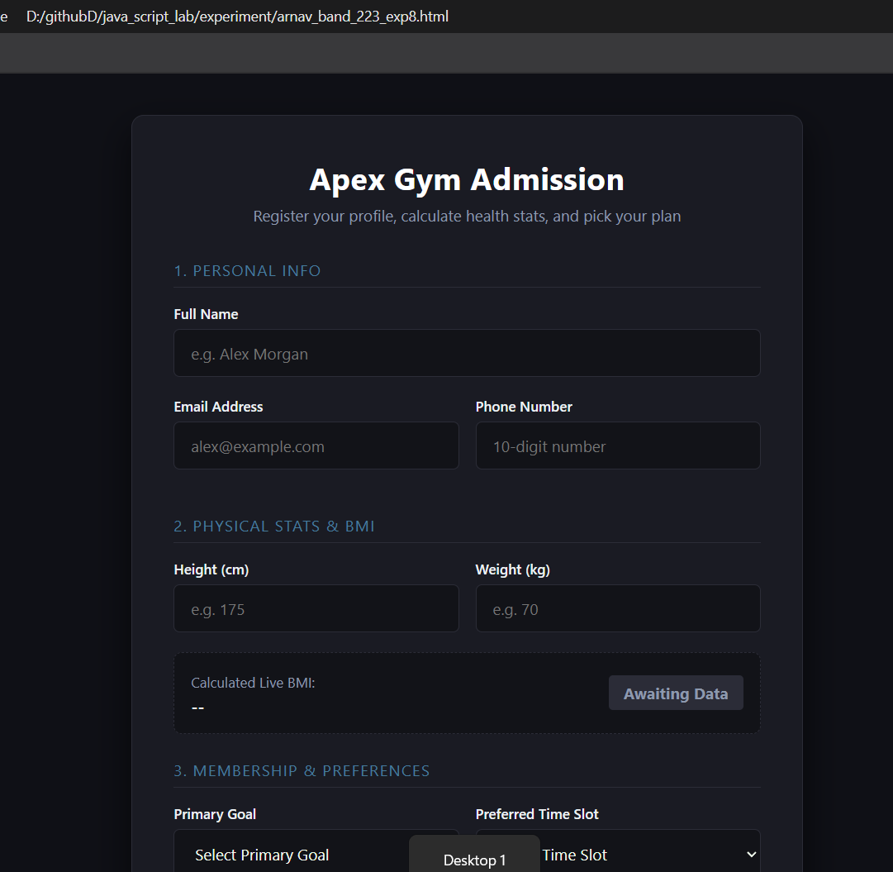

Case Study No.: 8
AIM:-
To Design a Multi-Section Job Application Portal Using Semantic HTML5 Form Elements, CSS Grid Layouts, and JavaScript Form Submission Handling.
Create a comprehensive, accessible career application form divided into logical sections (Personal Details, Role & Experience, Education & Skills, Work Preferences) utilizing modern HTML5 form input types, validation constraints, and JavaScript event processing.

<!DOCTYPE html>
<html lang="en" data-theme="dark">
<head>
<meta charset="UTF-8">
<meta name="viewport" content="width=device-width, initial-scale=1.0">
<title>Aetheria Careers | Job Application</title>
<style>
@import url('https://fonts.googleapis.com/css2?family=Inter:wght@400;500;600&family=Plus+Jakarta+Sans:wght@600;700;800&display=swap');

/* Dark Theme Variables (Default) */
[data-theme="dark"] {
--bg-base: #090d16;
--bg-surface: #0f172a;
--bg-elevated: #1e293b;
--bg-input: #1e293b;
--ink: #f1f5f9;
--ink-heading: #ffffff;
--muted: #94a3b8;
--line: #334155;
--line-focus: #38bdf8;
--radial-1: rgba(6, 182, 212, 0.08);
--radial-2: rgba(99, 102, 241, 0.12);
--topbar-border: rgba(51, 65, 85, 0.55);
--badge-bg: rgba(30, 41, 59, 0.85);
--card-shadow: 0 20px 50px rgba(0, 0, 0, 0.4);
--choice-hover-border: #64748b;
--footer-bg: #0c1322;
--summary-card-bg: #1e293b;
--success-bg: rgba(16, 185, 129, 0.15);
--success-border: rgba(16, 185, 129, 0.4);
--success-glow: 0 0 24px rgba(16, 185, 129, 0.25);
--input-border: #334155;
--showcase-bg: linear-gradient(145deg, #131d31 0%, #0c1424 100%);
--theme-toggle-bg: #1e293b;
--theme-toggle-border: #334155;
--theme-toggle-color: #f1f5f9;
}

/* Light Theme Variables */
[data-theme="light"] {
--bg-base: #f8fafc;
--bg-surface: #ffffff;
--bg-elevated: #f1f5f9;
--bg-input: #ffffff;
--ink: #1e293b;
--ink-heading: #0f172a;
--muted: #64748b;
--line: #e2e8f0;
--line-focus: #0284c7;
--radial-1: rgba(6, 182, 212, 0.12);
--radial-2: rgba(67, 56, 202, 0.08);
--topbar-border: rgba(226, 232, 240, 0.8);
--badge-bg: #e2e8f0;
--card-shadow: 0 20px 45px rgba(30, 41, 59, 0.07);
--choice-hover-border: #94a3b8;
--footer-bg: #f8fafc;
--summary-card-bg: #f8fafc;
--success-bg: #dcfce7;
--success-border: #bbf7d0;
--success-glow: 0 8px 24px rgba(5, 150, 105, 0.2);
--input-border: #cbd5e1;
--showcase-bg: linear-gradient(145deg, #1e1b4b 0%, #0f172a 100%);
--theme-toggle-bg: #ffffff;
--theme-toggle-border: #cbd5e1;
--theme-toggle-color: #0f172a;
}

/* Shared Global Tokens */
:root {
--brand-primary: #6366f1;
--brand-cyan: #06b6d4;
--tag-rose: #f43f5e;
--tag-rose-bg: rgba(244, 63, 94, 0.14);
--notice-amber: #b45309;
--notice-bg: rgba(245, 158, 11, 0.1);
--notice-border: #f59e0b;
--cta-emerald: #10b981;
--cta-emerald-dark: #059669;
}

* { box-sizing: border-box; transition: background-color 0.2s ease, border-color 0.2s ease, color 0.2s ease; }

body {
margin: 0;
color: var(--ink);
background: var(--bg-base);
font-family: 'Inter', -apple-system, BlinkMacSystemFont, sans-serif;
-webkit-font-smoothing: antialiased;
}

.page {
min-height: 100vh;
background:
radial-gradient(circle at 12% 10%, var(--radial-1) 0, transparent 35%),
radial-gradient(circle at 88% 8%, var(--radial-2) 0, transparent 40%),
var(--bg-base);
}

.topbar {
display: flex;
align-items: center;
justify-content: space-between;
max-width: 1180px;
margin: auto;
padding: 24px 32px;
border-bottom: 1px solid var(--topbar-border);
}

.brand {
display: flex;
align-items: center;
gap: 12px;
font-family: 'Plus Jakarta Sans', sans-serif;
font-size: 21px;
font-weight: 800;
letter-spacing: -0.02em;
color: var(--ink-heading);
}

.brand-mark {
display: grid;
width: 38px;
height: 38px;
place-items: center;
background: linear-gradient(135deg, var(--brand-primary), var(--brand-cyan));
border-radius: 10px;
box-shadow: 0 4px 16px rgba(99, 102, 241, 0.35);
}

.topbar-controls {
display: flex;
align-items: center;
gap: 12px;
}

.topbar small {
color: var(--muted);
font-size: 13px;
font-weight: 600;
background: var(--badge-bg);
padding: 6px 14px;
border: 1px solid var(--line);
border-radius: 20px;
}

.theme-toggle-btn {
display: flex;
align-items: center;
gap: 8px;
padding: 6px 14px;
background: var(--theme-toggle-bg);
color: var(--theme-toggle-color);
border: 1px solid var(--theme-toggle-border);
border-radius: 20px;
font-size: 13px;
font-weight: 600;
cursor: pointer;
outline: none;
}

.theme-toggle-btn:hover {
border-color: var(--line-focus);
}

main {
display: grid;
grid-template-columns: 295px minmax(0, 1fr);
gap: 54px;
max-width: 1120px;
margin: 28px auto 70px;
padding: 0 32px;
}

.intro { padding-top: 18px; }

.eyebrow {
display: inline-block;
margin: 0 0 14px;
color: var(--tag-rose);
background: var(--tag-rose-bg);
border: 1px solid rgba(244, 63, 94, 0.25);
padding: 4px 10px;
border-radius: 6px;
font-size: 11px;
font-weight: 800;
letter-spacing: .12em;
text-transform: uppercase;
}

h1, h2, legend { font-family: 'Plus Jakarta Sans', sans-serif; }
h1 { margin: 0; font-size: clamp(34px, 4.5vw, 48px); line-height: 1.08; letter-spacing: -.03em; color: var(--ink-heading); }
.intro > p:not(.eyebrow) { margin: 20px 0 28px; color: var(--muted); line-height: 1.6; font-size: 15px; }

.brand-showcase {
margin-top: 28px;
padding: 30px 24px;
background: var(--showcase-bg);
border: 1px solid rgba(6, 182, 212, 0.3);
border-radius: 18px;
box-shadow: 0 18px 40px rgba(0, 0, 0, 0.25);
display: flex;
flex-direction: column;
align-items: center;
text-align: center;
position: relative;
overflow: hidden;
}

.brand-showcase::before {
content: '';
position: absolute;
top: -35px;
right: -35px;
width: 120px;
height: 120px;
background: radial-gradient(circle, rgba(244, 63, 94, 0.28), transparent 70%);
border-radius: 50%;
}

.brand-showcase svg {
width: 72px;
height: 72px;
filter: drop-shadow(0 8px 18px rgba(6, 182, 212, 0.4));
}

.showcase-title {
margin-top: 14px;
font-family: 'Plus Jakarta Sans', sans-serif;
font-size: 20px;
font-weight: 800;
letter-spacing: 0.08em;
color: #ffffff;
text-transform: uppercase;
}

.showcase-tag {
margin-top: 5px;
font-size: 12px;
font-weight: 600;
color: #38bdf8;
letter-spacing: 0.04em;
}

.note {
padding: 16px 18px;
color: var(--notice-amber);
background: var(--notice-bg);
border-left: 4px solid var(--notice-border);
border-radius: 0 10px 10px 0;
font-size: 13px;
line-height: 1.55;
border-top: 1px solid rgba(245, 158, 11, 0.2);
border-right: 1px solid rgba(245, 158, 11, 0.2);
border-bottom: 1px solid rgba(245, 158, 11, 0.2);
}

.form-shell {
position: relative;
overflow: hidden;
background: var(--bg-surface);
border: 1px solid var(--line);
border-radius: 20px;
box-shadow: var(--card-shadow);
}

form { padding: 36px; }
fieldset { margin: 0; padding: 0 0 28px; border: 0; border-bottom: 1px solid var(--line); }
fieldset + fieldset { padding-top: 28px; }
fieldset:last-of-type { border-bottom: 0; padding-bottom: 8px; }

legend {
display: flex;
align-items: center;
gap: 10px;
margin-bottom: 20px;
font-size: 19px;
font-weight: 700;
color: var(--ink-heading);
}

.section-number {
display: inline-grid;
place-items: center;
width: 28px;
height: 28px;
background: var(--tag-rose-bg);
border: 1px solid rgba(244, 63, 94, 0.3);
color: var(--tag-rose);
font-size: 12px;
font-weight: 800;
border-radius: 8px;
}

.grid { display: grid; grid-template-columns: 1fr 1fr; gap: 18px 16px; }
.full { grid-column: 1 / -1; }
.field { display: flex; flex-direction: column; gap: 7px; }
label { color: var(--ink); font-size: 13px; font-weight: 600; }
.optional { color: var(--muted); font-weight: 400; }

input, select, textarea {
width: 100%;
padding: 12px 14px;
color: var(--ink-heading);
background: var(--bg-input);
border: 1.5px solid var(--input-border);
border-radius: 10px;
font: inherit;
font-size: 14px;
outline: none;
}
input::placeholder, textarea::placeholder { color: var(--muted); }
select option { background: var(--bg-surface); color: var(--ink-heading); }

textarea { min-height: 96px; resize: vertical; }
input:focus, select:focus, textarea:focus {
border-color: var(--line-focus);
box-shadow: 0 0 0 4px rgba(56, 189, 248, 0.15);
}

.choice-row { display: flex; flex-wrap: wrap; gap: 10px; }
.choice {
display: flex;
align-items: center;
gap: 8px;
padding: 10px 16px;
color: var(--muted);
background: var(--bg-elevated);
border: 1.5px solid var(--line);
border-radius: 10px;
font-size: 13px;
font-weight: 600;
cursor: pointer;
}
.choice:hover { border-color: var(--choice-hover-border); color: var(--ink-heading); }
.choice:has(input:checked) {
color: var(--line-focus);
background: rgba(56, 189, 248, 0.12);
border-color: var(--line-focus);
}
.choice input { width: auto; accent-color: var(--line-focus); }

.consent {
display: flex;
align-items: flex-start;
gap: 10px;
margin-top: 20px;
color: var(--muted);
font-size: 13px;
line-height: 1.5;
}
.consent input { width: auto; margin-top: 3px; accent-color: var(--cta-emerald); }

.actions {
display: flex;
align-items: center;
justify-content: space-between;
gap: 16px;
margin: 30px -36px -36px;
padding: 22px 36px;
background: var(--footer-bg);
border-top: 1px solid var(--line);
}
.actions p { margin: 0; color: var(--muted); font-size: 12px; font-weight: 500; }

button {
padding: 13px 26px;
color: #ffffff;
background: var(--cta-emerald);
border: 0;
border-radius: 10px;
font: inherit;
font-size: 14px;
font-weight: 700;
cursor: pointer;
box-shadow: 0 4px 18px rgba(16, 185, 129, 0.35);
}
button:hover { background: var(--cta-emerald-dark); }
button:active { transform: translateY(1px); }

/* Thank You View */
.thank-you-view {
display: none;
padding: 72px 40px;
text-align: center;
animation: fadeIn 0.4s ease-out forwards;
}

.success-icon {
display: inline-grid;
place-items: center;
width: 76px;
height: 76px;
margin-bottom: 24px;
background: var(--success-bg);
border: 2px solid var(--success-border);
border-radius: 50%;
box-shadow: var(--success-glow);
}

.thank-you-view h2 {
margin: 0 0 12px;
font-size: 30px;
font-weight: 800;
color: var(--ink-heading);
letter-spacing: -0.02em;
}

.thank-you-view p {
max-width: 480px;
margin: 0 auto 28px;
color: var(--muted);
font-size: 15px;
line-height: 1.6;
}

.app-summary-card {
max-width: 460px;
margin: 0 auto 32px;
padding: 20px 24px;
background: var(--summary-card-bg);
border: 1px dashed var(--line);
border-radius: 12px;
text-align: left;
font-size: 13px;
}

.app-summary-card strong { color: var(--ink-heading); }
.app-summary-card span { color: var(--line-focus); display: block; margin-top: 4px; font-weight: 500; }

.btn-return {
background: var(--brand-primary);
box-shadow: 0 4px 18px rgba(99, 102, 241, 0.35);
}
.btn-return:hover {
background: #4f46e5;
}

@keyframes fadeIn {
from { opacity: 0; transform: scale(0.98); }
to { opacity: 1; transform: scale(1); }
}

@media (max-width: 800px) {
main { grid-template-columns: 1fr; gap: 28px; margin-top: 10px; }
.intro { padding-top: 0; }
.intro > p:not(.eyebrow) { margin-bottom: 20px; }
.brand-showcase { max-width: 360px; margin-top: 24px; }
}
@media (max-width: 560px) {
.topbar { padding: 20px; }
.topbar small { display: none; }
main { padding: 0 16px; margin-bottom: 35px; }
form { padding: 24px 20px; }
.grid { grid-template-columns: 1fr; }
.full { grid-column: auto; }
.actions { align-items: stretch; flex-direction: column; margin: 26px -20px -24px; padding: 18px 20px; }
button { width: 100%; }
.thank-you-view { padding: 48px 20px; }
}
</style>
</head>
<body>
<div class="page">
<header class="topbar">
<div class="brand">
<div class="brand-mark">
<svg viewBox="0 0 24 24" width="22" height="22" fill="none" stroke="#ffffff" stroke-width="2.2" stroke-linecap="round" stroke-linejoin="round">
<polygon points="12 2 2 22 22 22"></polygon>
<line x1="6" y1="14" x2="18" y2="14"></line>
<circle cx="12" cy="9" r="1.5" fill="#38bdf8"></circle>
</svg>
</div>
<span>Aetheria</span>
</div>
<div class="topbar-controls">
<small>Talent Portal</small>
<button type="button" class="theme-toggle-btn" id="themeToggle" aria-label="Toggle theme">
<span id="themeIcon">☀️</span>
<span id="themeText">Light</span>
</button>
</div>
</header>

<main>
<aside class="intro">
<span class="eyebrow">We're hiring</span>
<h1>Join our global team.</h1>
<p>We build resilient infrastructure for ambitious engineering teams. Tell us about yourself and the work you love doing.</p>

<div class="note">
<strong>Hiring Notice:</strong> Applications are reviewed on a rolling basis. Typical response time is 3–5 business days.
</div>

<div class="brand-showcase">
<svg viewBox="0 0 100 100" fill="none" xmlns="http://www.w3.org/2000/svg">
<defs>
<linearGradient id="aethGrad" x1="0%" y1="0%" x2="100%" y2="100%">
<stop offset="0%" stop-color="#38bdf8" />
<stop offset="50%" stop-color="#06b6d4" />
<stop offset="100%" stop-color="#6366f1" />
</linearGradient>
</defs>
<path d="M50 14 L18 84 L34 84 L50 48 L66 84 L82 84 Z" fill="url(#aethGrad)" />
<path d="M38 60 L62 60 L58 50 L42 50 Z" fill="#ffffff" opacity="0.95" />
<circle cx="50" cy="34" r="3.5" fill="#f43f5e" />
</svg>
<div class="showcase-title">Aetheria</div>
<div class="showcase-tag">Systems & Distributed Engineering</div>
</div>
</aside>

<section class="form-shell">
<form id="careerForm" action="#" method="post">
<fieldset>
<legend><span class="section-number">01</span> Personal Details</legend>
<div class="grid">
<div class="field">
<label for="first-name">First name</label>
<input id="first-name" name="first-name" type="text" placeholder="Alex" required>
</div>
<div class="field">
<label for="last-name">Last name</label>
<input id="last-name" name="last-name" type="text" placeholder="Rivera" required>
</div>
<div class="field full">
<label for="email">Email address</label>
<input id="email" name="email" type="email" placeholder="alex@domain.com" required>
</div>
</div>
</fieldset>

<fieldset>
<legend><span class="section-number">02</span> Role & Experience</legend>
<div class="grid">
<div class="field full">
<label for="role">Target Role</label>
<select id="role" name="role" required>
<option value="" disabled selected>Select a discipline</option>
<option value="Senior Frontend Engineer">Senior Frontend Engineer</option>
<option value="Distributed Systems Engineer">Distributed Systems Engineer</option>
<option value="Product Designer">Product Designer</option>
</select>
</div>
<div class="field full">
<label>Work Arrangement</label>
<div class="choice-row">
<label class="choice">
<input type="radio" name="location" value="remote" checked> Remote
</label>
<label class="choice">
<input type="radio" name="location" value="hybrid"> Hybrid
</label>
<label class="choice">
<input type="radio" name="location" value="onsite"> On-site
</label>
</div>
</div>
<div class="field full">
<label for="notes">Cover letter / Notes <span class="optional">(Optional)</span></label>
<textarea id="notes" name="notes" placeholder="Tell us what you're looking for next..."></textarea>
</div>
</div>
</fieldset>

<label class="consent">
<input type="checkbox" required>
<span>I consent to Aetheria processing my application data for recruitment purposes.</span>
</label>

<div class="actions">
<p>All inputs are secured via 256-bit encryption.</p>
<button type="submit">Submit Application</button>
</div>
</form>

<div id="thankYouView" class="thank-you-view">
<div class="success-icon">
<svg viewBox="0 0 24 24" width="38" height="38" fill="none" stroke="#10b981" stroke-width="2.5" stroke-linecap="round" stroke-linejoin="round">
<polyline points="20 6 9 17 4 12"></polyline>
</svg>
</div>
<h2>Application Received!</h2>
<p>Thank you for your interest in joining Aetheria. Our engineering and recruiting teams are reviewing your qualifications.</p>

<div class="app-summary-card">
<strong>Applicant:</strong> <span id="summaryName"></span>
<strong style="margin-top: 10px; display: block;">Target Role:</strong> <span id="summaryRole"></span>
<strong style="margin-top: 10px; display: block;">Confirmation Sent To:</strong> <span id="summaryEmail"></span>
</div>

<button type="button" class="btn-return" id="resetBtn">Submit Another Application</button>
</div>
</section>
</main>
</div>

<script>
// Theme Toggle Logic
const htmlEl = document.documentElement;
const themeToggle = document.getElementById('themeToggle');
const themeIcon = document.getElementById('themeIcon');
const themeText = document.getElementById('themeText');

function updateTheme(theme) {
htmlEl.setAttribute('data-theme', theme);
localStorage.setItem('theme', theme);
if (theme === 'dark') {
themeIcon.textContent = '☀️';
themeText.textContent = 'Light';
} else {
themeIcon.textContent = '🌙';
themeText.textContent = 'Dark';
}
}

const savedTheme = localStorage.getItem('theme') || 'dark';
updateTheme(savedTheme);

themeToggle.addEventListener('click', () => {
const currentTheme = htmlEl.getAttribute('data-theme');
updateTheme(currentTheme === 'dark' ? 'light' : 'dark');
});

// Form Submit & Switch View
const form = document.getElementById('careerForm');
const thankYouView = document.getElementById('thankYouView');
const resetBtn = document.getElementById('resetBtn');

form.addEventListener('submit', (e) => {
e.preventDefault();

const firstName = document.getElementById('first-name').value;
const lastName = document.getElementById('last-name').value;
const email = document.getElementById('email').value;
const roleSelect = document.getElementById('role');
const roleText = roleSelect.options[roleSelect.selectedIndex].text;

document.getElementById('summaryName').textContent = `${firstName} ${lastName}`;
document.getElementById('summaryRole').textContent = roleText;
document.getElementById('summaryEmail').textContent = email;

form.style.display = 'none';
thankYouView.style.display = 'block';
window.scrollTo({ top: thankYouView.offsetTop - 50, behavior: 'smooth' });
});

resetBtn.addEventListener('click', () => {
form.reset();
thankYouView.style.display = 'none';
form.style.display = 'block';
});
</script>
</body>
</html>
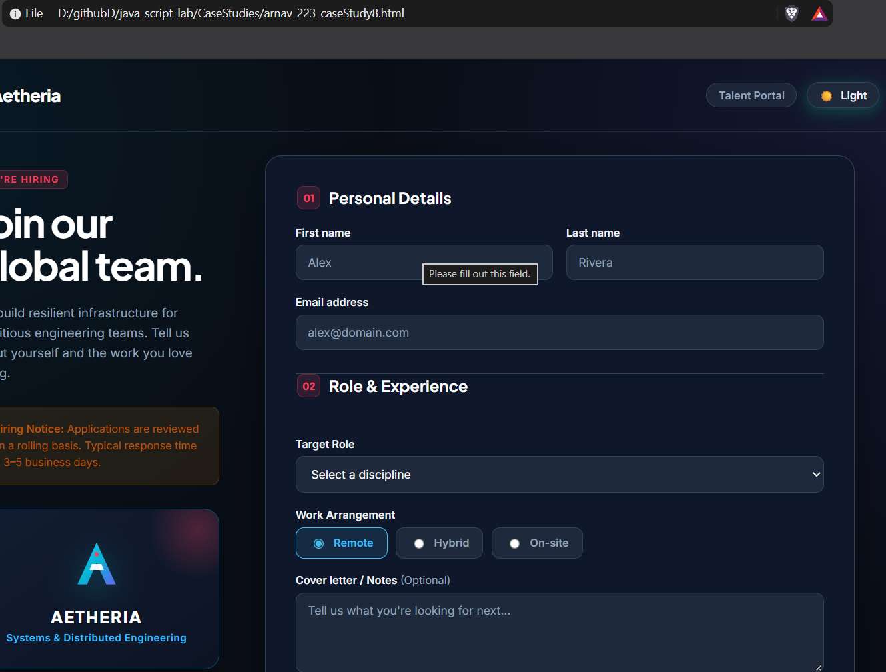

Experiment No. 9

Title
Implement localStorage and sessionStorage to save user preferences like theme settings.
Software / Tools Required
- Google Chrome — Web browser used for execution and testing.
- Visual Studio Code (VS Code) — Code editor used for writing HTML, CSS
<!DOCTYPE html>
<html lang="en">
<head>
<meta charset="UTF-8" />
<meta name="viewport" content="width=device-width, initial-scale=1.0" />
<title>User Preferences & Storage</title>
<style>
/* CSS Variables (Light Theme) */
:root {
--bg-gradient: radial-gradient(circle at 10% 20%, #f1f5f9 0%, #e2e8f0 90%);
--card-bg: rgba(255, 255, 255, 0.92);
--card-border: rgba(226, 232, 240, 0.8);
--card-shadow: 0 20px 40px -15px rgba(0, 0, 0, 0.07), 0 0 1px 1px rgba(0, 0, 0, 0.02);
--text-main: #1e293b;
--text-sub: #64748b;
--heading-color: #0f172a;
--input-bg: #f8fafc;
--input-border: #cbd5e1;
--input-focus-border: #3b82f6;
--accent-color: #2563eb;
--btn-secondary: #475569;
--btn-secondary-hover: #334155;
--btn-danger: #ef4444;
--btn-danger-hover: #dc2626;
--divider: #e2e8f0;
--session-bg: #f8fafc;
--font-size: 16px;
}

/* CSS Variables (Dark Theme) */
body.dark {
--bg-gradient: radial-gradient(circle at 10% 20%, #0b1120 0%, #030712 90%);
--card-bg: rgba(30, 41, 59, 0.85);
--card-border: rgba(51, 65, 85, 0.7);
--card-shadow: 0 20px 40px -15px rgba(0, 0, 0, 0.6), 0 0 1px 1px rgba(255, 255, 255, 0.05);
--text-main: #f1f5f9;
--text-sub: #94a3b8;
--heading-color: #f8fafc;
--input-bg: #0f172a;
--input-border: #334155;
--input-focus-border: #60a5fa;
--btn-secondary: #334155;
--btn-secondary-hover: #475569;
--divider: #334155;
--session-bg: rgba(15, 23, 42, 0.6);
}

* {
box-sizing: border-box;
margin: 0;
padding: 0;
font-family: -apple-system, BlinkMacSystemFont, "Segoe UI", Roboto, "Inter", "Helvetica Neue", sans-serif;
-webkit-font-smoothing: antialiased;
-moz-osx-font-smoothing: grayscale;
}

body {
background: var(--bg-gradient);
color: var(--text-main);
font-size: var(--font-size);
min-height: 100vh;
display: flex;
justify-content: center;
align-items: center;
padding: 32px 16px;
transition: background 0.4s ease, color 0.3s ease;
}

/* Container Card with Glassmorphism */
.card {
background-color: var(--card-bg);
backdrop-filter: blur(12px);
-webkit-backdrop-filter: blur(12px);
border: 1px solid var(--card-border);
border-radius: 16px;
box-shadow: var(--card-shadow);
width: 100%;
max-width: 500px;
padding: 36px 32px;
transition: background-color 0.3s ease, border-color 0.3s ease, transform 0.2s ease;
}

.card-header {
margin-bottom: 26px;
}

h2 {
color: var(--heading-color);
font-size: 1.5rem;
font-weight: 700;
letter-spacing: -0.025em;
margin-bottom: 6px;
display: flex;
align-items: center;
gap: 10px;
}

.accent-pill {
display: inline-block;
width: 10px;
height: 10px;
border-radius: 50%;
background-color: var(--accent-color);
box-shadow: 0 0 10px var(--accent-color);
transition: background-color 0.3s ease, box-shadow 0.3s ease;
}

.description {
font-size: 0.85rem;
color: var(--text-sub);
line-height: 1.45;
}

/* Form Layout */
.form-group {
display: flex;
justify-content: space-between;
align-items: center;
margin-bottom: 18px;
}

.form-group label {
font-size: 0.92rem;
font-weight: 600;
color: var(--text-main);
}

/* Inputs & Selects */
select,
input[type="text"] {
background-color: var(--input-bg);
border: 1.5px solid var(--input-border);
color: var(--text-main);
padding: 9px 14px;
border-radius: 8px;
font-size: 0.9rem;
outline: none;
transition: border-color 0.2s ease, box-shadow 0.2s ease, background-color 0.2s ease;
}

select {
min-width: 140px;
cursor: pointer;
}

select:focus,
input[type="text"]:focus {
border-color: var(--accent-color);
box-shadow: 0 0 0 3px rgba(37, 99, 235, 0.18);
}

/* Custom Color Input */
.color-picker-wrapper {
display: flex;
align-items: center;
gap: 10px;
}

input[type="color"] {
-webkit-appearance: none;
-moz-appearance: none;
appearance: none;
border: none;
width: 36px;
height: 36px;
border-radius: 50%;
cursor: pointer;
background: transparent;
padding: 0;
}

input[type="color"]::-webkit-color-swatch-wrapper {
padding: 0;
}

input[type="color"]::-webkit-color-swatch {
border: 2px solid var(--input-border);
border-radius: 50%;
box-shadow: 0 2px 6px rgba(0,0,0,0.12);
}

input[type="color"]::-moz-color-swatch {
border: 2px solid var(--input-border);
border-radius: 50%;
box-shadow: 0 2px 6px rgba(0,0,0,0.12);
}

/* Action Buttons */
.button-group {
display: flex;
gap: 10px;
margin: 24px 0 28px 0;
}

button {
flex: 1;
padding: 10px 14px;
border: none;
border-radius: 8px;
font-size: 0.88rem;
font-weight: 600;
cursor: pointer;
display: flex;
justify-content: center;
align-items: center;
gap: 6px;
transition: all 0.2s cubic-bezier(0.4, 0, 0.2, 1);
}

button:active {
transform: scale(0.97);
}

.btn-primary {
background-color: var(--accent-color);
color: #ffffff;
box-shadow: 0 4px 12px rgba(37, 99, 235, 0.25);
}

.btn-primary:hover {
filter: brightness(1.1);
}

.btn-secondary {
background-color: var(--btn-secondary);
color: #ffffff;
}

.btn-secondary:hover {
background-color: var(--btn-secondary-hover);
}

.btn-danger {
background-color: var(--btn-danger);
color: #ffffff;
}

.btn-danger:hover {
background-color: var(--btn-danger-hover);
}

/* Session Storage Box */
.session-section {
border-top: 1px solid var(--divider);
padding-top: 24px;
}

.session-section h3 {
font-size: 1.05rem;
font-weight: 600;
color: var(--heading-color);
margin-bottom: 4px;
}

.session-box {
background-color: var(--session-bg);
border: 1px dashed var(--input-border);
border-radius: 10px;
padding: 16px;
margin-top: 14px;
}

.session-box input[type="text"] {
width: 100%;
margin-bottom: 12px;
}

.session-box .btn-session {
background-color: var(--accent-color);
color: #ffffff;
padding: 9px 18px;
border-radius: 8px;
}

.session-display {
margin-top: 14px;
padding-top: 12px;
border-top: 1px solid var(--divider);
font-size: 0.88rem;
color: var(--text-main);
display: flex;
gap: 6px;
align-items: baseline;
word-break: break-word;
}

.session-display span {
color: var(--text-sub);
}

/* Notification Banner */
.toast-banner {
position: fixed;
bottom: 24px;
right: 24px;
background: var(--text-main);
color: var(--card-bg);
padding: 10px 18px;
border-radius: 8px;
font-size: 0.85rem;
font-weight: 500;
box-shadow: 0 10px 20px rgba(0,0,0,0.15);
opacity: 0;
transform: translateY(10px);
transition: opacity 0.3s ease, transform 0.3s ease;
pointer-events: none;
z-index: 99;
}

.toast-banner.show {
opacity: 1;
transform: translateY(0);
}
</style>
</head>
<body>

<div class="card">
<!-- Header -->
<div class="card-header">
<h2><span class="accent-pill"></span> User Preferences</h2>
<p class="description">Your theme, font size, and accent color are saved using <code>localStorage</code>.</p>
</div>

<!-- Controls -->
<div class="form-group">
<label for="themeSelect">Theme</label>
<select id="themeSelect">
<option value="light">Light</option>
<option value="dark">Dark</option>
</select>
</div>

<div class="form-group">
<label for="fontSizeSelect">Font Size</label>
<select id="fontSizeSelect">
<option value="small">Small</option>
<option value="medium" selected>Medium</option>
<option value="large">Large</option>
</select>
</div>

<div class="form-group">
<label for="accentColorInput">Accent Color</label>
<div class="color-picker-wrapper">
<input type="color" id="accentColorInput" value="#2563eb" title="Choose accent color" />
</div>
</div>

<div class="button-group">
<button class="btn-primary" id="savePrefBtn">Save</button>
<button class="btn-secondary" id="resetPrefBtn">Reset</button>
<button class="btn-danger" id="clearStorageBtn">Clear</button>
</div>

<!-- Session Storage Section -->
<div class="session-section">
<h3>Session Storage Message</h3>
<p class="description">This message is saved only for the current browser session.</p>

<div class="session-box">
<input type="text" id="sessionInput" placeholder="Enter session message..." />
<button class="btn-session" id="saveSessionBtn">Save Session Message</button>
<div class="session-display">
<span>Saved session message:</span>
<strong id="sessionDisplay"></strong>
</div>
</div>
</div>
</div>

<div id="toast" class="toast-banner">Settings updated</div>

<script>
const themeSelect = document.getElementById('themeSelect');
const fontSizeSelect = document.getElementById('fontSizeSelect');
const accentColorInput = document.getElementById('accentColorInput');

const savePrefBtn = document.getElementById('savePrefBtn');
const resetPrefBtn = document.getElementById('resetPrefBtn');
const clearStorageBtn = document.getElementById('clearStorageBtn');

const sessionInput = document.getElementById('sessionInput');
const saveSessionBtn = document.getElementById('saveSessionBtn');
const sessionDisplay = document.getElementById('sessionDisplay');
const toast = document.getElementById('toast');

const fontSizeMap = {
small: '14px',
medium: '16px',
large: '18px'
};

function showToast(text) {
toast.textContent = text;
toast.classList.add('show');
setTimeout(() => toast.classList.remove('show'), 2200);
}

function applyStyles(theme, fontSize, accentColor) {
if (theme === 'dark') {
document.body.classList.add('dark');
} else {
document.body.classList.remove('dark');
}
document.documentElement.style.setProperty('--font-size', fontSizeMap[fontSize] || '16px');
document.documentElement.style.setProperty('--accent-color', accentColor);
}

function savePreferences() {
const selectedTheme = themeSelect.value;
const selectedFontSize = fontSizeSelect.value;
const selectedAccentColor = accentColorInput.value;

localStorage.setItem('pref_theme', selectedTheme);
localStorage.setItem('pref_fontSize', selectedFontSize);
localStorage.setItem('pref_accentColor', selectedAccentColor);

applyStyles(selectedTheme, selectedFontSize, selectedAccentColor);
showToast('Preferences saved successfully');
}

function loadPreferences() {
const savedTheme = localStorage.getItem('pref_theme') || 'light';
const savedFontSize = localStorage.getItem('pref_fontSize') || 'medium';
const savedAccentColor = localStorage.getItem('pref_accentColor') || '#2563eb';

themeSelect.value = savedTheme;
fontSizeSelect.value = savedFontSize;
accentColorInput.value = savedAccentColor;

applyStyles(savedTheme, savedFontSize, savedAccentColor);
}

function resetPreferences() {
localStorage.removeItem('pref_theme');
localStorage.removeItem('pref_fontSize');
localStorage.removeItem('pref_accentColor');

themeSelect.value = 'light';
fontSizeSelect.value = 'medium';
accentColorInput.value = '#2563eb';

applyStyles('light', 'medium', '#2563eb');
showToast('Preferences restored to default');
}

function clearStorage() {
localStorage.clear();
resetPreferences();
showToast('Storage cleared');
}

function saveSessionMessage() {
const message = sessionInput.value.trim();
sessionStorage.setItem('session_message', message);
displaySessionMessage();
showToast('Session message saved');
}

function displaySessionMessage() {
const savedMessage = sessionStorage.getItem('session_message') || '';
sessionDisplay.textContent = savedMessage;
}

// Live preview when switching dropdowns or picking colors
themeSelect.addEventListener('change', () => {
applyStyles(themeSelect.value, fontSizeSelect.value, accentColorInput.value);
});

fontSizeSelect.addEventListener('change', () => {
applyStyles(themeSelect.value, fontSizeSelect.value, accentColorInput.value);
});

accentColorInput.addEventListener('input', () => {
applyStyles(themeSelect.value, fontSizeSelect.value, accentColorInput.value);
});

// Event listeners
savePrefBtn.addEventListener('click', savePreferences);
resetPrefBtn.addEventListener('click', resetPreferences);
clearStorageBtn.addEventListener('click', clearStorage);
saveSessionBtn.addEventListener('click', saveSessionMessage);

window.addEventListener('DOMContentLoaded', () => {
loadPreferences();
displaySessionMessage();
});
</script>
</body>
</html>
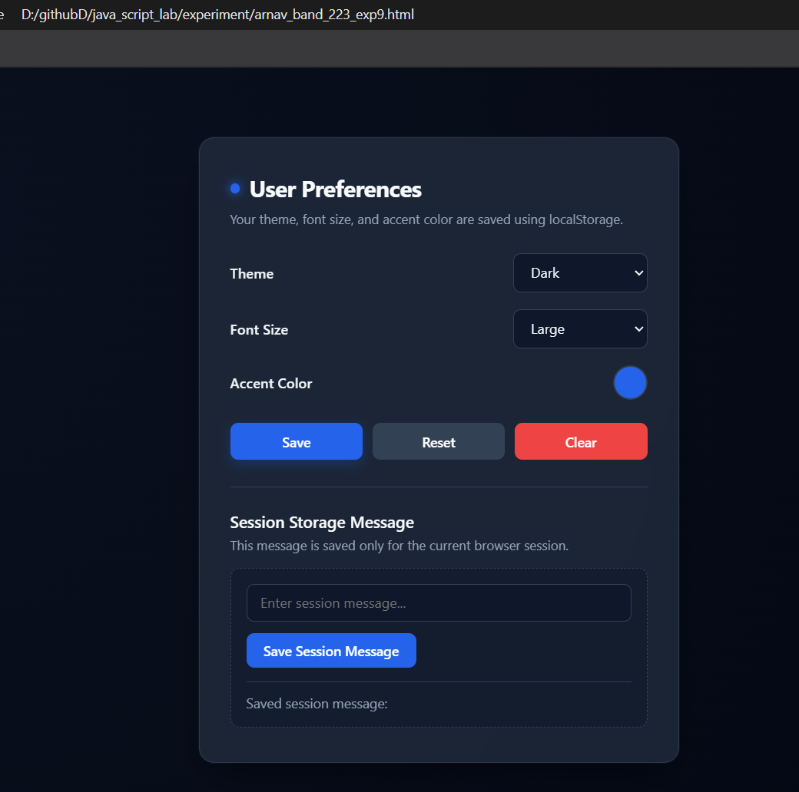

Case Study No.: 9
AIM:
To Design and Implement an Integrated Multi-Tab Student Task Management & Practical Lab Suite (Practicals 1–8) with Persistent Client-Side Theme Management using Web Storage (localStorage).
Develop a single-page, modular web portal that brings together all previous lab exercises (Practicals 1 through 8) under an interactive tabbed navigation system, featuring collapsible menus, responsive layouts, and persistent Light/Dark mode switching backed by HTML5 Web Storage (localStorage)

<!DOCTYPE html>
<html lang="en">
<head>
<meta charset="UTF-8" />
<meta name="viewport" content="width=device-width, initial-scale=1.0" />
<title>User Preferences & Storage</title>
<style>
/* CSS Variables (Light Theme) */
:root {
--bg-gradient: radial-gradient(circle at 10% 20%, #f1f5f9 0%, #e2e8f0 90%);
--card-bg: rgba(255, 255, 255, 0.92);
--card-border: rgba(226, 232, 240, 0.8);
--card-shadow: 0 20px 40px -15px rgba(0, 0, 0, 0.07), 0 0 1px 1px rgba(0, 0, 0, 0.02);
--text-main: #1e293b;
--text-sub: #64748b;
--heading-color: #0f172a;
--input-bg: #f8fafc;
--input-border: #cbd5e1;
--input-focus-border: #3b82f6;
--accent-color: #2563eb;
--btn-secondary: #475569;
--btn-secondary-hover: #334155;
--btn-danger: #ef4444;
--btn-danger-hover: #dc2626;
--divider: #e2e8f0;
--session-bg: #f8fafc;
--font-size: 16px;
}

/* CSS Variables (Dark Theme) */
body.dark {
--bg-gradient: radial-gradient(circle at 10% 20%, #0b1120 0%, #030712 90%);
--card-bg: rgba(30, 41, 59, 0.85);
--card-border: rgba(51, 65, 85, 0.7);
--card-shadow: 0 20px 40px -15px rgba(0, 0, 0, 0.6), 0 0 1px 1px rgba(255, 255, 255, 0.05);
--text-main: #f1f5f9;
--text-sub: #94a3b8;
--heading-color: #f8fafc;
--input-bg: #0f172a;
--input-border: #334155;
--input-focus-border: #60a5fa;
--btn-secondary: #334155;
--btn-secondary-hover: #475569;
--divider: #334155;
--session-bg: rgba(15, 23, 42, 0.6);
}

* {
box-sizing: border-box;
margin: 0;
padding: 0;
font-family: -apple-system, BlinkMacSystemFont, "Segoe UI", Roboto, "Inter", "Helvetica Neue", sans-serif;
-webkit-font-smoothing: antialiased;
-moz-osx-font-smoothing: grayscale;
}

body {
background: var(--bg-gradient);
color: var(--text-main);
font-size: var(--font-size);
min-height: 100vh;
display: flex;
justify-content: center;
align-items: center;
padding: 32px 16px;
transition: background 0.4s ease, color 0.3s ease;
}

/* Container Card with Glassmorphism */
.card {
background-color: var(--card-bg);
backdrop-filter: blur(12px);
-webkit-backdrop-filter: blur(12px);
border: 1px solid var(--card-border);
border-radius: 16px;
box-shadow: var(--card-shadow);
width: 100%;
max-width: 500px;
padding: 36px 32px;
transition: background-color 0.3s ease, border-color 0.3s ease, transform 0.2s ease;
}

.card-header {
margin-bottom: 26px;
}

h2 {
color: var(--heading-color);
font-size: 1.5rem;
font-weight: 700;
letter-spacing: -0.025em;
margin-bottom: 6px;
display: flex;
align-items: center;
gap: 10px;
}

.accent-pill {
display: inline-block;
width: 10px;
height: 10px;
border-radius: 50%;
background-color: var(--accent-color);
box-shadow: 0 0 10px var(--accent-color);
transition: background-color 0.3s ease, box-shadow 0.3s ease;
}

.description {
font-size: 0.85rem;
color: var(--text-sub);
line-height: 1.45;
}

/* Form Layout */
.form-group {
display: flex;
justify-content: space-between;
align-items: center;
margin-bottom: 18px;
}

.form-group label {
font-size: 0.92rem;
font-weight: 600;
color: var(--text-main);
}

/* Inputs & Selects */
select,
input[type="text"] {
background-color: var(--input-bg);
border: 1.5px solid var(--input-border);
color: var(--text-main);
padding: 9px 14px;
border-radius: 8px;
font-size: 0.9rem;
outline: none;
transition: border-color 0.2s ease, box-shadow 0.2s ease, background-color 0.2s ease;
}

select {
min-width: 140px;
cursor: pointer;
}

select:focus,
input[type="text"]:focus {
border-color: var(--accent-color);
box-shadow: 0 0 0 3px rgba(37, 99, 235, 0.18);
}

/* Custom Color Input */
.color-picker-wrapper {
display: flex;
align-items: center;
gap: 10px;
}

input[type="color"] {
-webkit-appearance: none;
-moz-appearance: none;
appearance: none;
border: none;
width: 36px;
height: 36px;
border-radius: 50%;
cursor: pointer;
background: transparent;
padding: 0;
}

input[type="color"]::-webkit-color-swatch-wrapper {
padding: 0;
}

input[type="color"]::-webkit-color-swatch {
border: 2px solid var(--input-border);
border-radius: 50%;
box-shadow: 0 2px 6px rgba(0,0,0,0.12);
}

input[type="color"]::-moz-color-swatch {
border: 2px solid var(--input-border);
border-radius: 50%;
box-shadow: 0 2px 6px rgba(0,0,0,0.12);
}

/* Action Buttons */
.button-group {
display: flex;
gap: 10px;
margin: 24px 0 28px 0;
}

button {
flex: 1;
padding: 10px 14px;
border: none;
border-radius: 8px;
font-size: 0.88rem;
font-weight: 600;
cursor: pointer;
display: flex;
justify-content: center;
align-items: center;
gap: 6px;
transition: all 0.2s cubic-bezier(0.4, 0, 0.2, 1);
}

button:active {
transform: scale(0.97);
}

.btn-primary {
background-color: var(--accent-color);
color: #ffffff;
box-shadow: 0 4px 12px rgba(37, 99, 235, 0.25);
}

.btn-primary:hover {
filter: brightness(1.1);
}

.btn-secondary {
background-color: var(--btn-secondary);
color: #ffffff;
}

.btn-secondary:hover {
background-color: var(--btn-secondary-hover);
}

.btn-danger {
background-color: var(--btn-danger);
color: #ffffff;
}

.btn-danger:hover {
background-color: var(--btn-danger-hover);
}

/* Session Storage Box */
.session-section {
border-top: 1px solid var(--divider);
padding-top: 24px;
}

.session-section h3 {
font-size: 1.05rem;
font-weight: 600;
color: var(--heading-color);
margin-bottom: 4px;
}

.session-box {
background-color: var(--session-bg);
border: 1px dashed var(--input-border);
border-radius: 10px;
padding: 16px;
margin-top: 14px;
}

.session-box input[type="text"] {
width: 100%;
margin-bottom: 12px;
}

.session-box .btn-session {
background-color: var(--accent-color);
color: #ffffff;
padding: 9px 18px;
border-radius: 8px;
}

.session-display {
margin-top: 14px;
padding-top: 12px;
border-top: 1px solid var(--divider);
font-size: 0.88rem;
color: var(--text-main);
display: flex;
gap: 6px;
align-items: baseline;
word-break: break-word;
}

.session-display span {
color: var(--text-sub);
}

/* Notification Banner */
.toast-banner {
position: fixed;
bottom: 24px;
right: 24px;
background: var(--text-main);
color: var(--card-bg);
padding: 10px 18px;
border-radius: 8px;
font-size: 0.85rem;
font-weight: 500;
box-shadow: 0 10px 20px rgba(0,0,0,0.15);
opacity: 0;
transform: translateY(10px);
transition: opacity 0.3s ease, transform 0.3s ease;
pointer-events: none;
z-index: 99;
}

.toast-banner.show {
opacity: 1;
transform: translateY(0);
}
</style>
</head>
<body>

<div class="card">
<!-- Header -->
<div class="card-header">
<h2><span class="accent-pill"></span> User Preferences</h2>
<p class="description">Your theme, font size, and accent color are saved using <code>localStorage</code>.</p>
</div>

<!-- Controls -->
<div class="form-group">
<label for="themeSelect">Theme</label>
<select id="themeSelect">
<option value="light">Light</option>
<option value="dark">Dark</option>
</select>
</div>

<div class="form-group">
<label for="fontSizeSelect">Font Size</label>
<select id="fontSizeSelect">
<option value="small">Small</option>
<option value="medium" selected>Medium</option>
<option value="large">Large</option>
</select>
</div>

<div class="form-group">
<label for="accentColorInput">Accent Color</label>
<div class="color-picker-wrapper">
<input type="color" id="accentColorInput" value="#2563eb" title="Choose accent color" />
</div>
</div>

<div class="button-group">
<button class="btn-primary" id="savePrefBtn">Save</button>
<button class="btn-secondary" id="resetPrefBtn">Reset</button>
<button class="btn-danger" id="clearStorageBtn">Clear</button>
</div>

<!-- Session Storage Section -->
<div class="session-section">
<h3>Session Storage Message</h3>
<p class="description">This message is saved only for the current browser session.</p>

<div class="session-box">
<input type="text" id="sessionInput" placeholder="Enter session message..." />
<button class="btn-session" id="saveSessionBtn">Save Session Message</button>
<div class="session-display">
<span>Saved session message:</span>
<strong id="sessionDisplay"></strong>
</div>
</div>
</div>
</div>

<div id="toast" class="toast-banner">Settings updated</div>

<script>
const themeSelect = document.getElementById('themeSelect');
const fontSizeSelect = document.getElementById('fontSizeSelect');
const accentColorInput = document.getElementById('accentColorInput');

const savePrefBtn = document.getElementById('savePrefBtn');
const resetPrefBtn = document.getElementById('resetPrefBtn');
const clearStorageBtn = document.getElementById('clearStorageBtn');

const sessionInput = document.getElementById('sessionInput');
const saveSessionBtn = document.getElementById('saveSessionBtn');
const sessionDisplay = document.getElementById('sessionDisplay');
const toast = document.getElementById('toast');

const fontSizeMap = {
small: '14px',
medium: '16px',
large: '18px'
};

function showToast(text) {
toast.textContent = text;
toast.classList.add('show');
setTimeout(() => toast.classList.remove('show'), 2200);
}

function applyStyles(theme, fontSize, accentColor) {
if (theme === 'dark') {
document.body.classList.add('dark');
} else {
document.body.classList.remove('dark');
}
document.documentElement.style.setProperty('--font-size', fontSizeMap[fontSize] || '16px');
document.documentElement.style.setProperty('--accent-color', accentColor);
}

function savePreferences() {
const selectedTheme = themeSelect.value;
const selectedFontSize = fontSizeSelect.value;
const selectedAccentColor = accentColorInput.value;

localStorage.setItem('pref_theme', selectedTheme);
localStorage.setItem('pref_fontSize', selectedFontSize);
localStorage.setItem('pref_accentColor', selectedAccentColor);

applyStyles(selectedTheme, selectedFontSize, selectedAccentColor);
showToast('Preferences saved successfully');
}

function loadPreferences() {
const savedTheme = localStorage.getItem('pref_theme') || 'light';
const savedFontSize = localStorage.getItem('pref_fontSize') || 'medium';
const savedAccentColor = localStorage.getItem('pref_accentColor') || '#2563eb';

themeSelect.value = savedTheme;
fontSizeSelect.value = savedFontSize;
accentColorInput.value = savedAccentColor;

applyStyles(savedTheme, savedFontSize, savedAccentColor);
}

function resetPreferences() {
localStorage.removeItem('pref_theme');
localStorage.removeItem('pref_fontSize');
localStorage.removeItem('pref_accentColor');

themeSelect.value = 'light';
fontSizeSelect.value = 'medium';
accentColorInput.value = '#2563eb';

applyStyles('light', 'medium', '#2563eb');
showToast('Preferences restored to default');
}

function clearStorage() {
localStorage.clear();
resetPreferences();
showToast('Storage cleared');
}

function saveSessionMessage() {
const message = sessionInput.value.trim();
sessionStorage.setItem('session_message', message);
displaySessionMessage();
showToast('Session message saved');
}

function displaySessionMessage() {
const savedMessage = sessionStorage.getItem('session_message') || '';
sessionDisplay.textContent = savedMessage;
}

// Live preview when switching dropdowns or picking colors
themeSelect.addEventListener('change', () => {
applyStyles(themeSelect.value, fontSizeSelect.value, accentColorInput.value);
});

fontSizeSelect.addEventListener('change', () => {
applyStyles(themeSelect.value, fontSizeSelect.value, accentColorInput.value);
});

accentColorInput.addEventListener('input', () => {
applyStyles(themeSelect.value, fontSizeSelect.value, accentColorInput.value);
});

// Event listeners
savePrefBtn.addEventListener('click', savePreferences);
resetPrefBtn.addEventListener('click', resetPreferences);
clearStorageBtn.addEventListener('click', clearStorage);
saveSessionBtn.addEventListener('click', saveSessionMessage);

window.addEventListener('DOMContentLoaded', () => {
loadPreferences();
displaySessionMessage();
});
</script>
</body>
</html>
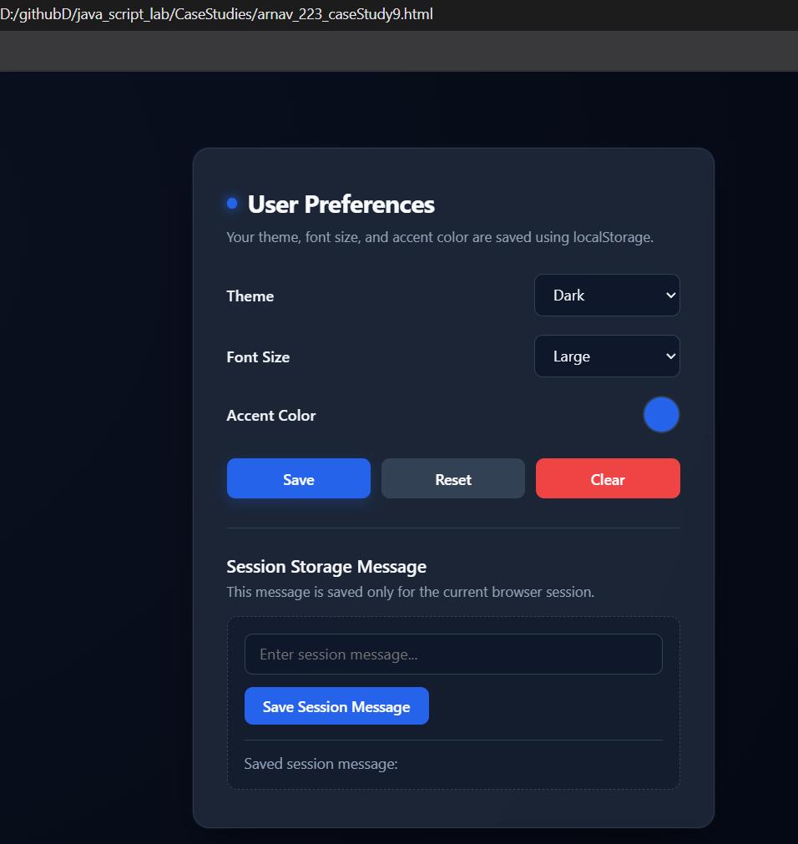

Experiment No. 10

Title
Load and display JSON data using fetch() and jQuery $.getJSON(); render results dynamically in a table.
Software / Tools Required
- Google Chrome — Web browser used for execution and testing.
- Visual Studio Code (VS Code) — Code editor used for writing HTML, CSS

<!DOCTYPE html>
<html lang="en">
<head>
<meta charset="UTF-8">
<meta name="viewport" content="width=device-width, initial-scale=1.0">

<title>Student Data</title>

<!-- jQuery Library -->
<script src="https://code.jquery.com/jquery-3.7.1.min.js"></script>

<style>
body {
font-family: Arial, sans-serif;
background-color: #f2f2f2;
padding: 30px;
}

.container {
width: 90%;
margin: auto;
background-color: white;
padding: 25px;
border-radius: 10px;
}

h1 {
text-align: center;
color: #333;
}

button {
padding: 10px 20px;
margin: 10px;
border: none;
border-radius: 5px;
cursor: pointer;
}

#fetchBtn {
background-color: #2563eb;
color: white;
}

#jqueryBtn {
background-color: #16a34a;
color: white;
}

.buttons {
text-align: center;
}

table {
width: 100%;
border-collapse: collapse;
margin-top: 20px;
}

th, td {
border: 1px solid #ccc;
padding: 12px;
text-align: center;
}

th {
background-color: #333;
color: white;
}

tr:nth-child(even) {
background-color: #f5f5f5;
}

#message {
text-align: center;
font-weight: bold;
}
</style>
</head>

<body>

<div class="container">

<h1>Student Data</h1>

<div class="buttons">
<button id="fetchBtn">Load using fetch()</button>

<button id="jqueryBtn">
Load using $.getJSON()
</button>
</div>

<p id="message">
Click any button to load student data.
</p>

<table>

<thead>
<tr>
<th>Roll No.</th>
<th>Name</th>
<th>Course</th>
<th>Year</th>
<th>Email</th>
<th>Marks</th>
</tr>
</thead>

<tbody id="studentTable">
<!-- Student data will be added here -->
</tbody>

</table>

</div>

<script src="script.js"></script>

</body>
</html>

// Function to display student data in the table

function displayStudents(students) {

let tableBody = document.getElementById("studentTable");

// Clear previous data
tableBody.innerHTML = "";

// Loop through student records
students.forEach(function(student) {

// Create a new table row
let row = document.createElement("tr");

// Add student data into table cells
row.innerHTML = `
<td>${student.rollNo}</td>
<td>${student.name}</td>
<td>${student.course}</td>
<td>${student.year}</td>
<td>${student.email}</td>
<td>${student.marks}</td>
`;

// Append row to table body
tableBody.appendChild(row);
});
}

// ============================================
// USING FETCH()
// ============================================

document.getElementById("fetchBtn").addEventListener("click", function() {

document.getElementById("message").innerText =
"Loading data using fetch()...";

fetch("students.json")

.then(function(response) {

return response.json();

})

.then(function(data) {

displayStudents(data);

document.getElementById("message").innerText =
"Student data loaded using fetch()";

})

.catch(function(error) {

console.log(error);

document.getElementById("message").innerText =
"Error loading student data.";

});
});

// ============================================
// USING jQuery $.getJSON()
// ============================================

$("#jqueryBtn").click(function() {

$("#message").text(
"Loading data using $.getJSON()..."
);

$.getJSON("students.json")

.done(function(data) {

displayStudents(data);

$("#message").text(
"Student data loaded using $.getJSON()"
);

})

.fail(function() {

$("#message").text(
"Error loading student data."
);

});
})

[
{
"id": 101,
"name": "Arnav Band",
"course": "B.Tech Computer Science",
"year": "3rd Year",
"email": "arnav@example.com",
"marks": 87
},
{
"id": 102,
"name": "Jayesh Mundle",
"course": "B.Tech Information Technology",
"year": "3rd Year",
"email": "jayesh@example.com",
"marks": 91
},
{
"id": 103,
"name": "dhawle",
"course": "B.Tech Computer Science",
"year": "2nd Year",
"email": "dhawle@example.com",
"marks": 78
},
{
"id": 104,
"name": "Aditya Joshi",
"course": "B.Tech Electronics",
"year": "3rd Year",
"email": "aditya@example.com",
"marks": 84
},
{
"id": 105,
"name": "kunali",
"course": "B.Tech Computer Science",
"year": "2nd Year",
"email": "kunali@example.com",
"marks": 93
}
]

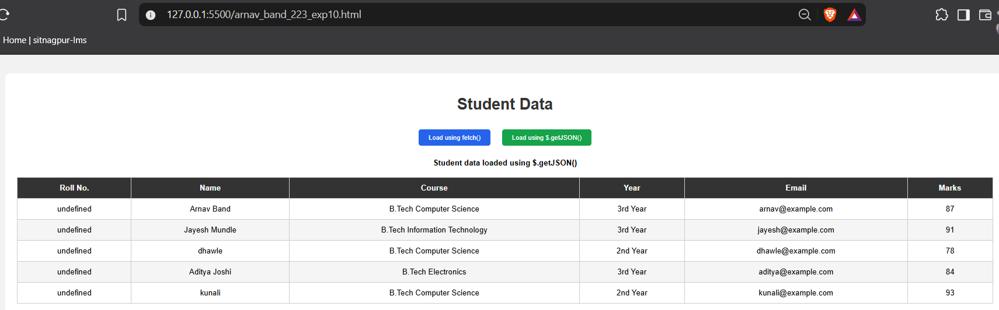

Result / Conclusion
In conclusion, this experiment demonstrated the loading and display of JSON data using JavaScript fetch() and jQuery $.getJSON(). The application successfully retrieved student records asynchronously, rendered them dynamically in a table, and provided search, filter, and sort functionality along with response latency feedback. Thus, the experiment demonstrated effective use of asynchronous data fetching and dynamic DOM manipulation in a web application.

Case Study No.: 10
AIM:
To Asynchronously Fetch, Parse, and Dynamically Render JSON Data in a Responsive Web Application Using Native JavaScript fetch() API and jQuery $.getJSON().
Develop a Campus Event Registration System that loads student event records from an external students.json file using both ES6 fetch() and jQuery $.getJSON(), dynamically generating an interactive data table complete with live search filtering, department/status filters, and real-time statistical KPI metrics.

<!DOCTYPE html>
<html lang="en">
<head>
<meta charset="UTF-8" />
<meta name="viewport" content="width=device-width, initial-scale=1.0" />
<title>Campus Event Registration System</title>

<!-- jQuery Library CDN -->
<script src="https://code.jquery.com/jquery-3.7.1.min.js"></script>

<style>
:root {
--bg: #f8fafc;
--card-bg: #ffffff;
--text: #0f172a;
--text-muted: #64748b;
--border: #cbd5e1;
--primary: #2563eb;
--primary-hover: #1d4ed8;
--secondary: #475569;
--secondary-hover: #334155;
--table-header: #f1f5f9;
--table-row-hover: #f8fafc;
--status-reg-bg: #dcfce7;
--status-reg-text: #166534;
--status-pen-bg: #fef3c7;
--status-pen-text: #92400e;
--status-can-bg: #fee2e2;
--status-can-text: #991b1b;
--card-shadow: 0 10px 25px -5px rgba(0, 0, 0, 0.05);
}

body.dark-theme {
--bg: #0b1120;
--card-bg: #1e293b;
--text: #f8fafc;
--text-muted: #94a3b8;
--border: #334155;
--primary: #38bdf8;
--primary-hover: #7dd3fc;
--secondary: #334155;
--secondary-hover: #475569;
--table-header: #0f172a;
--table-row-hover: #243044;
--status-reg-bg: #064e3b;
--status-reg-text: #86efac;
--status-pen-bg: #451a03;
--status-pen-text: #fcd34d;
--status-can-bg: #450a0a;
--status-can-text: #fca5a5;
--card-shadow: 0 20px 30px -10px rgba(0, 0, 0, 0.5);
}

* {
box-sizing: border-box;
margin: 0;
padding: 0;
font-family: -apple-system, BlinkMacSystemFont, "Segoe UI", Roboto, sans-serif;
}

body {
background-color: var(--bg);
color: var(--text);
min-height: 100vh;
padding: 40px 20px;
font-size: 1.05rem;
transition: background-color 0.3s ease, color 0.3s ease;
}

.container {
max-width: 1100px;
margin: 0 auto;
}

.theme-toggle-btn {
position: fixed;
top: 20px;
right: 20px;
padding: 10px 20px;
font-size: 1rem;
font-weight: 700;
background: var(--card-bg);
color: var(--text);
border: 1.5px solid var(--border);
border-radius: 24px;
cursor: pointer;
box-shadow: var(--card-shadow);
transition: all 0.2s ease;
z-index: 1000;
}

.theme-toggle-btn:hover {
transform: translateY(-2px);
}

header {
text-align: center;
margin-bottom: 32px;
}

header h1 {
font-size: 2.4rem;
font-weight: 800;
margin-bottom: 8px;
}

header p {
color: var(--text-muted);
font-size: 1.15rem;
}

.card {
background: var(--card-bg);
border: 1px solid var(--border);
border-radius: 14px;
padding: 26px;
margin-bottom: 24px;
box-shadow: var(--card-shadow);
}

.toolbar {
display: flex;
flex-wrap: wrap;
gap: 14px;
align-items: center;
justify-content: space-between;
}

.btn-group {
display: flex;
gap: 12px;
flex-wrap: wrap;
}

button.btn {
padding: 12px 22px;
border: none;
border-radius: 8px;
font-size: 1.05rem;
font-weight: 600;
cursor: pointer;
transition: background-color 0.2s, transform 0.1s;
}

button.btn:active {
transform: scale(0.98);
}

.btn-fetch {
background-color: var(--primary);
color: #ffffff;
}

body.dark-theme .btn-fetch {
color: #0b1120;
}

.btn-fetch:hover {
background-color: var(--primary-hover);
}

.btn-jquery {
background-color: var(--secondary);
color: #ffffff;
}

.btn-jquery:hover {
background-color: var(--secondary-hover);
}

.filter-controls {
display: flex;
gap: 12px;
flex-wrap: wrap;
flex: 1;
justify-content: flex-end;
}

.filter-controls input[type="text"],
.filter-controls select {
padding: 12px 16px;
border: 1.5px solid var(--border);
border-radius: 8px;
background: var(--card-bg);
color: var(--text);
font-size: 1.05rem;
outline: none;
transition: border-color 0.2s;
}

.filter-controls input[type="text"] {
min-width: 280px;
}

.filter-controls input:focus,
.filter-controls select:focus {
border-color: var(--primary);
}

.status-alert {
padding: 14px 20px;
border-radius: 8px;
font-size: 1.05rem;
font-weight: 500;
margin-bottom: 18px;
display: none;
}

.alert-error {
background: rgba(239, 68, 68, 0.15);
border: 1px solid #ef4444;
color: #ef4444;
}

.alert-info {
background: rgba(56, 189, 248, 0.15);
border: 1px solid var(--primary);
color: var(--primary);
}

.table-container {
overflow-x: auto;
}

table {
width: 100%;
border-collapse: collapse;
text-align: left;
font-size: 1.05rem;
}

thead th {
background-color: var(--table-header);
padding: 16px 16px;
font-weight: 700;
color: var(--text-muted);
border-bottom: 2px solid var(--border);
text-transform: uppercase;
font-size: 0.9rem;
letter-spacing: 0.6px;
}

tbody td {
padding: 16px 16px;
border-bottom: 1px solid var(--border);
}

tbody tr:hover {
background-color: var(--table-row-hover);
}

.status-badge {
display: inline-block;
padding: 6px 14px;
border-radius: 14px;
font-size: 0.9rem;
font-weight: 700;
text-transform: uppercase;
letter-spacing: 0.4px;
}

.status-Registered {
background-color: var(--status-reg-bg);
color: var(--status-reg-text);
}

.status-Pending {
background-color: var(--status-pen-bg);
color: var(--status-pen-text);
}

.status-Cancelled {
background-color: var(--status-can-bg);
color: var(--status-can-text);
}

.empty-state {
text-align: center;
color: var(--text-muted);
padding: 38px 12px;
font-size: 1.1rem;
font-style: italic;
}
</style>
</head>
<body>

<!-- Theme Toggle Button -->
<button class="theme-toggle-btn" id="themeToggle">🌙 Dark Mode</button>

<div class="container">
<header>
<h1>Campus Event Registration System</h1>
<p>Dynamic JSON Data Loader using JavaScript fetch() and jQuery $.getJSON()</p>
</header>

<!-- Action Controls & Filter Toolbar -->
<div class="card">
<div class="toolbar">
<div class="btn-group">
<button class="btn btn-fetch" id="loadFetchBtn">Load Student Data (fetch)</button>
<button class="btn btn-jquery" id="loadJqueryBtn">Load via jQuery ($.getJSON)</button>
</div>

<div class="filter-controls">
<input type="text" id="searchInput" placeholder="Search by Student Name or PRN..." disabled />
<select id="statusFilter" disabled>
<option value="ALL">All Statuses</option>
<option value="Registered">Registered</option>
<option value="Pending">Pending</option>
<option value="Cancelled">Cancelled</option>
</select>
</div>
</div>
</div>

<!-- Alert / Message Output Area -->
<div id="alertBox" class="status-alert"></div>

<!-- Table Skeleton -->
<div class="card">
<div class="table-container">
<table>
<thead>
<tr>
<th>#</th>
<th>Student Name</th>
<th>PRN</th>
<th>Department</th>
<th>Year</th>
<th>Event Name</th>
<th>Registration Status</th>
</tr>
</thead>
<tbody id="studentTableBody">
<tr>
<td colspan="7" class="empty-state">No student records loaded. Click a load button above.</td>
</tr>
</tbody>
</table>
</div>
</div>
</div>

<script>
let studentData = [];

// 1. Theme Management (localStorage persistence)
function applyTheme(theme) {
if (theme === 'dark') {
$('body').addClass('dark-theme');
$('#themeToggle').text('☀️ Light Mode');
} else {
$('body').removeClass('dark-theme');
$('#themeToggle').text('🌙 Dark Mode');
}
}

$('#themeToggle').on('click', function () {
const nextTheme = $('body').hasClass('dark-theme') ? 'light' : 'dark';
localStorage.setItem('campus_event_theme', nextTheme);
applyTheme(nextTheme);
});

// 2. Alert Box Display Helpers
function showAlert(message, type = 'info') {
const alertBox = $('#alertBox');
alertBox.removeClass('alert-error alert-info');
alertBox.addClass(type === 'error' ? 'alert-error' : 'alert-info');
alertBox.text(message).fadeIn(200);
}

function hideAlert() {
$('#alertBox').hide();
}

function enableControls() {
$('#searchInput, #statusFilter').prop('disabled', false);
}

// 3. Dynamic HTML Table Generation with Live Filtering
function renderTable() {
hideAlert();
const tbody = $('#studentTableBody');
tbody.empty();

if (!studentData || studentData.length === 0) {
tbody.append(`<tr><td colspan="7" class="empty-state">No student records loaded.</td></tr>`);
return;
}

const searchTerm = $('#searchInput').val().trim().toLowerCase();
const selectedStatus = $('#statusFilter').val();

const filtered = studentData.filter(student => {
const matchesSearch = student.studentName.toLowerCase().includes(searchTerm) ||
student.prn.toLowerCase().includes(searchTerm);
const matchesStatus = (selectedStatus === 'ALL') || (student.registrationStatus === selectedStatus);

return matchesSearch && matchesStatus;
});

if (filtered.length === 0) {
tbody.append(`<tr><td colspan="7" class="empty-state">No student matches the search/filter criteria.</td></tr>`);
return;
}

filtered.forEach((student, index) => {
const row = `
<tr>
<td>${index + 1}</td>
<td><strong>${student.studentName}</strong></td>
<td><code>${student.prn}</code></td>
<td>${student.department}</td>
<td>${student.year}</td>
<td>${student.eventName}</td>
<td><span class="status-badge status-${student.registrationStatus}">${student.registrationStatus}</span></td>
</tr>
`;
tbody.append(row);
});
}

// 4. Data Loading via JavaScript fetch()
$('#loadFetchBtn').on('click', function () {
fetch('students.json')
.then(response => {
if (!response.ok) throw new Error();
return response.json();
})
.then(data => {
studentData = data;
enableControls();
renderTable();
showAlert(`Successfully loaded ${studentData.length} records using JavaScript fetch().`, 'info');
})
.catch(() => {
studentData = [];
renderTable();
showAlert("JSON data cannot be loaded. Ensure 'students.json' is present in the folder.", "error");
});
});

// 5. Data Loading via jQuery $.getJSON()
$('#loadJqueryBtn').on('click', function () {
$.getJSON('students.json')
.done(function (data) {
studentData = data;
enableControls();
renderTable();
showAlert(`Successfully loaded ${studentData.length} records using jQuery $.getJSON().`, 'info');
})
.fail(function () {
studentData = [];
renderTable();
showAlert("JSON data cannot be loaded. Ensure 'students.json' is present in the folder.", "error");
});
});

// 6. Live Search & Dropdown Change Listeners
$('#searchInput').on('input', renderTable);
$('#statusFilter').on('change', renderTable);

// Initial load setup
$(document).ready(function () {
const savedTheme = localStorage.getItem('campus_event_theme') || 'light';
applyTheme(savedTheme);
});
</script>
</body>
</html>

[
{
"studentName": "Arnav Band",
"prn": "24070521223",
"department": "Computer Science & Engineering",
"year": "3rd Year",
"eventName": "Hackathon 2026",
"registrationStatus": "Registered"
},
{
"studentName": "Rohit Sharma",
"prn": "24070521224",
"department": "Information Technology",
"year": "3rd Year",
"eventName": "Web Design Sprint",
"registrationStatus": "Pending"
},
{
"studentName": "Gaurav jammu ",
"prn": "24070521105",
"department": "Electronics & Telecommunication",
"year": "2nd Year",
"eventName": "Robotics Expo",
"registrationStatus": "Cancelled"
},
{
"studentName": "Aditya Patil",
"prn": "24070521188",
"department": "Computer Science & Engineering",
"year": "4th Year",
"eventName": "Hackathon 2026",
"registrationStatus": "Registered"
},
{
"studentName": "Rakesh Kulkarni",
"prn": "24070521092",
"department": "Mechanical Engineering",
"year": "1st Year",
"eventName": "AI Symposium",
"registrationStatus": "Pending"
},
{
"studentName": "Tanmay Joshi",
"prn": "24070521310",
"department": "Computer Science & Engineering",
"year": "3rd Year",
"eventName": "Code Debugging Clash",
"registrationStatus": "Cancelled"
}
]

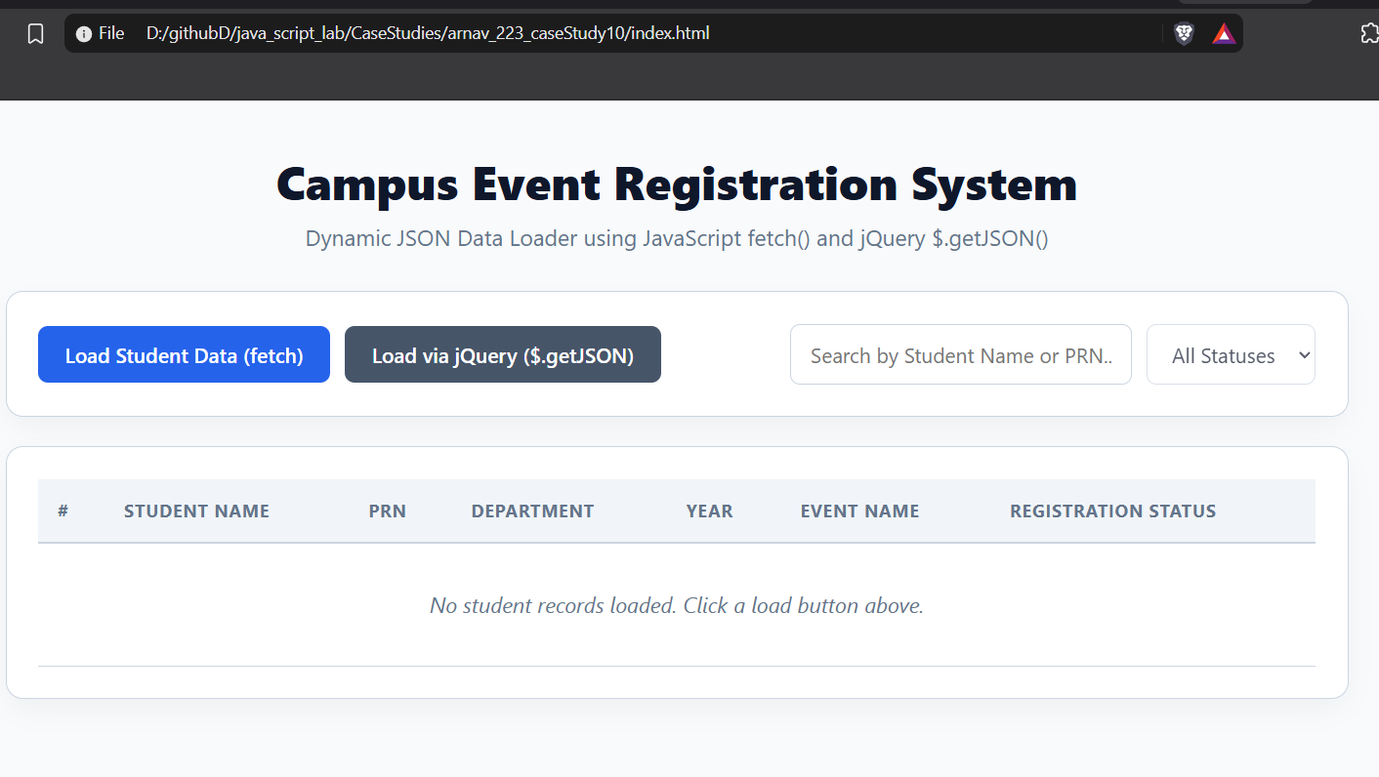

Conclusion / Result
Through this experiment, core asynchronous programming paradigms—specifically ES6 Promises via fetch() and AJAX-based data retrieval via jQuery $.getJSON()—were effectively analyzed and deployed. The resulting Campus Event Registration System highlights zero-latency client-side state updates, illustrating how dynamic DOM rendering and array filtering (filter(), reduce()) can handle external JSON payloads efficiently within a modern web interface.

THANKYOU.

